SUPPLEMENTARY DATA

How effective are conservation areas to preserve biodiversity in Mexico?

Armando Falcón-Brindisª, Jorge L. León-Cortésª*, Marytania Montañez-Reynaª

ªDepartamento de Conservación de la Biodiversidad, El Colegio de la Frontera Sur. Carretera Panamericana & Periférico Sur S/N, 29290. San Cristóbal de las Casas, Chiapas, Mexico.

Armando Falcón-Brindis: armandofalcon123@gmail.com
Jorge L. León-Cortés: jleon@ecosur.mx (Corresponding author)
Marytania Montañez-Reyna: tania59@live.com.mx

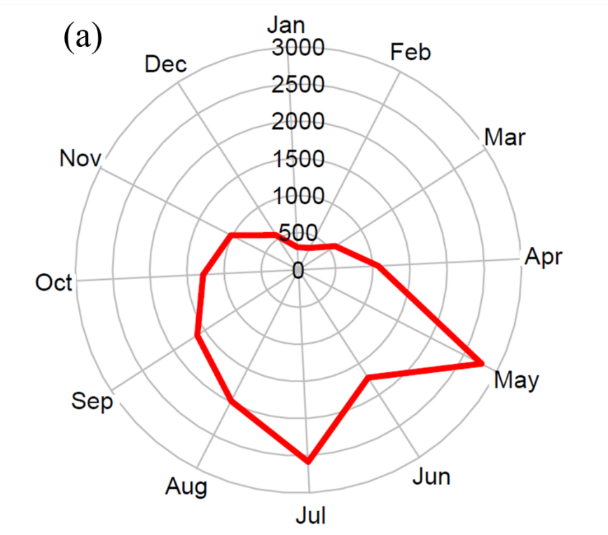

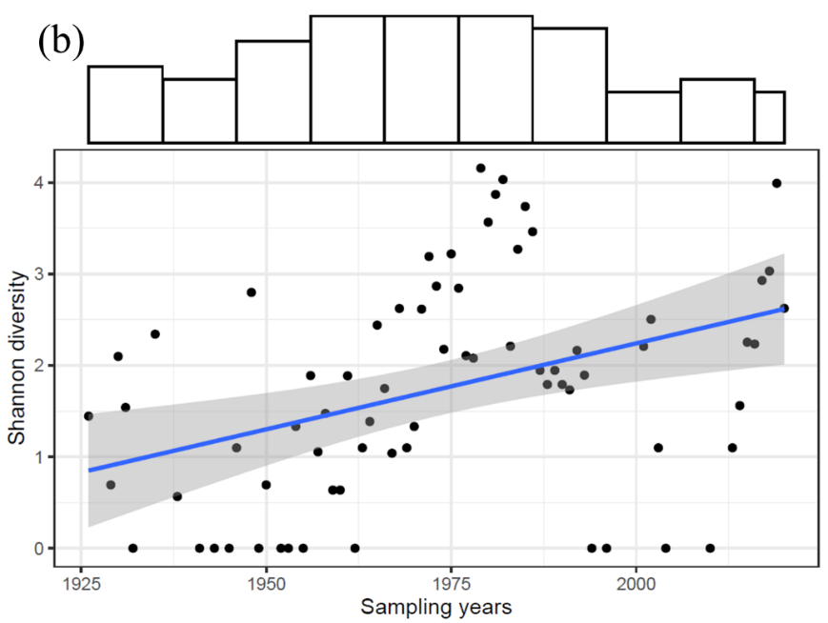
Fig 1. Erebidae sampling through time in Mexico. (a) Historical temporal (months) collecting efforts; (b) changes in species diversity across sampling years in Chiapas.

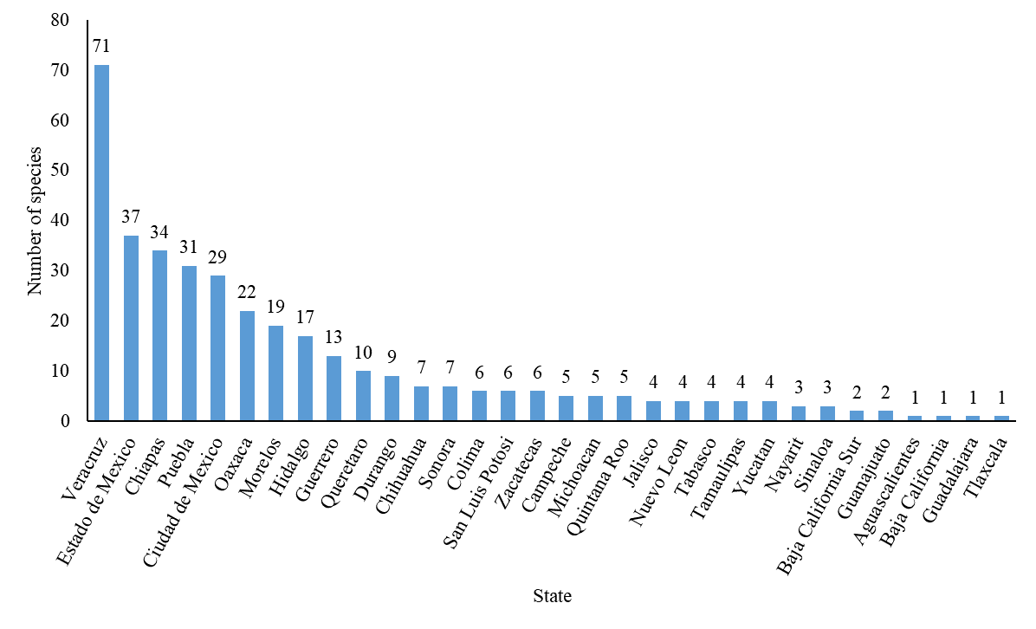
Fig 2. Number of endemic species of Erebidae per state.

Table 1. Proportion of Erebidae species and records across climatic classification from Chiapas. Codes follow the modifications of Köppen´s climatic classification (García 2004).

Climate | Sub-type code | Area km2 | Records | % records | Species | % species
Semi-warm | (A)C(fm) | 0.07 | 0 | 0.0 | 0 | 0.0
 | (A)C(m) | 70.71 | 552 | 19.6 | 103 | 23.2
 | (A)C(m)(f) | 78.26 | 170 | 6.0 | 95 | 21.4
 | (A)C(w1) | 12.49 | 193 | 6.9 | 45 | 10.1
 | (A)C(w2) | 4.91 | 47 | 1.7 | 35 | 7.9
 | TOTAL | 166.45 | 962 | 34.2 | 278 | 62.6
Tropical | A(f) | 133.49 | 103 | 3.7 | 58 | 13.1
 | Am | 473.8 | 496 | 17.6 | 185 | 41.7
 | Am(f) | 16.98 | 45 | 1.6 | 32 | 7.2
 | Aw1 | 13.35 | 22 | 0.8 | 18 | 4.1
 | Aw2 | 24.98 | 70 | 2.5 | 46 | 10.4
 | Aw2(x') | 0.06 | 2 | 0.1 | 2 | 0.5
 | Awo | 34.44 | 113 | 4.0 | 59 | 13.3
 | TOTAL | 697.13 | 815 | 30.2 | 400 | 90.1
Dry | BS1(h')w | 0.01 | 0 | 0.0 | 0 | 0.0
Temperate | C(f) | 0.007 | 0 | 0.0 | 0 | 0.0
 | C(m) | 8.44 | 656 | 23.3 | 64 | 14.4
 | C(m)(f) | 0.94 | 20 | 0.7 | 17 | 3.8
 | C(w1) | 1.07 | 13 | 0.5 | 3 | 0.7
 | C(w2) | 48.4 | 317 | 11.3 | 102 | 23.0
 | Cb'(m)(f) | 0.001 | 0 | 0.0 | 0 | 0.0
 | Cb'(w2) | 0.004 | 3 | 0.1 | 3 | 0.7
 | TOTAL | 58.89 | 1009 | 35.8 | 189 | 42.6

Table 2. Proportion of Erebidae species and records across conservation polygons in Chiapas.
Conservation category | Name/class | Area (km2) | Records | % records | Species | % species
PNA | Bonampak | 43.5 | 35 | 1.2 | 23 | 5.2
 | Cañón del sumidero | 217.8 | 28 | 1.0 | 11 | 2.5
 | Cañón del Usumacinta | 461.2 | 0 | 0.0 | 0 | 0.0
 | Cascada de Agua Azul | 25.8 | 1 | 0.0 | 1 | 0.2
 | Chan-Kin | 121.8 | 0 | 0.0 | 0 | 0.0
 | El Triunfo | 1191.7 | 1101 | 39.1 | 108 | 24.3
 | La Encrucijada | 1448.6 | 0 | 0.0 | 0 | 0.0
 | La Sepultura | 1673.1 | 5 | 0.2 | 4 | 0.9
 | Lacan-Tun | 618.7 | 0 | 0.0 | 0 | 0.0
 | Lagunas de Montebello | 64.25 | 58 | 2.1 | 44 | 9.9
 | Metzabok | 0.33 | 0 | 0.0 | 0 | 0.0
 | Montes Azules | 33.1 | 2 | 0.1 | 2 | 0.5
 | Nahá | 38.4 | 7 | 0.2 | 3 | 0.7
 | Palenque | 17.7 | 17 | 0.6 | 15 | 3.4
 | Playa de Puerto Arista | 2.1 | 0 | 0.0 | 0 | 0.0
 | Selva El Ocote | 1012.8 | 38 | 1.3 | 25 | 5.6
 | Volcán Tacaná | 63.7 | 2 | 0.1 | 2 | 0.5
 | Yaxchilán | 26.2 | 0 | 0.0 | 0 | 0.0
 | Z.P.F. | 1775.4 | 5 | 0.2 | 4 | 0.9
 |  | TOTAL | 1298 | 46.1 | 187 | 42.1
TPR | Bosques mesófilos de Chiapas¹ | 2222.0 | 11 | 0.4 | 11 | 2.5
 | El Manzanillal | 606.0 | 0 | 0.0 | 0 | 0.0
 | El Momón-Montebello | 2446.0 | 188 | 6.7 | 99 | 22.3
 | El Mozotal | 311.0 | 23 | 0.8 | 16 | 3.6
 | El Triunfo-La Encrucijada-Palo Blanco | 5786.0 | 1153 | 40.9 | 123 | 27.7
 | Huitepec-Tzontehuitz | 252.0 | 2 | 0.1 | 2 | 0.5
 | La Chacona-Cañón del Sumidero | 589.0 | 19 | 0.7 | 9 | 2.0
 | Lacandona² | 12988.0 | 460 | 16.3 | 171 | 38.5
 | Lagunas de Catazajá-Emiliano Zapata | 1197.0 | 0 | 0.0 | 0 | 0.0
 | Selva espinosa Alto Grijalva-Motozintla | 177.0 | 0 | 0.0 | 0 | 0.0
 | Selva Zoque-La Sepultura | 11319.0 | 9 | 0.3 | 7 | 1.6
 | Tacaná-Boquerón | 574.0 | 41 | 1.5 | 13 | 2.9
 |  | TOTAL | 1906 | 67.7 | 317 | 71.4
¹High diversity of Lepidoptera and relictual populations. ²Harbors the richest butterfly diversity across the country.

Table 2. Continued.

Conservation category | Name/Class | Area (km2) | Records | % records | Species | % species
TPS | Medium | 13005 | 322 | 11.4 | 129 | 29.1
 | High | 19635 | 608 | 21.6 | 129 | 29.1
 | Extreme | 5355 | 1346 | 47.8 | 259 | 58.3
 |  | TOTAL | 2168 | 76.9 | 374 | 84.2
PRS | Medium | 1773 | 22 | 0.8 | 20 | 4.5
 | High | 7676 | 38 | 1.3 | 29 | 6.5
 | Extreme | 7310 | 637 | 22.6 | 137 | 30.9
 |  | TOTAL | 697 | 24.7 | 165 | 37.2

