Supplemental Material
Perspectives in Ecology and Conservation

Implications of unreliable species identification methods for Neotropical deer conservation planning
Pedro Henrique de Faria Peres¹; Francisco Grotta-Neto¹,²; Douglas Jovino Luduvério¹; Márcio Leite de Oliveira¹; José Maurício Barbanti Duarte¹

¹ Deer Research and Conservation Center (NUPECCE), São Paulo State University (UNESP)
² Laboratório de Biodiversidade, Conservação e Ecologia de Animais Silvestres (LABCEAS), Departamento de Zoologia, Universidade Federal do Paraná (UFPR).

Correponding Author Adress and Email
Pedro H. F Peres
Email: pedrof182@gmail.com
Universidade Estadual Paulista, Departamento de Zootecnia, NUPECCE.
Via de Acesso Prof. Paulo Donato Castellane s/n, CEP 14884-900, Jaboticabal, São Paulo, Brazil.

A. Geographic distribution of the eight deer species found in Brazil.

B. Comparative photograph of the eight deer species currently described for Brazil and kept at the scientific breeding site of the São Paulo State University. In the background, a size scale is shown in centimeters. (A) Mazama gouazoubira, (B) Mazama nemorivaga, (C) Mazama americana, (D) Mazama nana, (E) Mazama bororo, (F) Odocoileus virginianus, (G) Blastocerus dichotomus and (H) Ozotoceros bezoarticus.
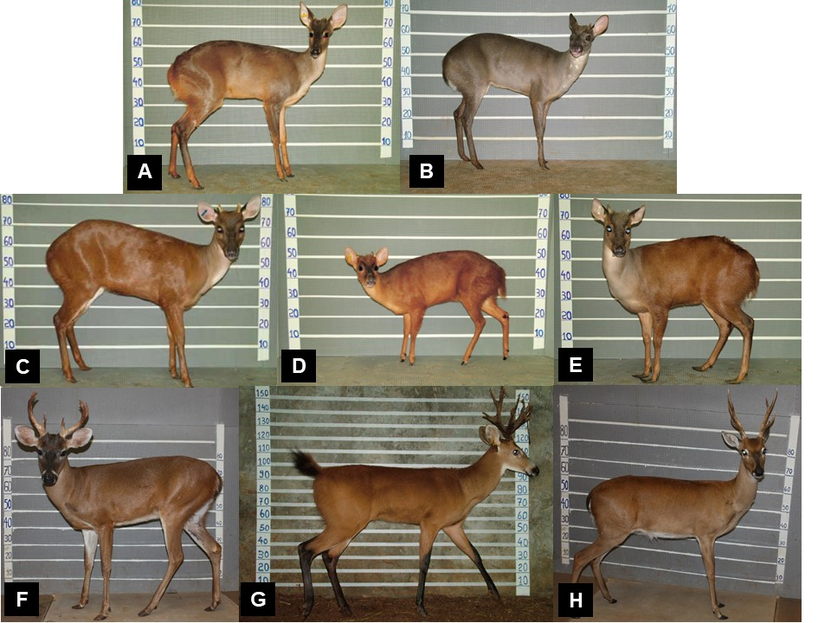

C. List of protected areas with evaluated management plans, their administration and management responsibility, area occupied and position related to Brazilian biomes.
Protected Areas | Management Class | Area (ha) | Biome
Alto Chandless State Park | Public | 693294 | Amazon
Amazônia National Park | Public | 1110528 | Amazon
Anavilhanas Ecological Station | Public | 340832 | Amazon
Angatuba Ecological Station | Public | 1412 | Cerrado
Aparados da Serra National Park | Public | 13064 | Atlantic forest
Araguaia National Park | Public | 564529 | Cerrado
Araguaia State Park | Public | 229921 | Cerrado
Araucárias National Park | Public | 12847 | Atlantic forest
Assis Ecological Station | Public | 1287 | Cerrado
Cabo Orange National Park | Public | 657316 | Amazon
Campos Amazônicos National Park | Public | 879714 | Amazon
Campos de Palmas Wildlife Refuge | Public | 16594 | Atlantic forest
Cantão State Park | Public | 100415 | Cerrado
Caparaó National Park | Public | 31763 | Atlantic forest
Carlos Botelho State Park | Public | 40219 | Atlantic forest
Cavernas do Peruaçu National Park | Public | 56476 | Cerrado
Chapada Diamantina National Park | Public | 149694 | Caatinga
Chapada dos Guimarães National Park | Public | 32656 | Cerrado
Chapada dos Veadeiros National Park | Public | 64796 | Cerrado
Corumbiara State Park | Public | 407148 | Amazon
Cristalino II State Park | Public | 141351 | Amazon
Descobrimento National Park | Public | 21145 | Atlantic forest
Desengano State Park | Public | 21403 | Atlantic forest
Emas National Park | Public | 132600 | Cerrado
Grande Sertão Veredas National Park | Public | 230853 | Cerrado
Grão Pará Ecological Station | Public | 4203564 | Amazon
Guaporé Biological Reserve | Public | 615211 | Amazon
Gurupi Biological Reserve | Public | 271198 | Amazon
Histórico do Monte Pascoal National Park | Public | 22332 | Atlantic forest
Iguaçu National Park | Public | 169696 | Atlantic forest
Ilha do Cardoso State Park | Public | 13155 | Atlantic forest
Ilha Grande National Park | Public | 107917 | Atlantic forest
Intervales State Park | Public | 49560 | Atlantic forest
Itatiaia National Park | Public | 28245 | Atlantic forest
Itirapina Ecological Station | Public | 2206 | Cerrado
Jalapão State Park | Public | 158973 | Cerrado
Jataí Ecological Station | Public | 9000 | Cerrado
Juami-Japurá Ecological Station | Public | 831531 | Amazon
Juruena National Park | Public | 1955256 | Amazon
Jurupará State Park | Public | 25178 | Atlantic forest
Jutaí-Solimões Ecological Station | Public | 289513 | Amazon
Lajeado State Park | Public | 10750 | Cerrado
Lauráceas State Park | Public | 27682 | Atlantic forest
Maicuru Biological Reserve | Public | 1149306 | Amazon
Montanhas do Tumucumaque National Park | Public | 3865324 | Amazon
Nascentes da Serra do Cachimbo Biological Reserve | Public | 342192 | Amazon
Nascentes do Taquari State Park | Public | 30648 | Cerrado
Pacaas Novos National Park | Public | 707975 | Amazon
Pantanal do Rio Negro State Park | Public | 77908 | Pantanal
Pantanal Matogrossense National Park | Public | 135683 | Pantanal
Pau Brasil National Park | Public | 11553 | Atlantic forest
Pirapitinga Ecological Station | Public | 1384 | Cerrado
Raso da Catarina Ecological Station | Public | 104843 | Caatinga
Rio Doce State Park | Public | 36010 | Atlantic forest
Rio Negro Setor Norte State Park | Public | 149739 | Amazon
Rio Negro Setor Sul State Park | Public | 155853 | Amazon
Rio Trombetas Biological Reserve | Public | 407754 | Amazon
*RPPN Acurizal | Private | 13031 | Pantanal
RPPN Ambientalista Francy Nunes | Private | 110 | Caatinga
RPPN Buraco das Araras | Private | 52 | Cerrado
RPPN Cabeceira do Mimoso | Private | 475 | Cerrado
RPPN Engenheiro Eliezer Batista | Private | 20223 | Pantanal
RPPN Estância Dorochê | Private | 114 | Pantanal
RPPN Estância Ecol. SESC Pantanal | Private | 87883 | Pantanal
RPPN Fazenda Águas Belas | Private | 591 | Atlantic forest
RPPN Fazenda Barra Mansa | Private | 114 | Atlantic forest
RPPN Fazenda Bom Jardim | Private | 114 | Cerrado
RPPN Fazenda Cabeceira do Prata | Private | 292 | Cerrado
RPPN Fazenda da Barra | Private | 88 | Pantanal
RPPN Fazenda João Pereira/Poço Fundo | Private | 337 | Atlantic forest
RPPN Fazenda Nhumirim | Private | 671 | Pantanal
RPPN Fazenda Palmital | Private | 112 | Atlantic forest
RPPN Fazenda Rio Negro | Private | 7001 | Pantanal
RPPN Fazenda São Bento | Private | 219 | Atlantic forest
RPPN Fazenda São Geraldo | Private | 677 | Atlantic forest
RPPN Galheiros | Private | 4063 | Cerrado
RPPN Ita-Y-Tiba | Private | 1083 | Atlantic forest
RPPN Mata do Sossego | Private | 392 | Atlantic forest
RPPN Mitra do Bispo | Private | 101 | Atlantic forest
RPPN Morro da Mina | Private | 1335 | Atlantic forest
RPPN Não Me Deixes | Private | 111 | Caatinga
RPPN Penha | Private | 12268 | Pantanal
RPPN Reserva Ecológica Amadeu Botelho | Private | 114 | Atlantic forest
RPPN Reserva Jacob | Private | 429 | Cerrado
RPPN Reserva Natural Serra do Tombador | Private | 8730 | Cerrado
RPPN Salto do Morato | Private | 885 | Atlantic forest
RPPN Santuário da Serra do Caraça | Private | 12791 | Atlantic forest
RPPN Serra das Almas | Private | 6146 | Caatinga
RPPN Soluar | Private | 45 | Cerrado
RPPN Tarumã | Private | 913 | Atlantic forest
RPPN Vale das Araras | Private | 31 | Cerrado
RPPN Xodó do Vô Ruy | Private | 40 | Cerrado
Santa Bárbara Ecological Station | Public | 3164 | Cerrado
Sempre-Vivas National Park | Public | 124154 | Cerrado
Seridó Ecological Station | Public | 1124 | Caatinga
Serra Azul State Park | Public | 11007 | Cerrado
Serra da Bocaina National Park | Public | 97878 | Atlantic forest
Serra da Bodoquena National Park | Public | 77022 | Cerrado
Serra da Canastra National Park | Public | 197811 | Cerrado
Serra da Cutia National Park | Public | 280706 | Amazon
Serra das Araras I Ecological Station | Public | 23764 | Cerrado
Serra das Confusões National Park | Public | 523924 | Cerrado
Serra do Cipó National Park | Public | 31639 | Cerrado
Serra do Itajaí National Park | Public | 68729 | Atlantic forest
Serra do Mar State Park | Public | 332000 | Atlantic forest
Serra do Pardo National Park | Public | 445394 | Amazon
Serra Geral do Tocantins Ecological Station | Public | 718472 | Cerrado
Serra Geral National Park | Public | 17359 | Atlantic forest
Sete Cidades National Park | Public | 6304 | Caatinga
Sete Passagens State Park | Public | 2822 | Caatinga
Sooretama Biological Reserve | Public | 27859 | Atlantic forest
Terra do Meio Ecological Station | Public | 3360976 | Amazon
Turvo State Park | Public | 16979 | Atlantic forest
Uatumã Biological Reserve | Public | 938721 | Amazon
Ubajara National Park | Public | 6271 | Caatinga
Una Biological Reserve | Public | 10604 | Atlantic forest
Várzeas do Rio Ivinhema State Park | Public | 74224 | Atlantic forest
Viruá National Park | Public | 214948 | Amazon
* RPPN= Private Reserve of Natural Heritage.

D. Number of occurrence records for each species, per biome, and their respective coherence with the species’ geographic distributions.
Biome | Species | Records (n) | Status
Caatinga | M. gouazoubira | 6 | Inside its distribution
 | M. americana | 4 | Outside its distribution
 | O. bezoarticus | 1 | Outside its distribution
Atlantic Forest | M. americana | 29 | Inside its distribution
 | M. gouazoubira | 24 | Inside its distribution
 | M. nana | 11 | Inside its distribution
 | O. bezoarticus | 7 | Inside its distribution
 | M. bororo | 5 | Inside its distribution
 | B. dichotomus | 3 | Inside its distribution
Amazon | M. americana | 19 | Inside its distribution
 | M. gouazoubira | 11 | Outside its distribution
 | M. nemorivaga | 4 | Inside its distribution
 | B. dichotomus | 2 | Inside its distribution
 | O. bezoarticus | 2 | Inside its distribution
 | O. virginianus | 2 | Inside its distribution
Cerrado | M. gouazoubira | 27 | Inside its distribution
 | M. americana | 26 | Inside its distribution
 | O. bezoarticus | 14 | Inside its distribution
 | B. dichotomus | 9 | Inside its distribution
Pantanal | M. gouazoubira | 9 | Inside its distribution
 | B. dichotomus | 6 | Inside its distribution
 | M. americana | 6 | Inside its distribution
 | O. bezoarticus | 5 | Inside its distribution
Total | M. americana | 84 | -
 | M. gouazoubira | 77 | -
 | O. bezoarticus | 29 | -
 | B. dichotomus | 20 | -
 | M. nana | 11 | -
 | M. bororo | 5 | -
 | M. nemorivaga | 4 | -
 | O. virginianus | 2 | -

