Are narrow-ranging species doomed to extinction? Potentially dramatic and generalised decline in future climate suitability of highly threatened species

Supporting information
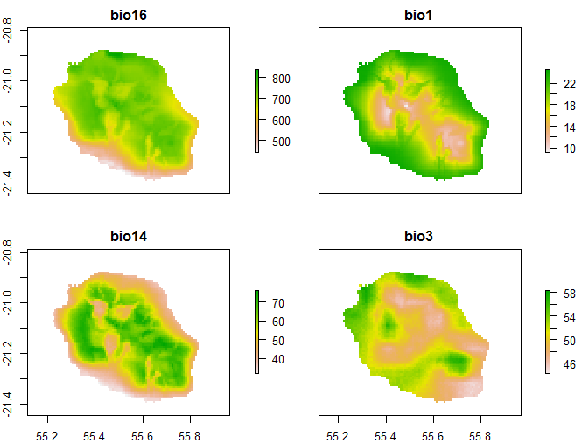
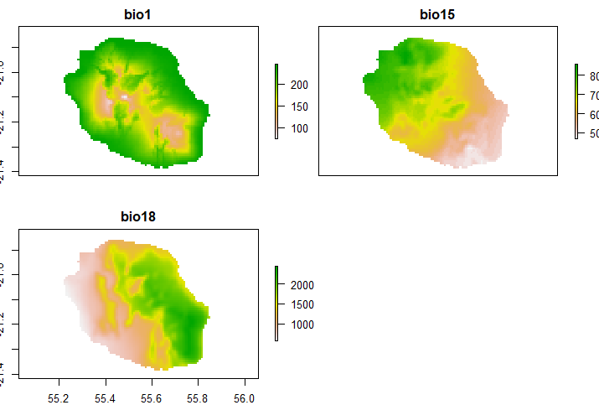
Fig. S1 Selected current bioclimatic variables for Phelsuma inexpectata (Top: Chelsa; Bottom: Worldclim). Bio1: Annual mean temperature; Chelsa: Bio1: Annual mean temperature (°C * 10); Bio15: precipitation seasonality; Bio18: summer precipitation. Worldclim: Bio3: Isothermality; Bio14: Precipitation of Driest Month; Bio16: Precipitation of Wettest Quarter.

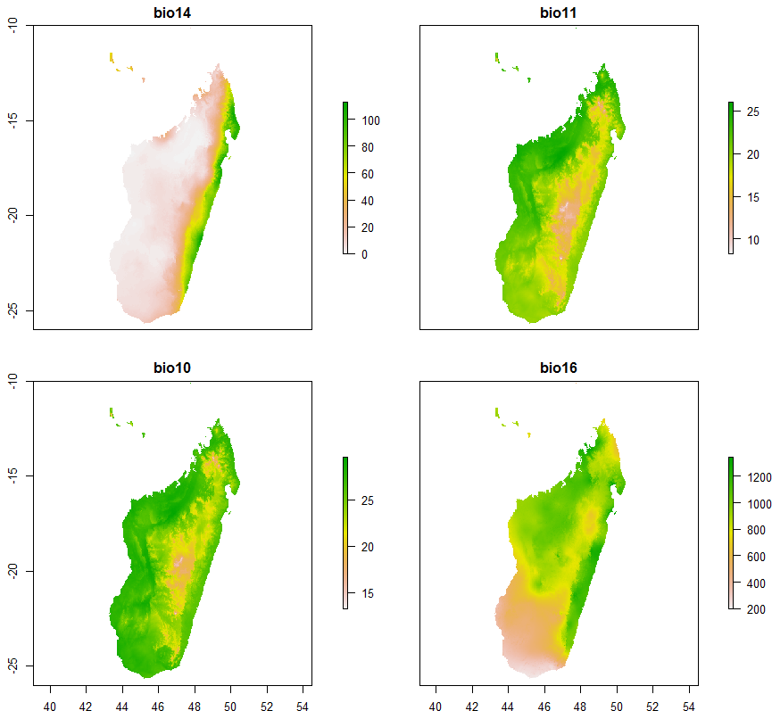
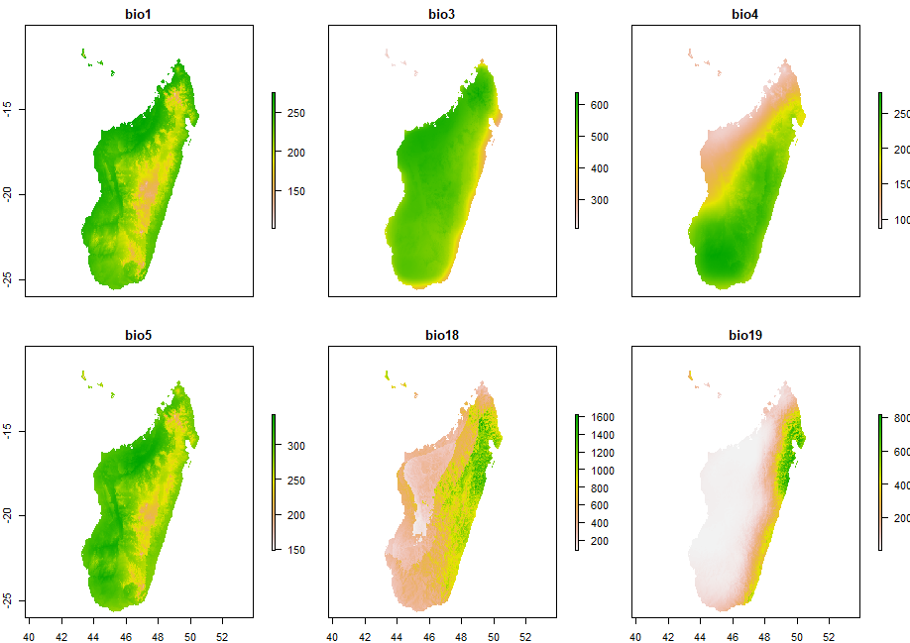
Fig. S2 Selected current bioclimatic variables for Mantella aurantiaca. Top: Chelsa; Bottom: Worldclim. Chelsa: Bio1: Annual mean temperature (°C * 10), Bio3: Isothermality; Bio4: Temperature seasonality: Bio5: Maximum temperature; Bio18: Summer precipitation; Bio19: Winter precipitation. Worldclim: Bio14: Winter precipitation; Bio11: Winter temperature; Bio10; Summer temperature; Bio16: Summer precipitation.

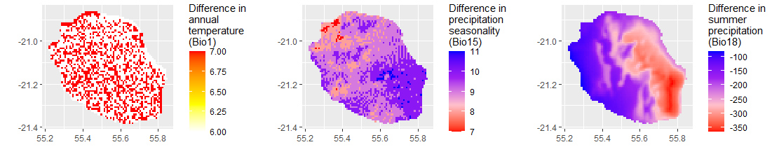
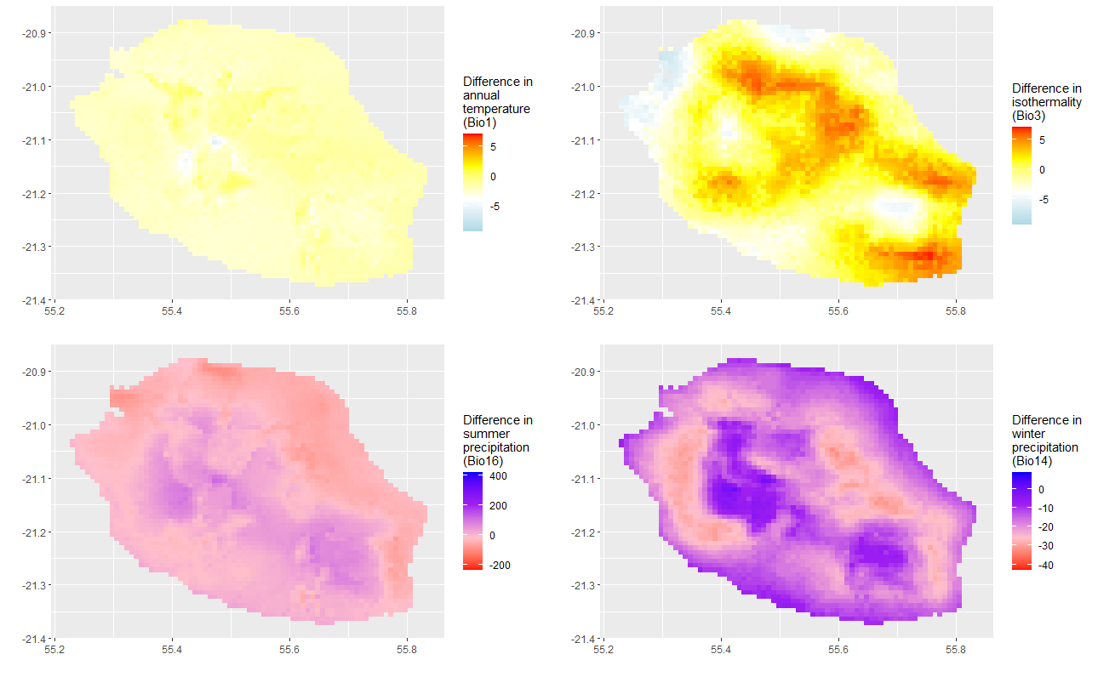
Fig. S3a scenario 2.6 GCM bcc-csm1-1 (top: Chelsa; bottom: Worldclim)

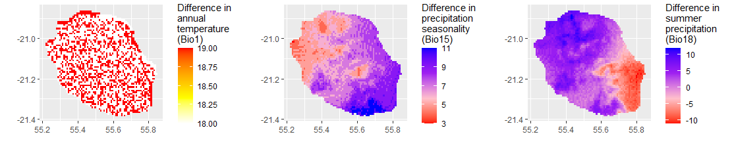
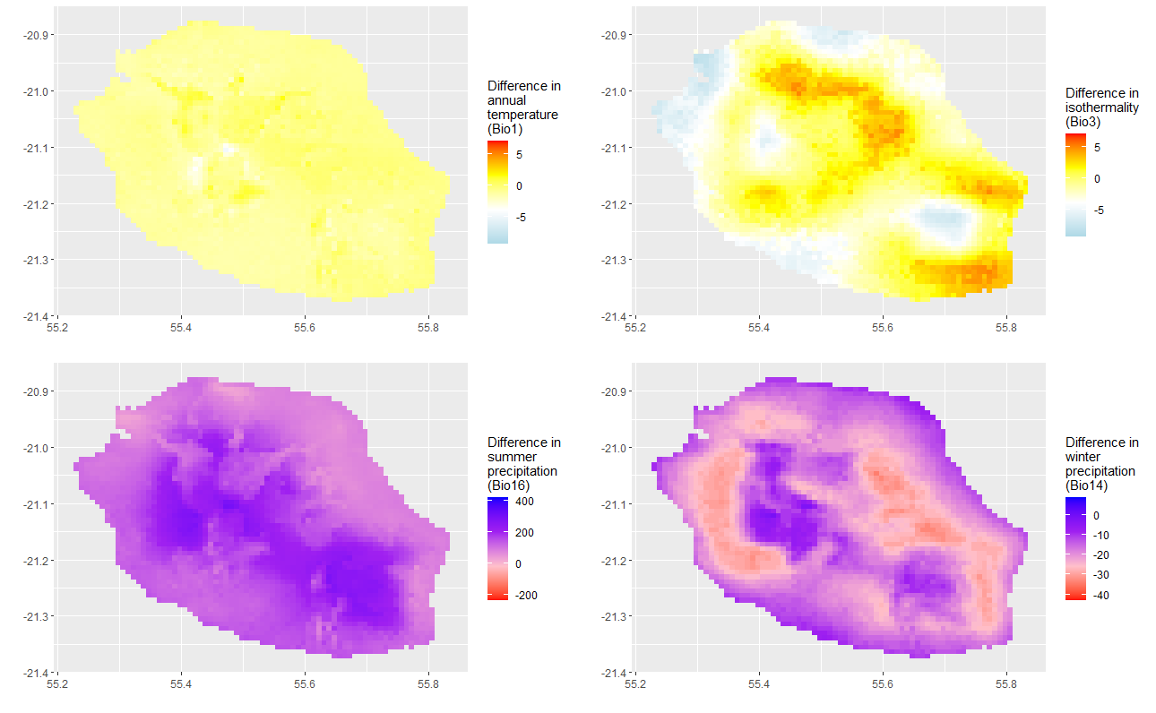
Fig S3b scenario 8.5 GCM bcc-csm1-1 (top: Chelsa; bottom: Worldclim)
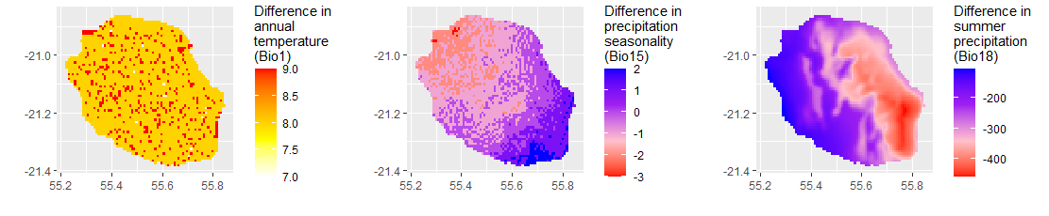
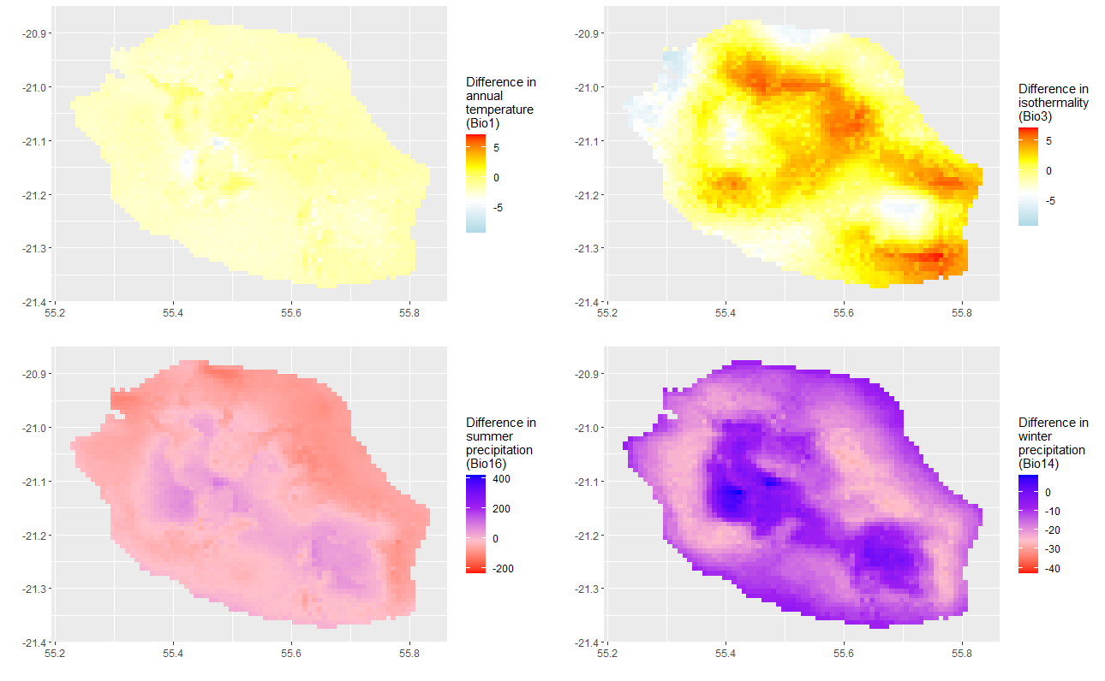
Fig S3c scenario 2.6 GCM Miroc5(top: Chelsa; bottom: Worldclim)

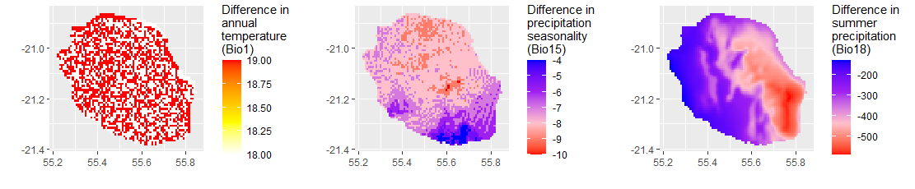
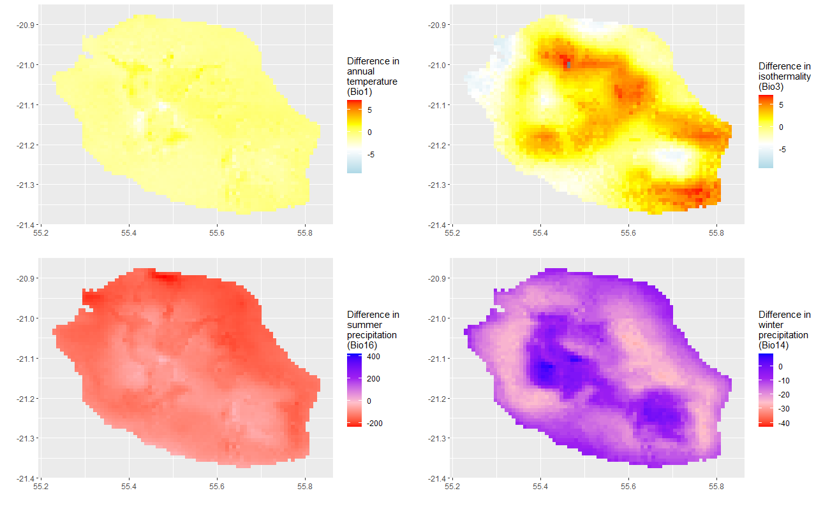
Fig S3d scenario 8.5 GCM Miroc5(top: Chelsa; bottom: Worldclim)
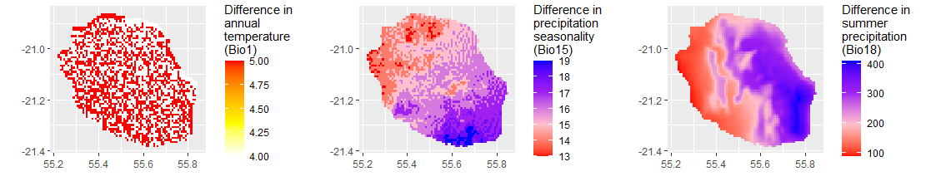
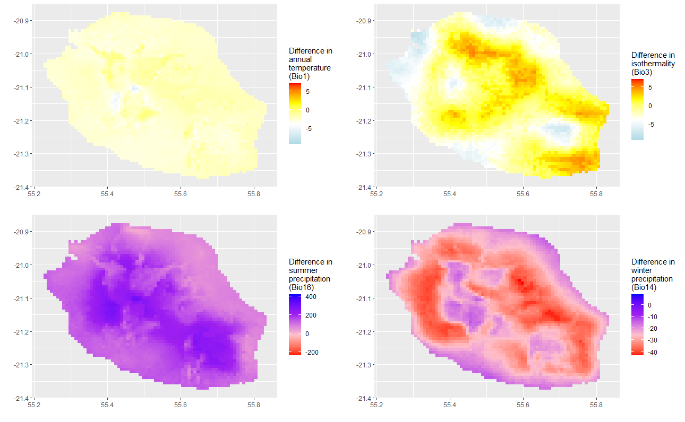
Fig S3e scenario 2.6 GCM HadGEM2(top: Chelsa; bottom: Worldclim)

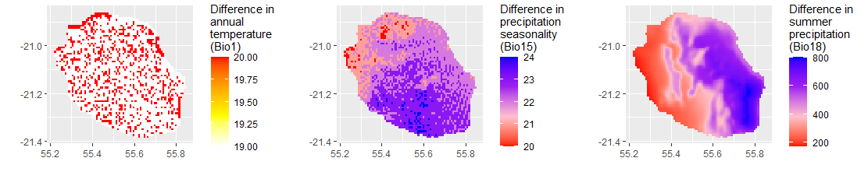
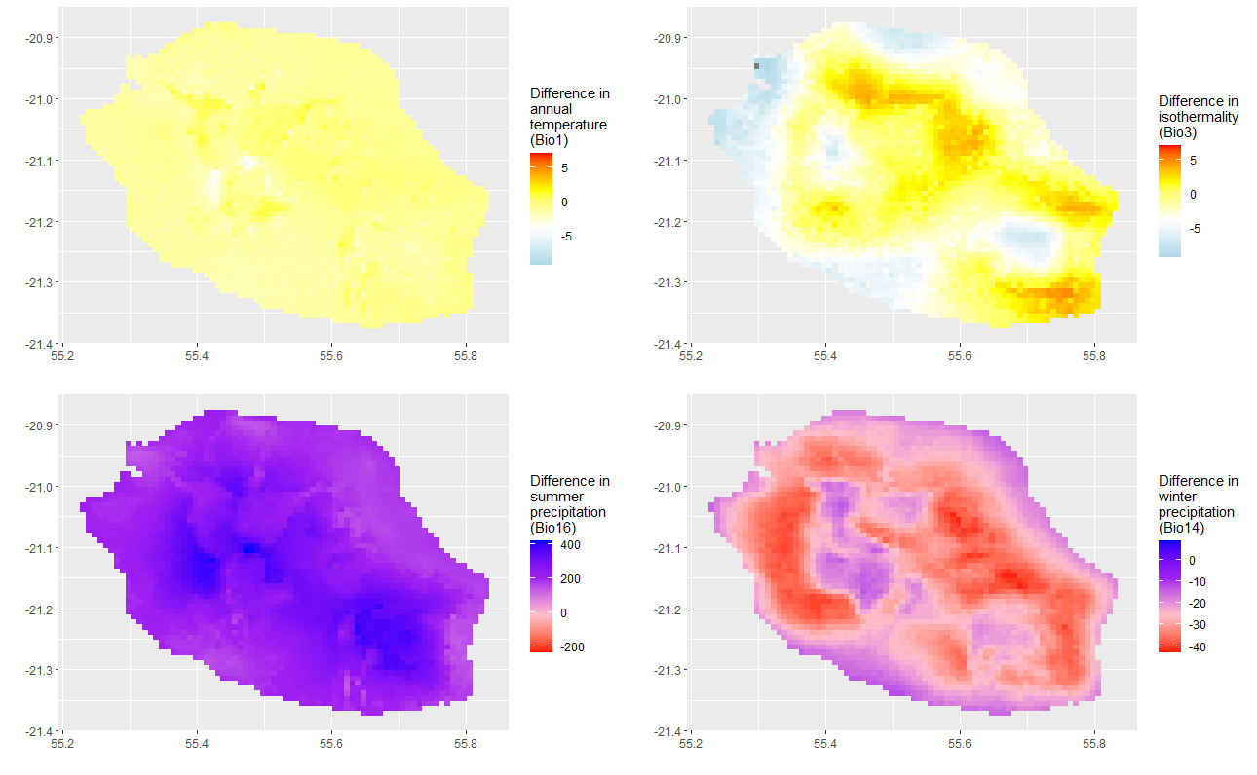*
Fig S3f scenario 8.5 GCM HadGEM2 (top: Chelsa; bottom: Worldclim)
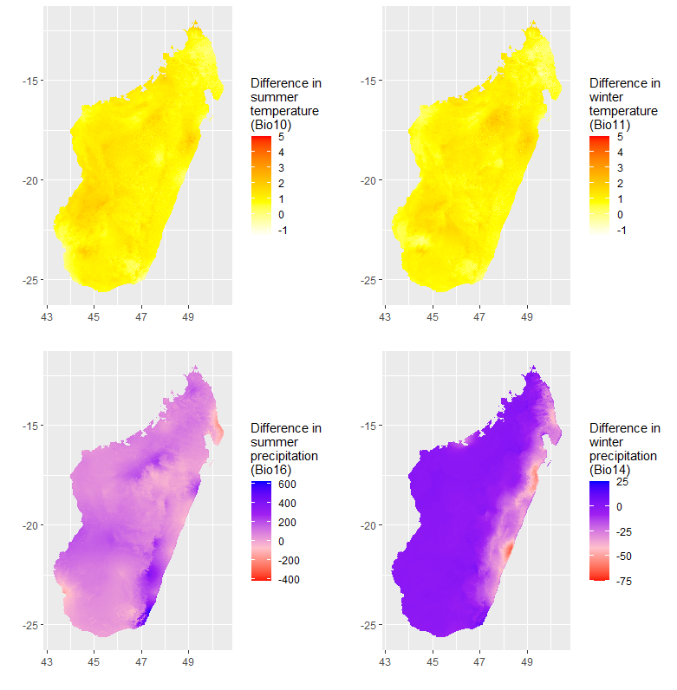
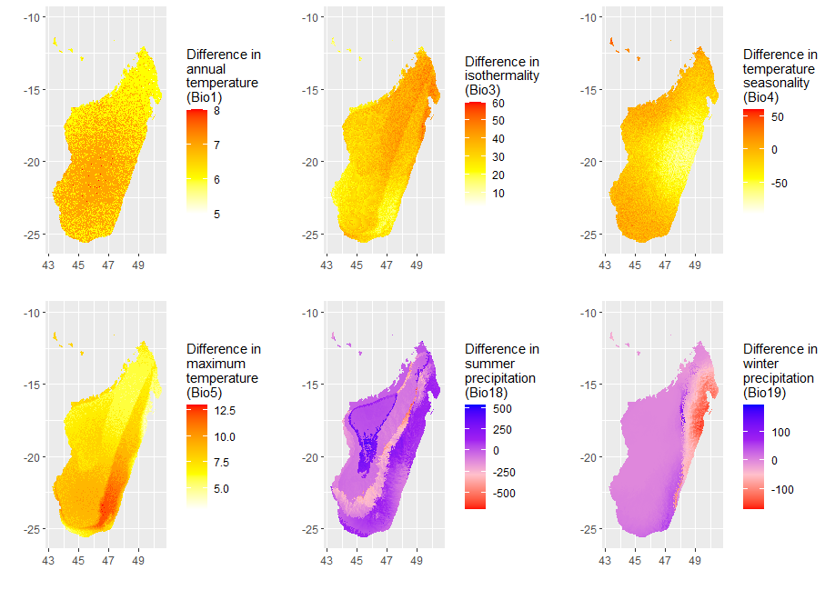
Fig S4a Scenario 2.6 BCC-csm1-1 (top: CHELSA; bottom: Worldclim)

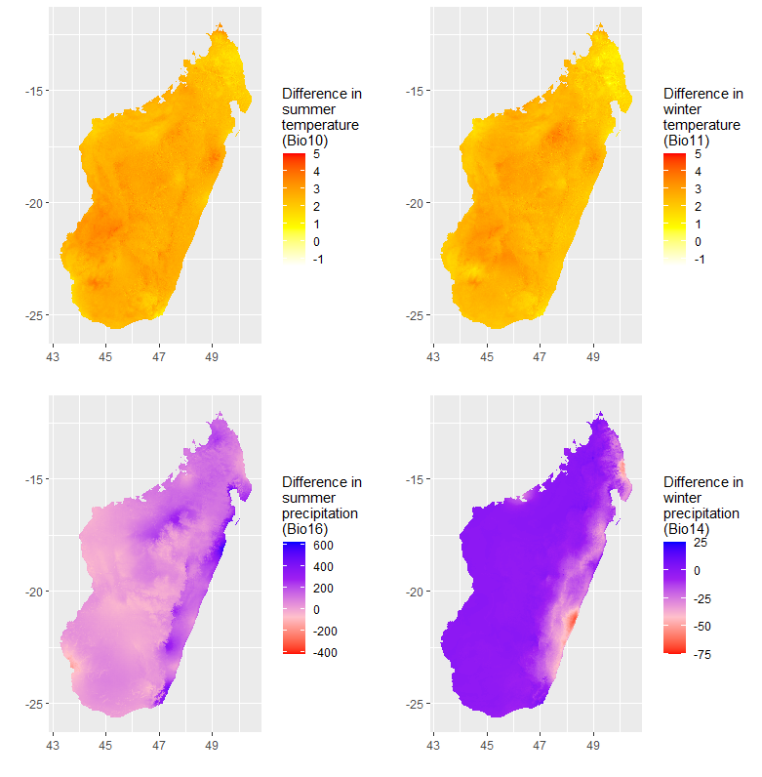
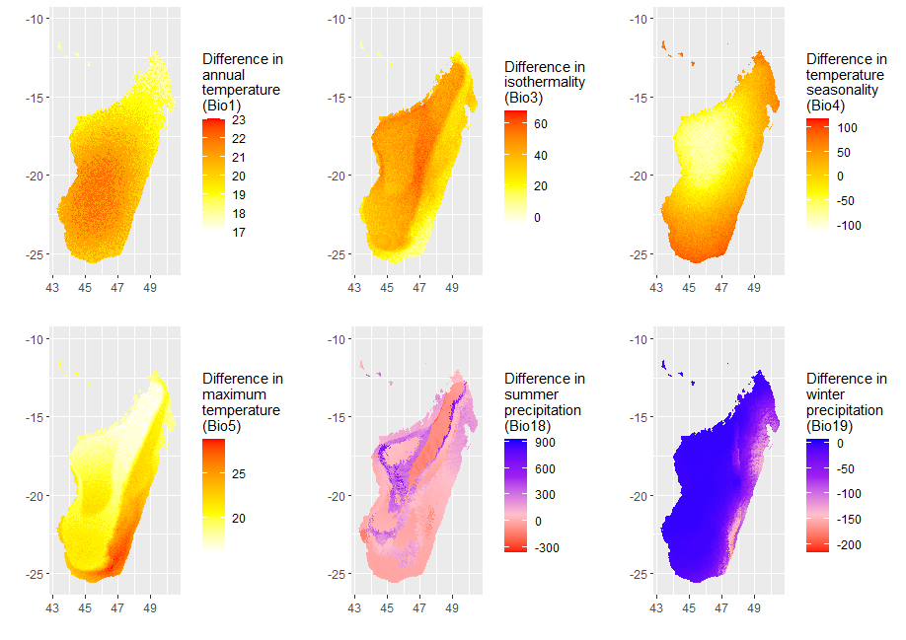
Fig. S4b Continued. BC85 (top: CHELSA; bottom: Worldclim)
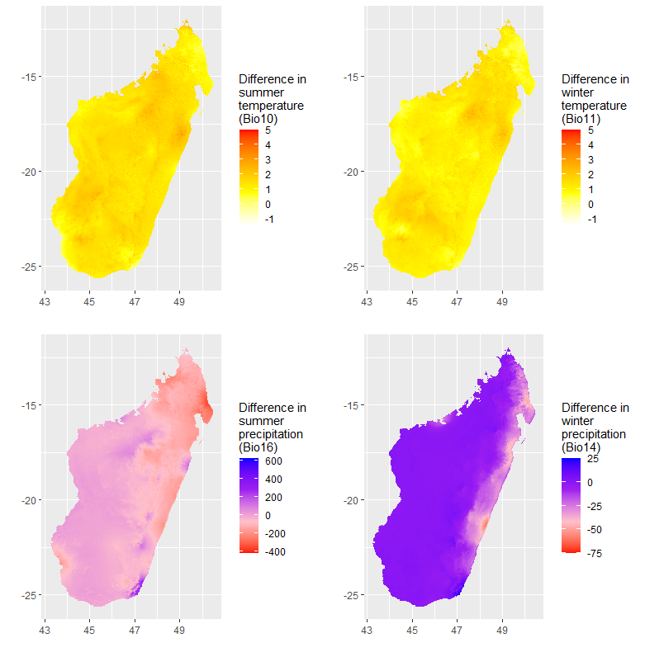
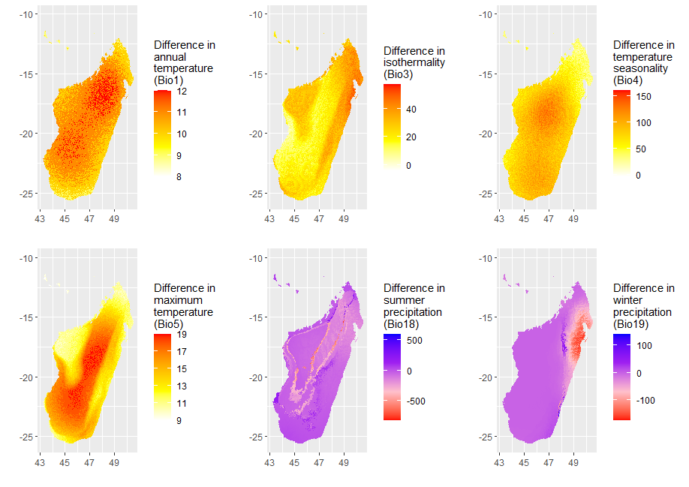
Fig. S4c Continued. Miroc5 RCP26 (top: CHELSA; bottom: Worldclim)
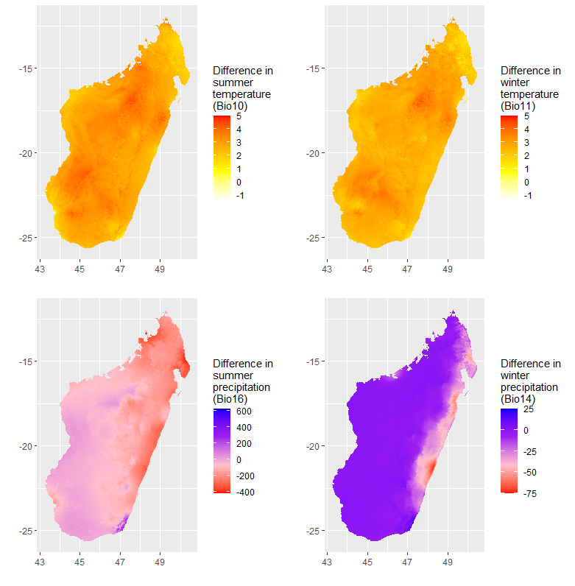
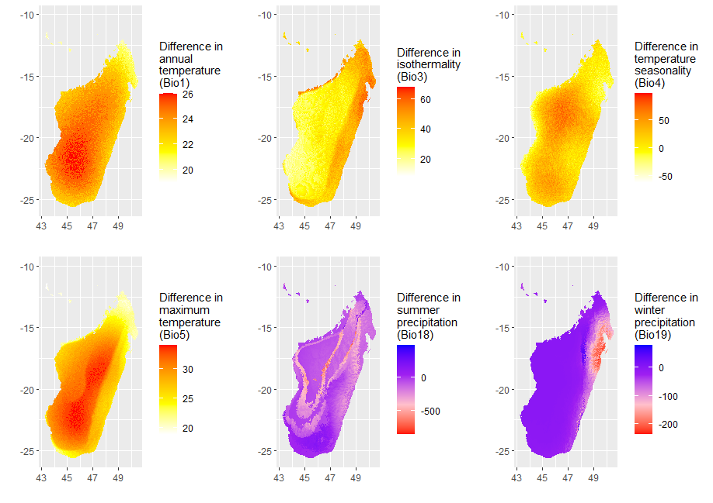
Fig S4d continued. MIROC5 85 (top: CHELSA; bottom: Worldclim)
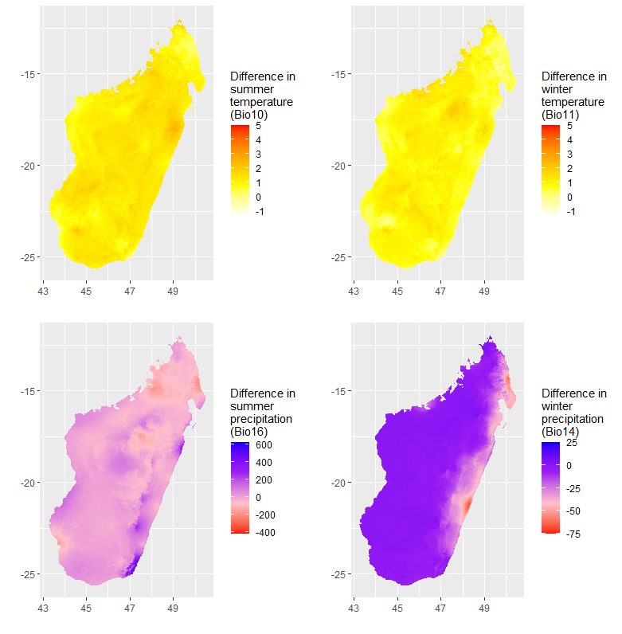
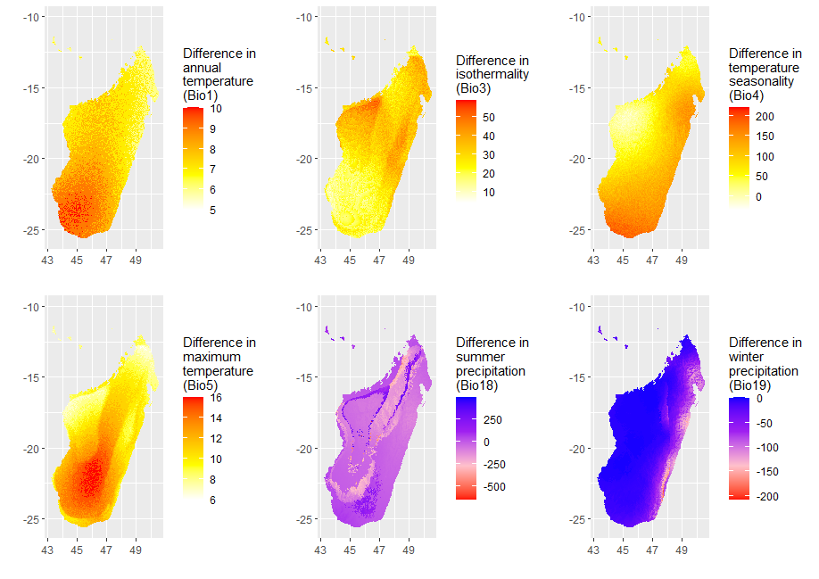
Fig S4e Scenario 2.6 HadGEM2 (top: CHELSA; bottom: Worldclim)
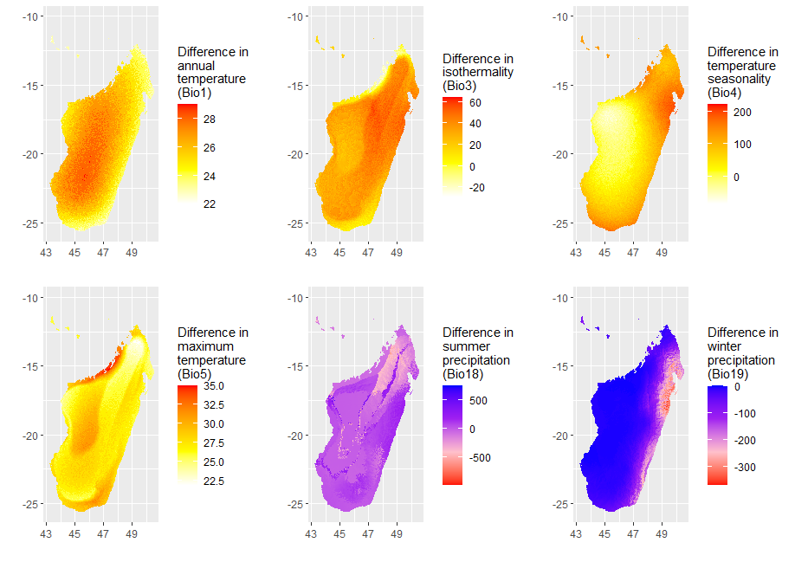
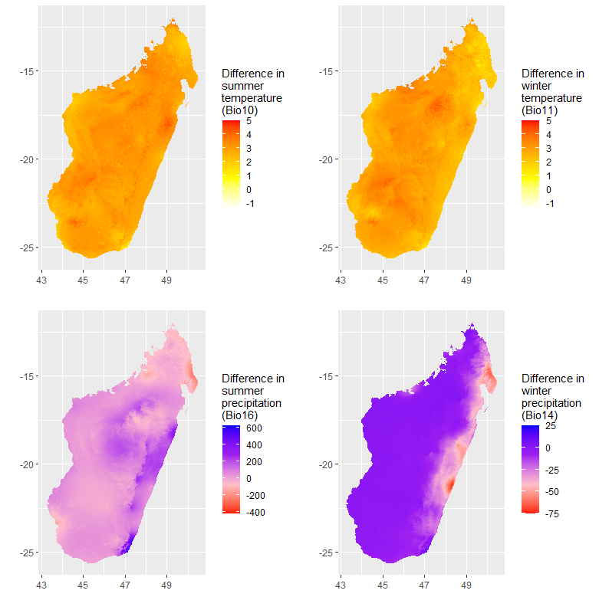
Fig S4f Scenario 8.5 HadGEM2 (top: CHELSA; bottom: Worldclim)

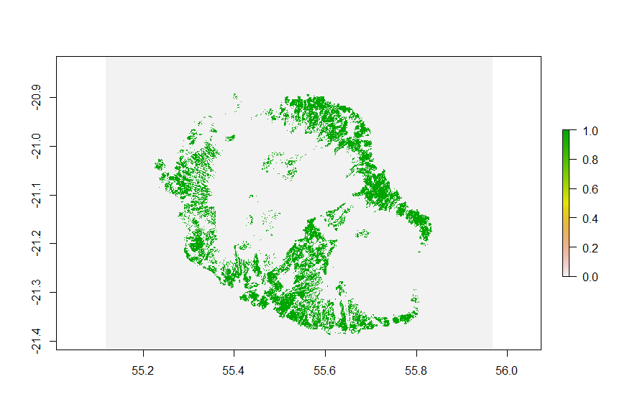
Fig.S5 Agricultural area cover in Reunion for 2017.
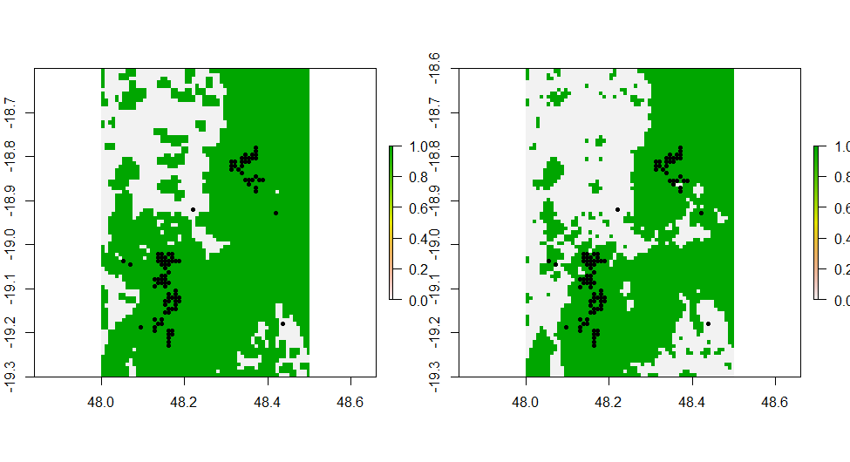
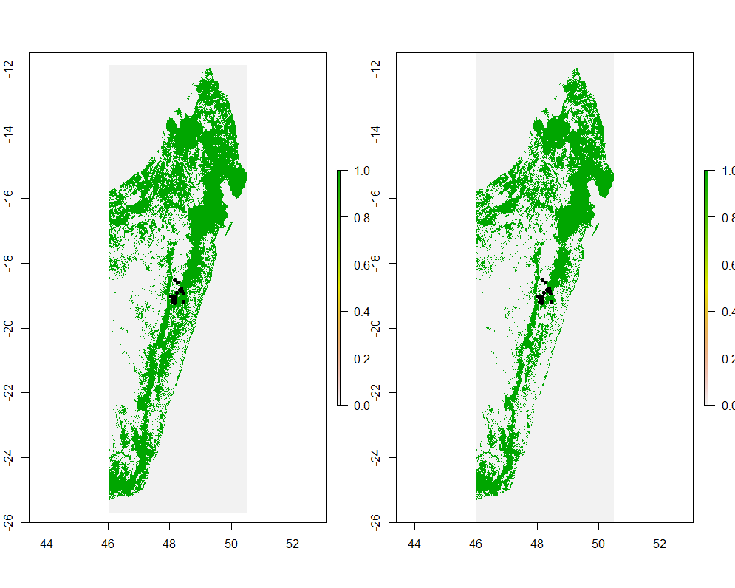
Fig.S6 Madagascar forest cover for 1990 (left) and 2017 (right), with a zoom on the area occupied by Mantella aurantiaca (bottom). Black points indicate occurrence records.

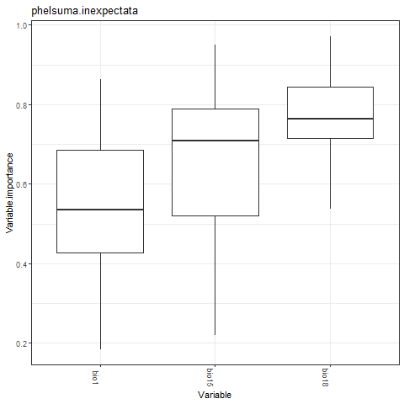
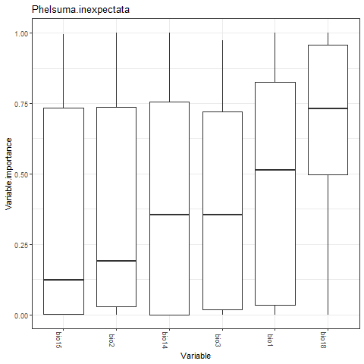
Fig S7. Variable importance for Phelsuma inexpectata (top: Chelsa baseline; bottom: Worldclim baseline). Variable importance was similar for Equal total weights and the two background extents.

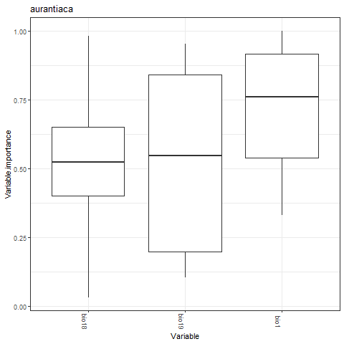
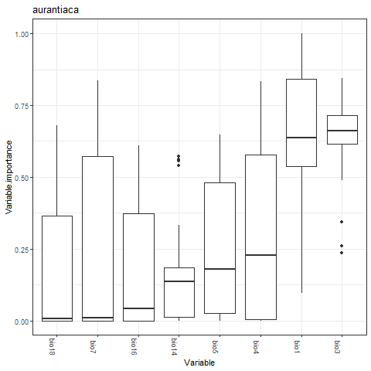
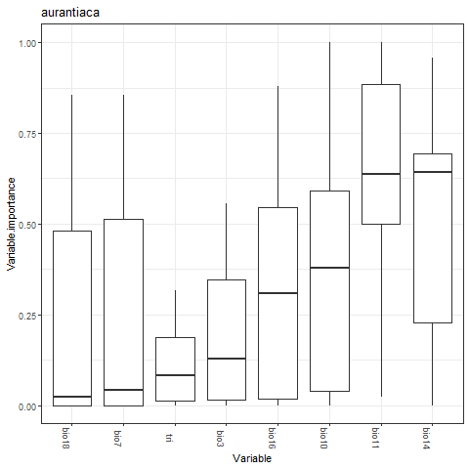
Fig. S8 Variable importance for Mantella aurantiaca. Top: Chelsa climate; Middle: Chelsa climate, restricted background; Bottom: Worldclim climate.
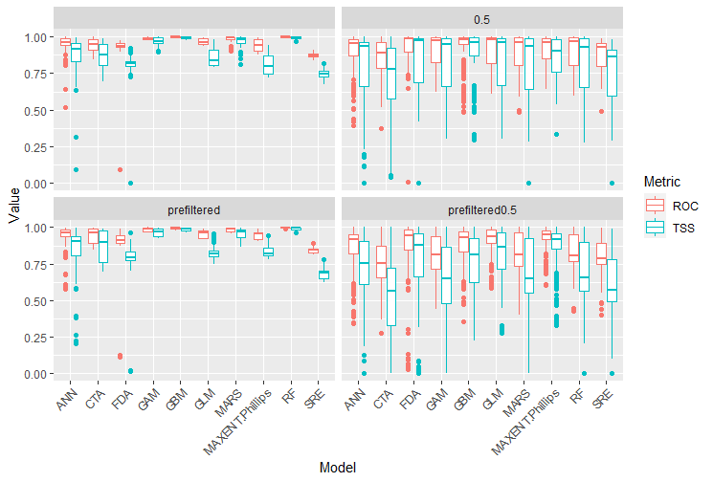
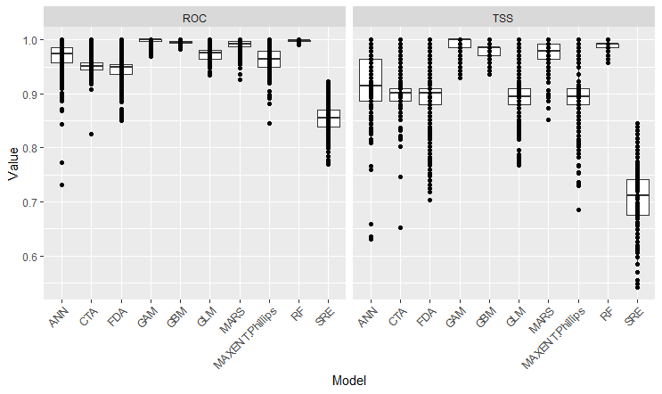
Fig. S9 Model performance for P. inexpectata (Ensemble of small models and jackknife procedure; Mean AUC = 0.96; Mean TSS = 0.90). In black: Worldclim baseline climate. In colour: Chelsa baseline climate. The groups refer to the extent of the background: restricted (prefiltered) versus large, and prevalence 0.5 (Equal Total Weights) versus no setting.
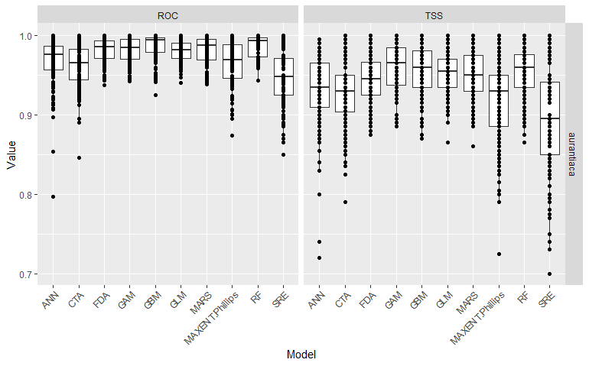
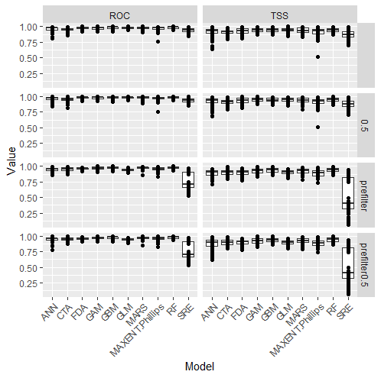
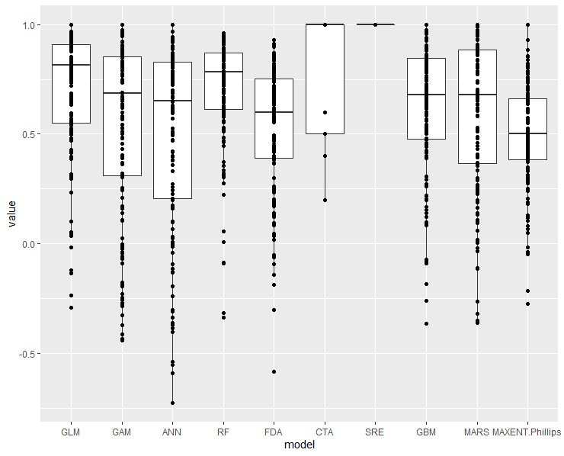
Fig. S10 Model performance for Mantella aurantiaca (Top: Chelsa baseline, Bottom: Worldclim baseline). Right: AUC (ROC) and TSS; Left: Boyce index.

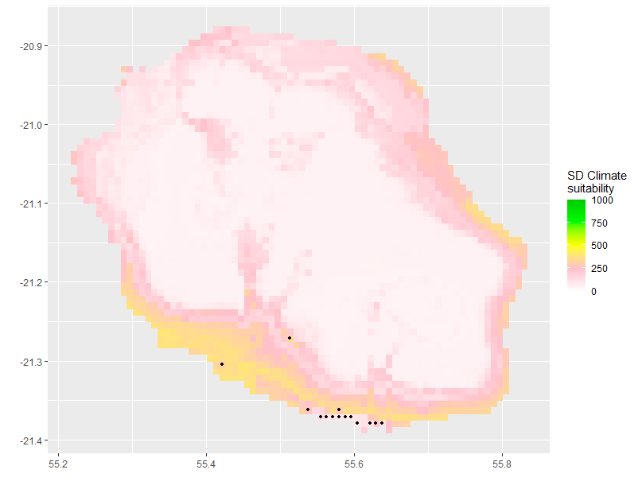
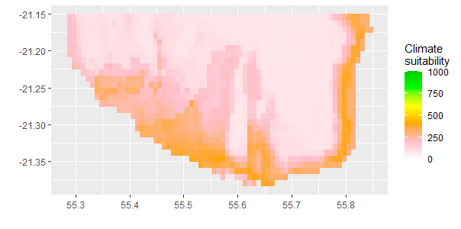
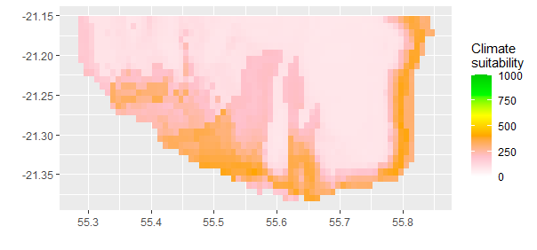
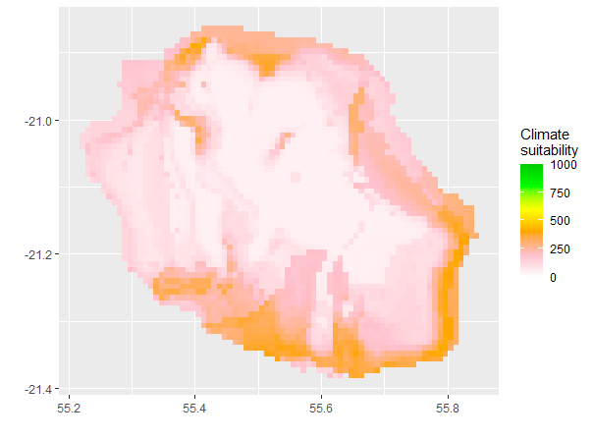
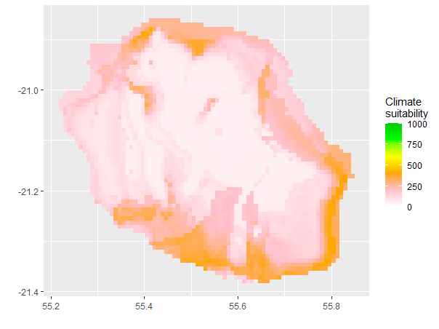
Fig. S11 Uncertainty map (intermodel variability as the standard deviation of suitability scores) for the distribution modelling of Phelsuma inexpectata (Top: wide background; Centre: restricted background; Bottom: Worldclim baseline; Left: Equal total weights; Right: No Equal Total Weights).
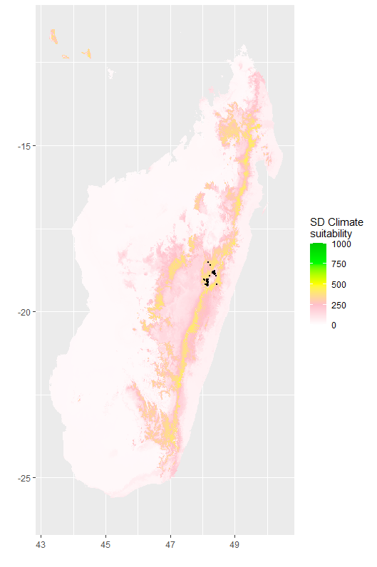
Fig. S12 Uncertainty map (intermodel variability as the standard deviation of suitability scores) for the distribution modelling of Mantella aurantiaca.

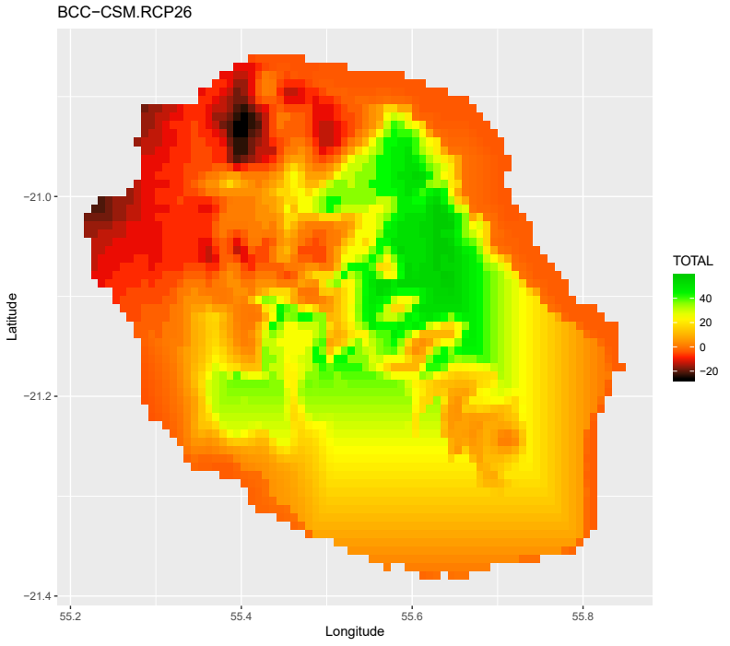
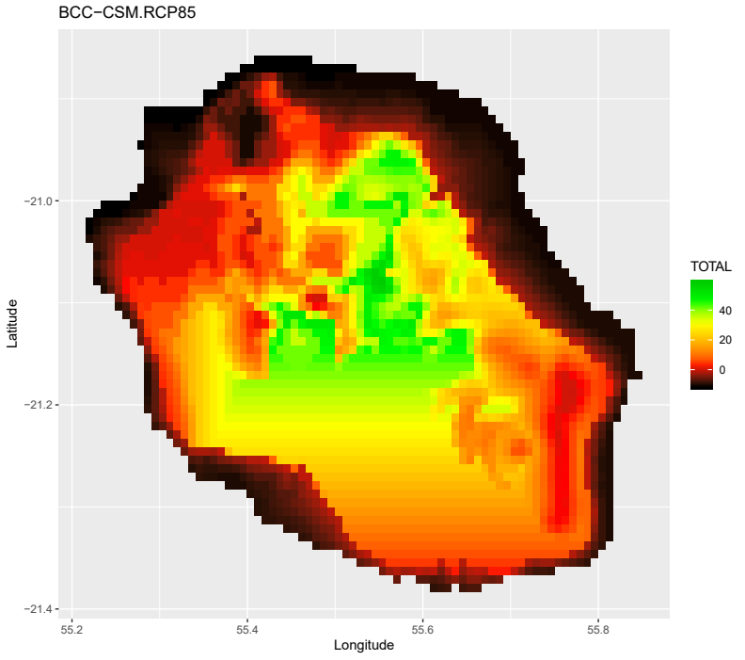
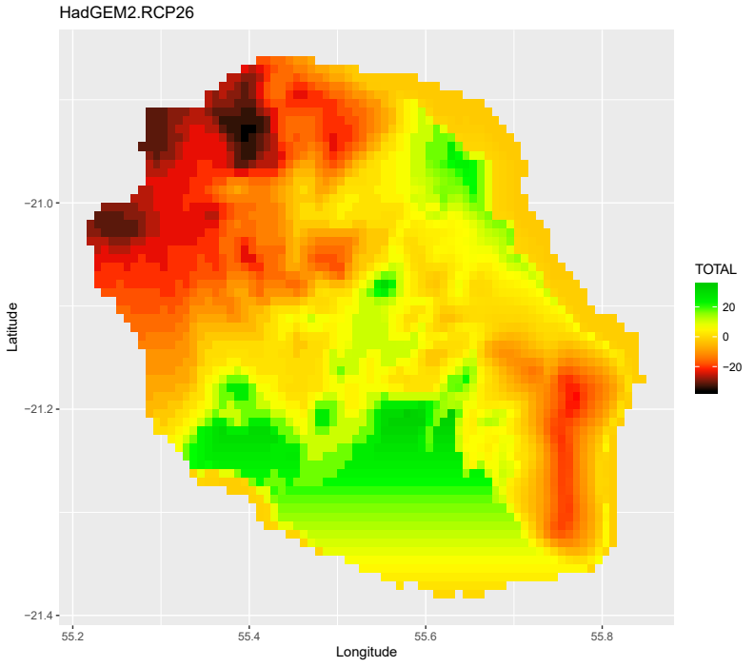
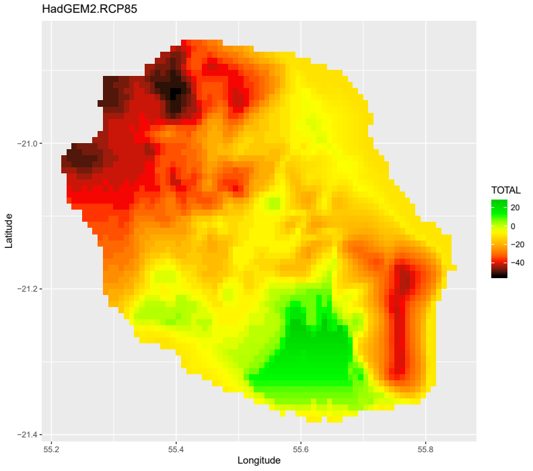
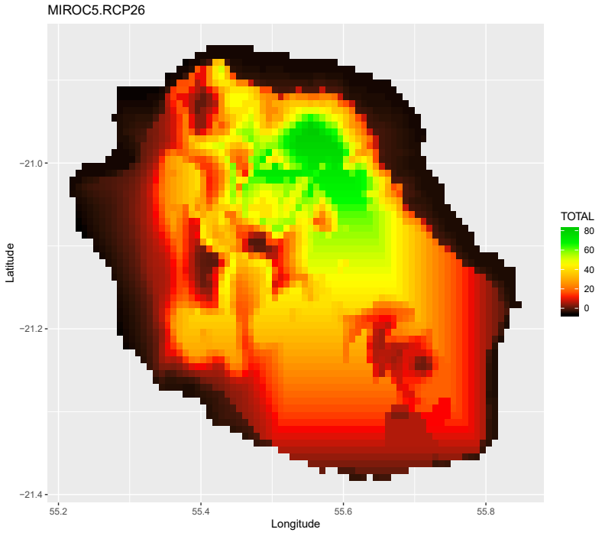
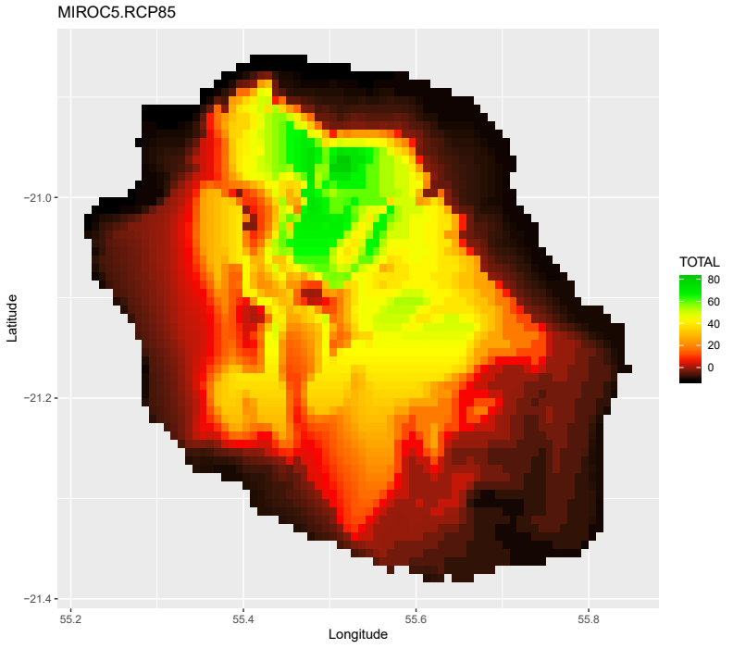
Fig Sxa MESS analyses for 3 GCMs and 2 RCPs for the Reunion Island (for both backgrounds, the selected variables were bio1, bio15, bio18).
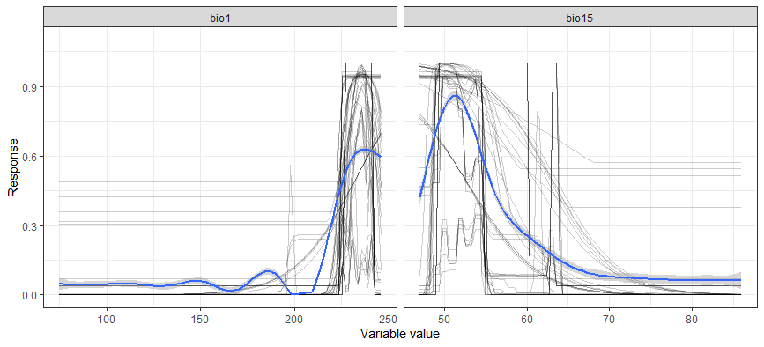
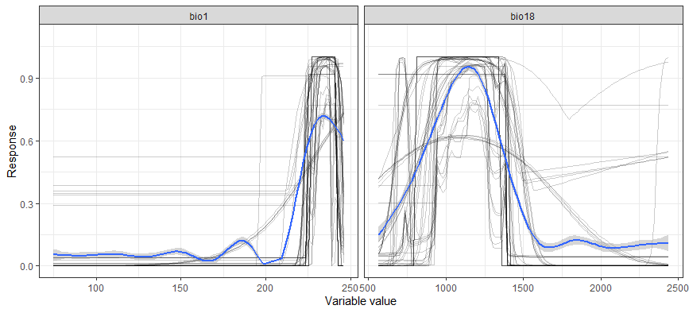
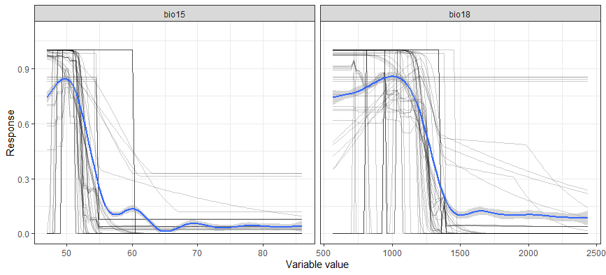
Fig S14a Examples of response plots for Phelsuma inexpectata obtained from bivariate models (Chelsa baseline, wide background). Equal total weights and jackknife iterations produced similar responses.
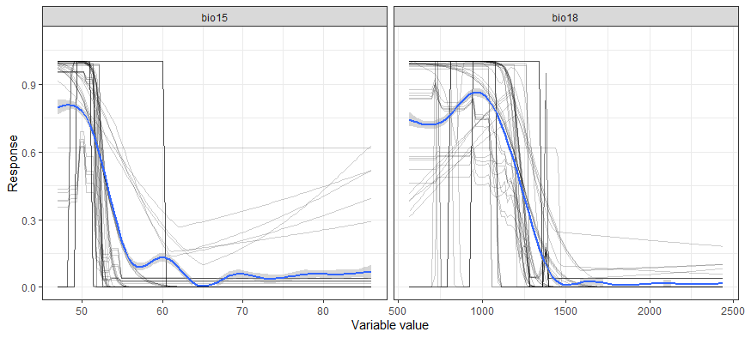
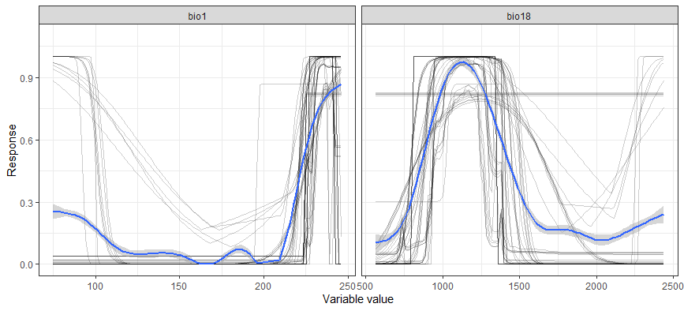
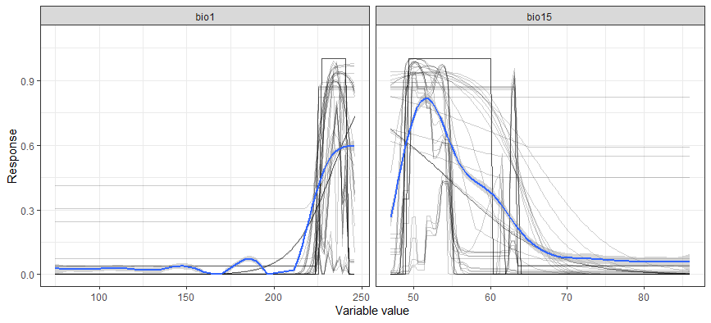
Fig S14b Examples of response plots for Phelsuma inexpectata obtained from bivariate models (Chelsa baseline, restricted background). Equal total weights and jackknife iterations produced similar responses.
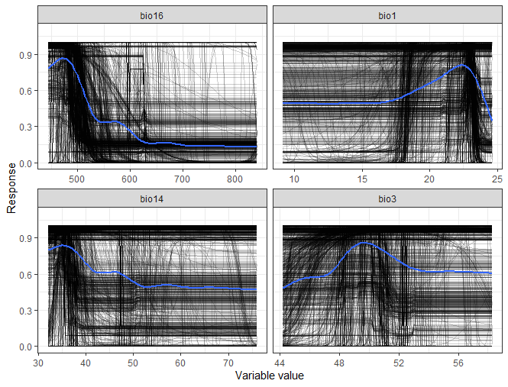
Fig S14c Mean response plots for Phelsuma inexpectata (Worldclim baseline).

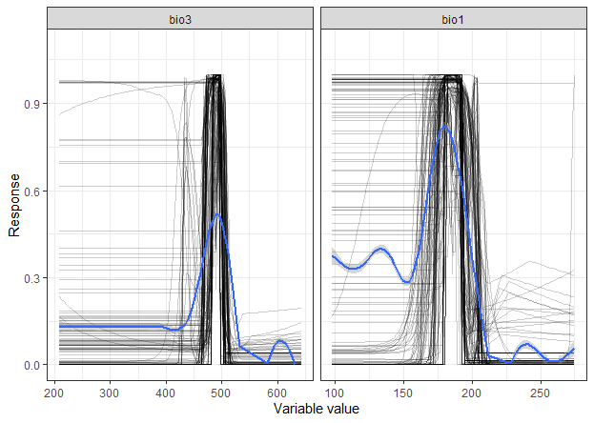
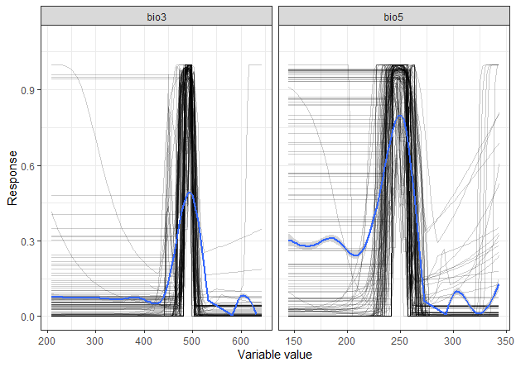
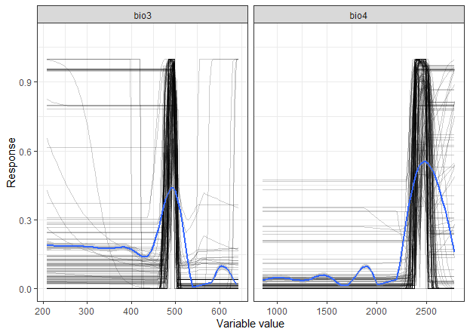
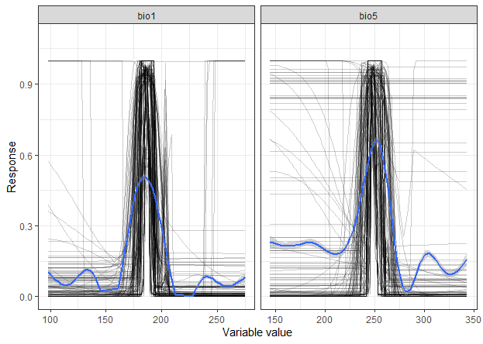
Fig. S15a Examples of response plots for Mantella aurantiaca obtained from bivariate models (Chelsa baseline, wide background). Equal total weights and jackknife iterations produced similar responses.
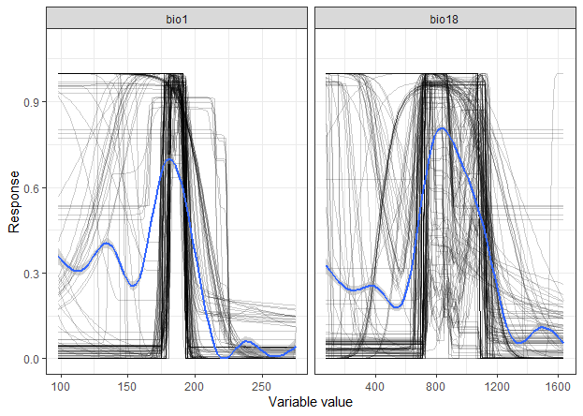
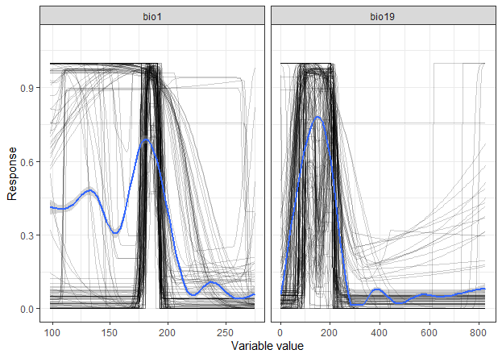
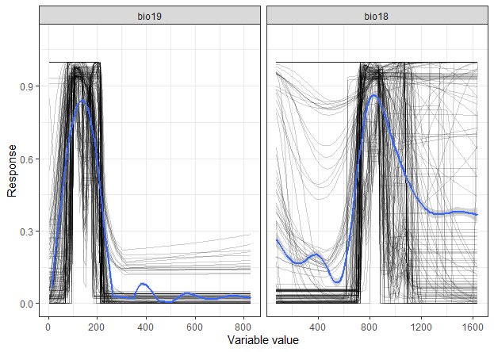
Fig. S15b Examples of response plots for Mantella aurantiaca obtained from bivariate models (Chelsa baseline, restricted background). Equal total weights and jackknife iterations produced similar responses.
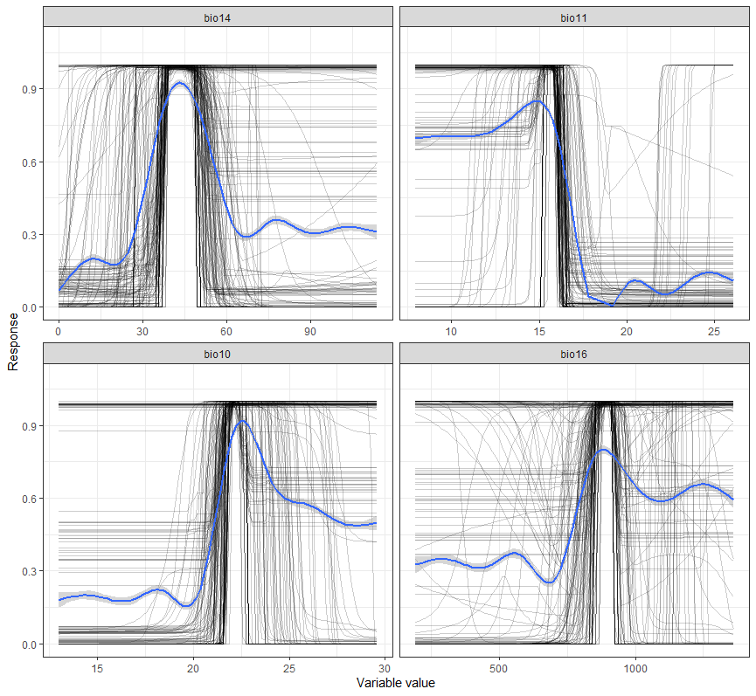
Fig. S15 Response curve for Mantella aurantiaca (Worldclim baseline climate).

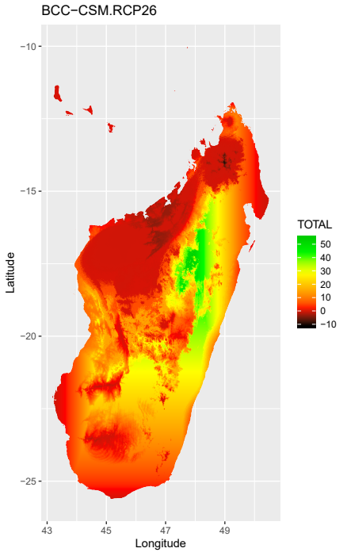
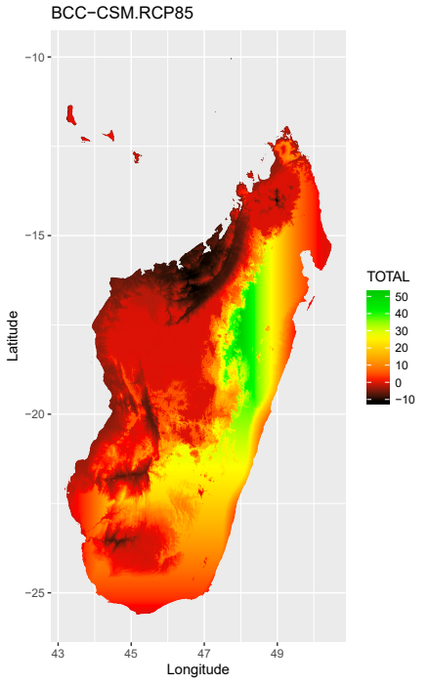
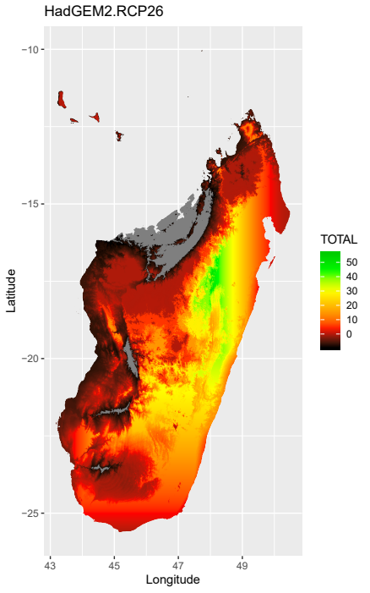
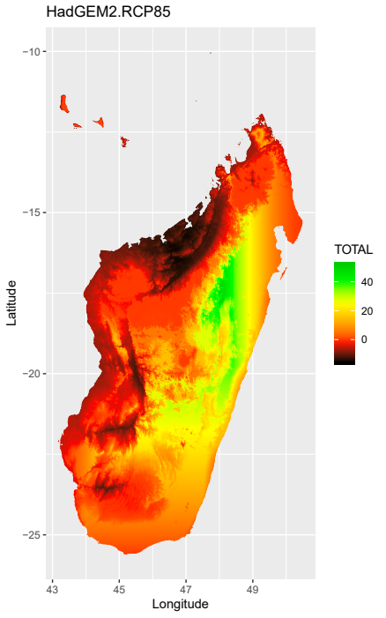
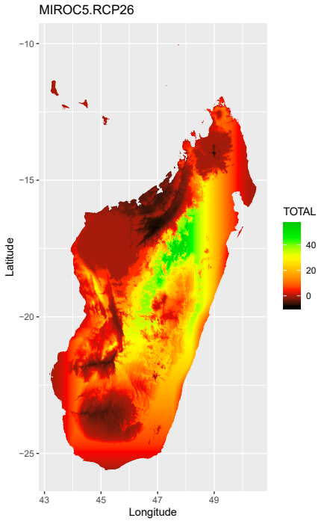
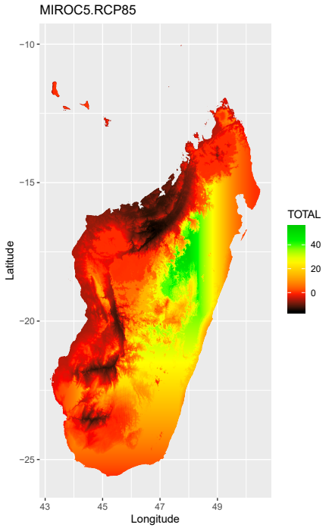
Fig S16a MESS analyses for 3 GCMs and 2 RCPs for the ‘wide background’ (selected variables: bio1, bio3, bio4, bio5).

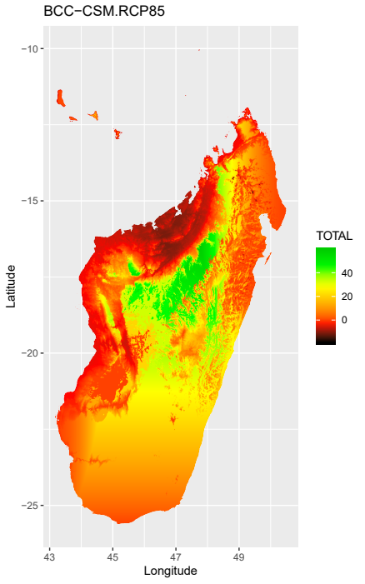
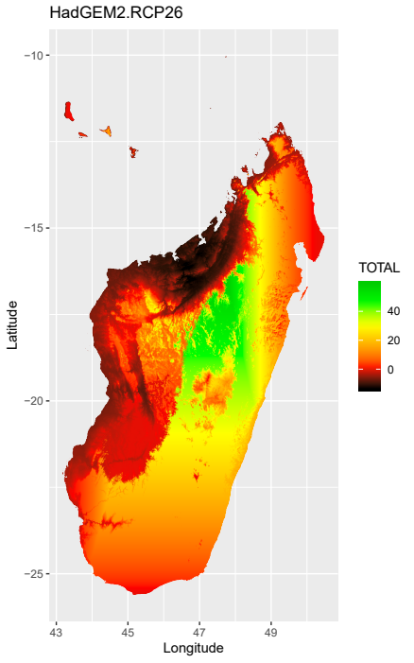
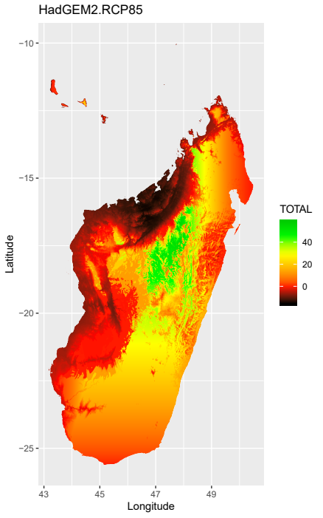
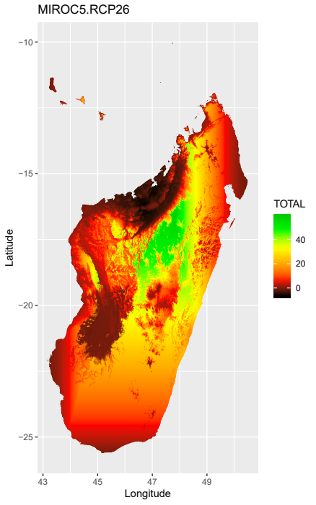
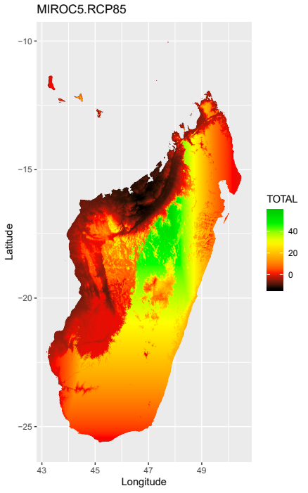
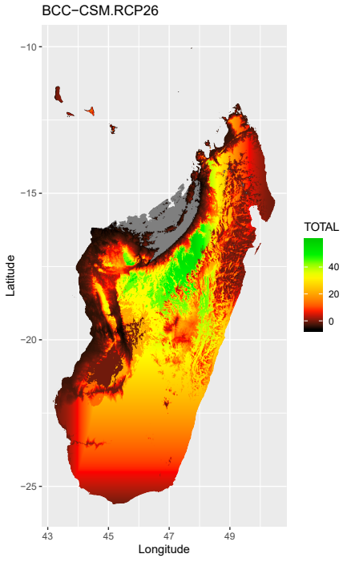
Fig S16b MESS analyses for 3 GCMs and 2 RCPs for the ‘restricted background’ (selected variables: bio1, bio18, bio19).

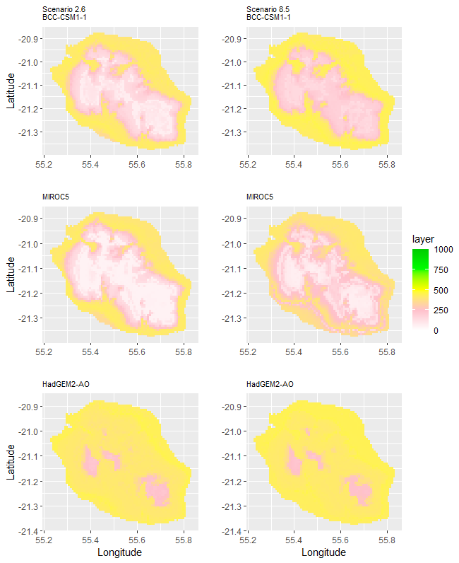
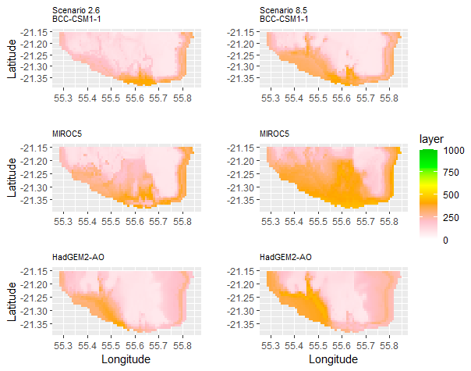
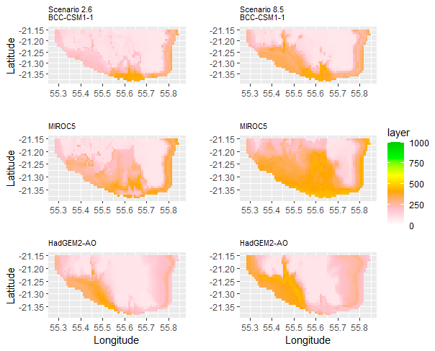
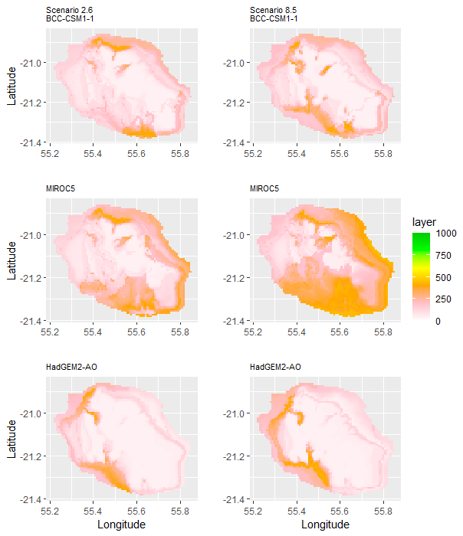
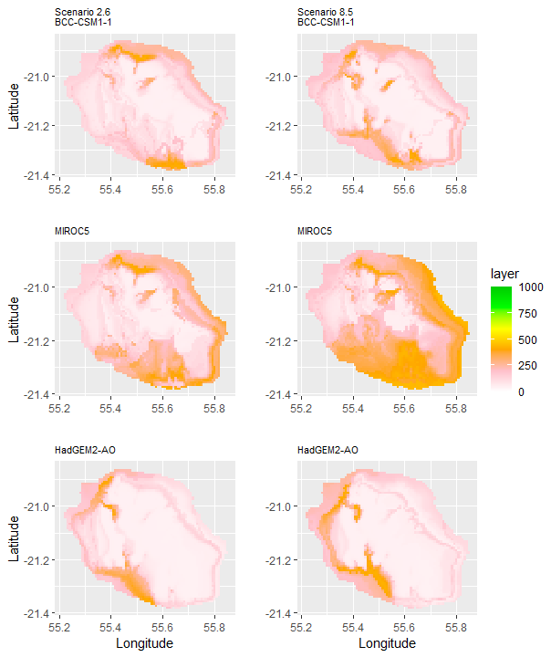
Fig. S17 Uncertainty maps for future distribution models of Phelsuma inexpectata (Top: wide background; Bottom: restricted background; Left: Equal total weights; Right: No Equal Total Weights: Bottom right: Worldclim baseline; ).
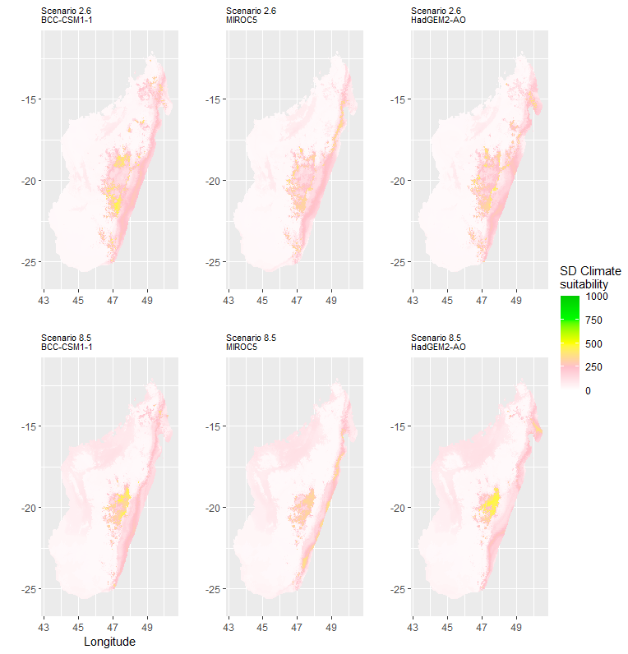
Fig. S18 Uncertainty maps for future distribution models of Mantella aurantiaca

