Supporting Information: Macroscale climate change predictions have little influence on landscape-scale habitat suitability

Luara Tourinho^{a,1}, Jayme Augusto Prevedello^{b}, Bruno M. Carvalho^{c}, Diogo S. B. Rocha^{d}, Mariana M. Vale^{f}

ª Universidade do Estado do Rio de Janeiro, Programa de Pós-Graduação em Ecologia e Evolução, R. São Francisco Xavier, 524, Maracanã, 20550-013, Rio de Janeiro, Brazil.
^{b} Universidade do Estado do Rio de Janeiro, Departamento de Ecologia e Evolução, R. São Francisco Xavier, 524, Maracanã, 20550-013, Rio de Janeiro, Brazil.
^{c} Barcelona Institute for Global Health. Calle Rosselló, 132, 08036 Barcelona, Spain.
^{d} Instituto Internacional para Sustentabilidade. Estrada Dona Castorina, 124 Horto, 22460-320, Rio de Janeiro, Brazil.
^{f} Universidade Federal do Rio de Janeiro, Departamento de Ecologia, IB, CCS, Ilha do Fundão, 21941-970, Rio de Janeiro, Brazil.
¹ Corresponding author. E-mail: loptourinho@gmail.com; Phone: +55 71 988055121
Methods
Estimating bird dispersal ability
Because the dispersal ability of most neotropical birds is unknown, we estimated the median dispersal ability relying on an allometric model for birds from Sutherland et al., (2000):
$$D_{average}=13.1*M^{0.63}$$
Where M is body mass (kg), and the values represent the means of the two parameters of the scaling equation. The median dispersal ability is estimated in kilometers. Considering that the Sutherland et al.’s model is the best model available for birds, but has a relatively low explanatory power for individual species (adjusted coefficient of determination r² = 0.32), we adopted a group-based method to increase the robustness of the analysis. First, we compiled a list of 107 bird species that are forest-dependent and endemic to the Atlantic Forest from Vale et al. (2018). From that list, we selected 11 species that differ in phylogenetic history, functional traits (body mass and diet), and conservation status (Table S1). The species were then grouped into six functional groups for dispersal ability allocation purposes, based on body mass and diet (from Vale et al. 2018). These traits are important for dispersal ability (Crouzeilles et al., 2014; Sutherland et al., 2000). Species were categorized as light (≤ 22 g) or medium-to-heavy (> 22 g), and as herbivorous (frugivorous and/or nectarivorous), invertivorous or omnivorous, considering the most common feeding habits. The six functional groups were: 1) light omnivores (N. chrysolophum and C. cristata), 2) light invertivores (D. genei and J. tridactyla), 3) light herbivores (P. eurynome and G. dohrnii), 4) medium-to-heavy invertivores (C. robustus and B. ruficapillus), 5) medium-to-heavy omnivores (A. brasiliensis and P. cruentata) and 6) medium-to-heavy herbivores (O. capueira). We calculated the dispersal ability for all 107 forest dependent bird’s endemic to the Atlantic Forest (Table S2), and calculated the average for each of the six functional group. We used this functional group dispersal ability for the 11 target species in the study.
Sutherland et al. (2000) defined dispersal as “the movement of an individual out of an area larger than its home range, with no predictable returns, i.e., excluding migrations”. They also justify the natal dispersal as a relevant pattern as it is important for interpopulation genetic structure and local population dynamics, being “the single largest (and often only) long-distance movement made by individual animals and is generally accepted as the major agent of gene flow among populations”. The model generated by Sutherland et al. (2000) was based on a review in which they used a series of studies that estimated the natal dispersal of several species, in several different locations, consequently, at different time periods. The model went through several parameterizations and normalizations, and is not directly based on a distance-time relationship.

Table S1: Target bird species used in this study. Body mass and diet from Vale et al. (2018). Conservation status from (IUCN, 2019) (NT = Near threatened, LC = least concern, VU = vulnerable, EN= endangered). Taxonomic order following the Brazilian Committee on Ornithological Records (CBRO) (Piacentini et al. 2015). Here we consider herbivorous as nectivorous and frugivorous.
Species | Author | Body  mass (g) | Diet | Occurrence records | Status
GALLIFORMES
Odontophorus capueira (Odontophoridae) | Spix 1825 | 426.5 | herbivorous | 63 | LC
APODIFORMES
Phaethornis eurynome (Trochilidae) | Lesson 1832 | 5.3 | herbivorous | 89 | LC
Glaucis dohrnii (Trochilidae) | (Bourcierand Mulsant 1852) | 5.8 | herbivorous | 15 | EN
CORACIIFORMES
Baryphthengus ruficapillus (Momotidae) | Vieillot 1818 | 147.7 | invertivore | 51 | LC
GALBULIFORMES |  | 18.3 | invertivore |  | VU
Jacamaralcyon tridactyla (Galbulidae) | (Vieillot 1817) | 18.3 | invertivore | 28 | VU
PICIFORMES |  | 200 | invertivore |  | LC
Campephilus robustus (Picidae) | Lichtenstein 1819 | 200 | invertivore | 27 | LC
PSITTACIFORMES
Pyrrhura cruentata (Psittacidae) | (Wied 1820) | 152.8 | omnivore | 32 | VU
Amazona brasiliensis (Psittacidae) | (Linnaeus 1758) | 227 | omnivore | 22 | NT
PASSERIFORMES
Drymophila genei (Thamnophilidae) | Fillipi 1847 | 18.7 | invertivore | 26 | LC
Neopelma chrysolophum (Pipridae) | Pinto 1944 | 19.2 | omnivore | 30 | LC
Mionectes rufiventris (Rhynchocyclidae) | Cabanis 1846 | 13.3 | omnivore | 86 | LC
Table S2: Dispersal ability for all 107 forest dependent birds, endemic to the Atlantic Forest, within six functional groups. The mean dispersal ability per group (µ) is shown. The 11 target species in the study are depicted with an asterisk (*).
Species | Dispersal ability (m)
Light invertivores (µ = 845.3 m)
Anabacerthia amaurotis | 1085.8
Anabacerthia lichtensteini | 1148.9
Automolus lammi | 1114.1
Conopophaga cearae | 986.9
Cranioleuca pallida | 786.2
Drymophila ferruginea | 746.8
Drymophila genei * | 1067.9
Drymophila malura | 849.3
Drymophila ochropyga | 742.4
Drymophila rubricollis | 719.9
Dysithamnus plumbeus | 1131.6
Dysithamnus xanthopterus | 901.8
Eleoscytalopus psychopompus | 1035.2
Heliobletus contaminatus | 889.9
Hemitriccus diops | 719.9
Hemitriccus obsoletus | 790.5
Hemitriccus orbitatus | 706.2
Jacamaralcyon tridactyla * | 1053.5
Myrmoderus loricatus | 1179.6
Myrmotherula minor | 543.5
Myrmotherula snowi | 710.8
Myrmotherula unicolor | 786.2
Myrmotherula urosticta | 645.0
Nemosia rourei | 1183.0
Onychorhynchus swainsoni | 889.9
Philydor atricapillus | 1189.8
Phyllomyias virescens | 635.3
Phylloscartes beckeri | 659.4
Phylloscartes ceciliae | 605.6
Phylloscartes difficilis | 569.8
Phylloscartes oustaleti | 719.9
Phylloscartes paulista | 600.6
Phylloscartes sylviolus | 625.5
Picumnus temminckii | 786.2
Piprites pileata | 929.4
Platyrinchus leucoryphus | 968.0
Pogonotriccus eximius | 600.6
Rhopias gularis | 777.5
Scytalopus gonzagai | 948.8
Scytalopus pachecoi | 933.3
Scytalopus speluncae | 849.3
Terenura maculata | 548.8
Terenura sicki | 543.5
Thamnophilus ambiguus | 1179.6
Thlypopsis pyrrhocoma | 952.7
Light omnivores (µ = 815.3m)
Calyptura cristata | 476.8
Ilicura militaris | 836.9
Mionectes rufiventris * | 861.6
Neopelma chrysolophum * | 1085.8
Light herbivores (µ = 657.5m)
Antilophia bokermanni | 1107.1
Glaucis dohrnii * | 510.8
Haplospiza unicolor | 941.1
Machaeropterus regulus | 692.4
Neopelma aurifrons | 889.9
Phaethornis eurynome * | 482.6
Phaethornis idaliae | 308.1
Phaethornis squalidus | 364.8
Ramphodon naevius | 620.5
Medium to heavy invertivores (µ = 2,826.6 m)
Anabazenops fuscus | 1619.0
Automolus leucophthalmus | 1570.7
Baryphthengus ruficapillus* | 3926.3
Buteogallus lacernulatus | 8671.4
Campephilus robustus* | 4752.5
Celeus tinnunculus | 3692.7
Cichlocolaptes leucophrus | 1677.6
Cichlocolaptes mazarbarnetti | 1777.9
Glaucidium minutissimum | 1984.4
Glaucidium mooreorum | 2009.3
Hylatomus galeatus | 3516.6
Hypoedaleus guttatus | 1691.4
Merulaxis ater | 1587.9
Notharchus swainsoni | 2485.9
Phacellodomus erythrophthalmus | 1266.0
Philydor novaesi | 1669.3
Piculus aurulentus | 2561.9
Pseudastur polionotus | 9957.3
Pyriglena atra | 1498.0
Saltator fuliginosus | 2225.9
Saltator maxillosus | 2004.3
Sclerurus cearensis | 1527.3
Sclerurus scansor | 1638.7
Trogon aurantius | 2525.1
Medium to heavy omnivores (µ = 5,120.9 m)
Amazona brasiliensis* | 5147.2
Arremon semitorquatus | 1282.3
Chiroxiphia caudata | 1301.6
Cyanocorax coeruleus | 5768.3
Laniisoma elegans | 1888.0
Leptodon forbesi | 9264.3
Pyrrhura cruentata* | 4011.2
Schiffornis virescens | 1301.6
Tinamus solitarius | 16123.9
Medium to heavy herbivores (µ = 5,132.7 m)
Amazona rhodocorytha | 8195.7
Amazona vinacea | 5524.8
Carpornis cucullata | 2544.6
Cotinga maculata | 2341.0
Lipaugus ater | 3575.3
Lipaugus conditus | 2668.2
Lipaugus lanioides | 2969.3
Mitu mitu | 25355.0
Odontophorus capueira* | 7658.1
Procnias nudicollis | 4353.3
Pteroglossus bailloni | 3897.7
Pyrrhura griseipectus | 2925.7
Selenidera maculirostris | 4193.9
Touit melanonotus | 1759.2
Touit surdus | 1900.8
Xipholena atropurpurea | 2260.8

Table S3: Coefficients of determination (R²) of Generalized Least Square (GLS) models controlling spatial autocorrelation, considering each landscape as sampling unit.
Species | R²
Amazona brasiliensis | 0.9993
Baryphthengus ruficapillus | 0.9969
Campephilus robustus | 0.9964
Drymophila genei | 0.9996
Glaucis dohrnii | 0.9993
Jacamaralcyon tridactyla | 0.9998
Mionectes rufiventris | 0.9972
Neopelma chrysolophum | 0.9996
Odontophorus capueira | 0.9983
Phaethornis eurynome | 0.9978
Pyrrhura cruentata | 0.9932

Table S4. Number of landscapes (50,000-ha hexagons) greater and smaller than the 30% and 50% forest cover thresholds suggested by Banks-Leite et al., (2014), and their corresponding percentages within the species’ distribution range. The 30% forest cover represents a threshold for population persistence and the 50% represents a threshold for the maintenance of community’ integrity.

Species | ≤ 30%  forest cover | > 30%  forest cover | ≤ 50%  forest cover | > 50%  forest cover | Number of landscapes within the distribution
Amazona brasiliensis | 25 (43%) | 33 (57%) | 43 (74%) | 15 (26%) | 58
Baryphthengus ruficapillus | 2295 (93%) | 170 (7%) | 2398 (97%) | 67 (3%) | 2465
Campephilus robustus | 2244 (93%) | 165 (7%) | 2341 (97%) | 68 (3%) | 2409
Drymophila genei | 371 (78%) | 102 (22%) | 426 (90%) | 47 (10%) | 473
Glaucis dohrnii | 343 (94%) | 21 (6%) | 362 (99%) | 2 (1%) | 364
Jacamaralcyon tridactyla | 1077 (94%) | 73 (6%) | 1121 (98%) | 29 (2%) | 1150
Mionectes rufiventris | 1377 (90%) | 150 (10%) | 1461 (96%) | 66 (4%) | 1527
Neopelma chrysolophum | 582 (84%) | 108 (16%) | 640 (93%) | 50 (7%) | 690
Odontophorus capueira | 1962 (93%) | 159 (7%) | 2054 (97%) | 67 (3%) | 2121
Phaethornis eurynome | 1222 (89%) | 148 (11%) | 1305 (95%) | 65 (5%) | 1370
Pyrrhura cruentata | 541 (91%) | 53 (9%) | 577 (97%) | 17 (3%) | 594

References
Banks-Leite, C., Pardini, R., Tambosi, L.R., Pearse, W.D., Bueno, A.A., Bruscagin, R.T., Condez, T.H., Dixo, M., Igari, A.T., Martensen, A.C., Metzger, J.P., 2014. Using ecological thresholds to evaluate the costs and benefits of set-asides in a biodiversity hotspot. Science (80-. ). 345, 1041–1045. https://doi.org/10.1126/science.1255768
Crouzeilles, R., Prevedello, J.A., Figueiredo, M. de S.L., Lorini, M.L., Grelle, C.E.V., 2014. The effects of the number, size and isolation of patches along a gradient of native vegetation cover: how can we increment habitat availability? Landsc. Ecol. 29, 479–489. https://doi.org/10.1007/s10980-013-9978-6
Fundação SOS Mata Atlântica, Instituto Nacional de Pesquisas Espaciais INPE, 2013. Atlas dos remanescentes florestais da Mata Atlântica perído 2011-2012, Relatório Técnico. São Paulo.
IUCN, 2016. The IUCN red list of threatened species. Version 2016-3 [WWW Document]. URL www.iucnredlist.org (accessed 3.17.20).
Sutherland, G.D., Harestad, A.S., Price, K., Lertzman, K.P., 2000. Scaling of Natal Dispersal Distances in Terrestrial Birds and Mammals. Conserv. Ecol. 4, 1–36. https://doi.org/https://www.jstor.org/stable/26271738
Vale, M.M., Tourinho, L., Lorini, M.L., Rajão, H., Figueiredo, M.S.L., 2018. Endemic birds of the Atlantic Forest: traits, conservation status, and patterns of biodiversity. J. F. Ornithol. 89, 193–206. https://doi.org/10.1111/jofo.12256

Fig. S1. The Brazilian Atlantic Forest remaining (in green) from Fundação SOS Mata Atlântica and Instituto Nacional de Pesquisas Espaciais INPE (2013), and the original Atlantic Forest extension in the small overview (in gray).

Fig. S2. Maps of Combined Landscape Suitability (CLS, ranging from 0 to 1) inside of the distribution range area of the 11 target species (small maps on the left). As current and future results were highly correlated, i.e. there was little change in the future, we show only the maps under current conditions. Each unit of the map is a “landscape” within the Brazilian Atlantic Forest biome, represented by a 50,000 ha hexagon).”

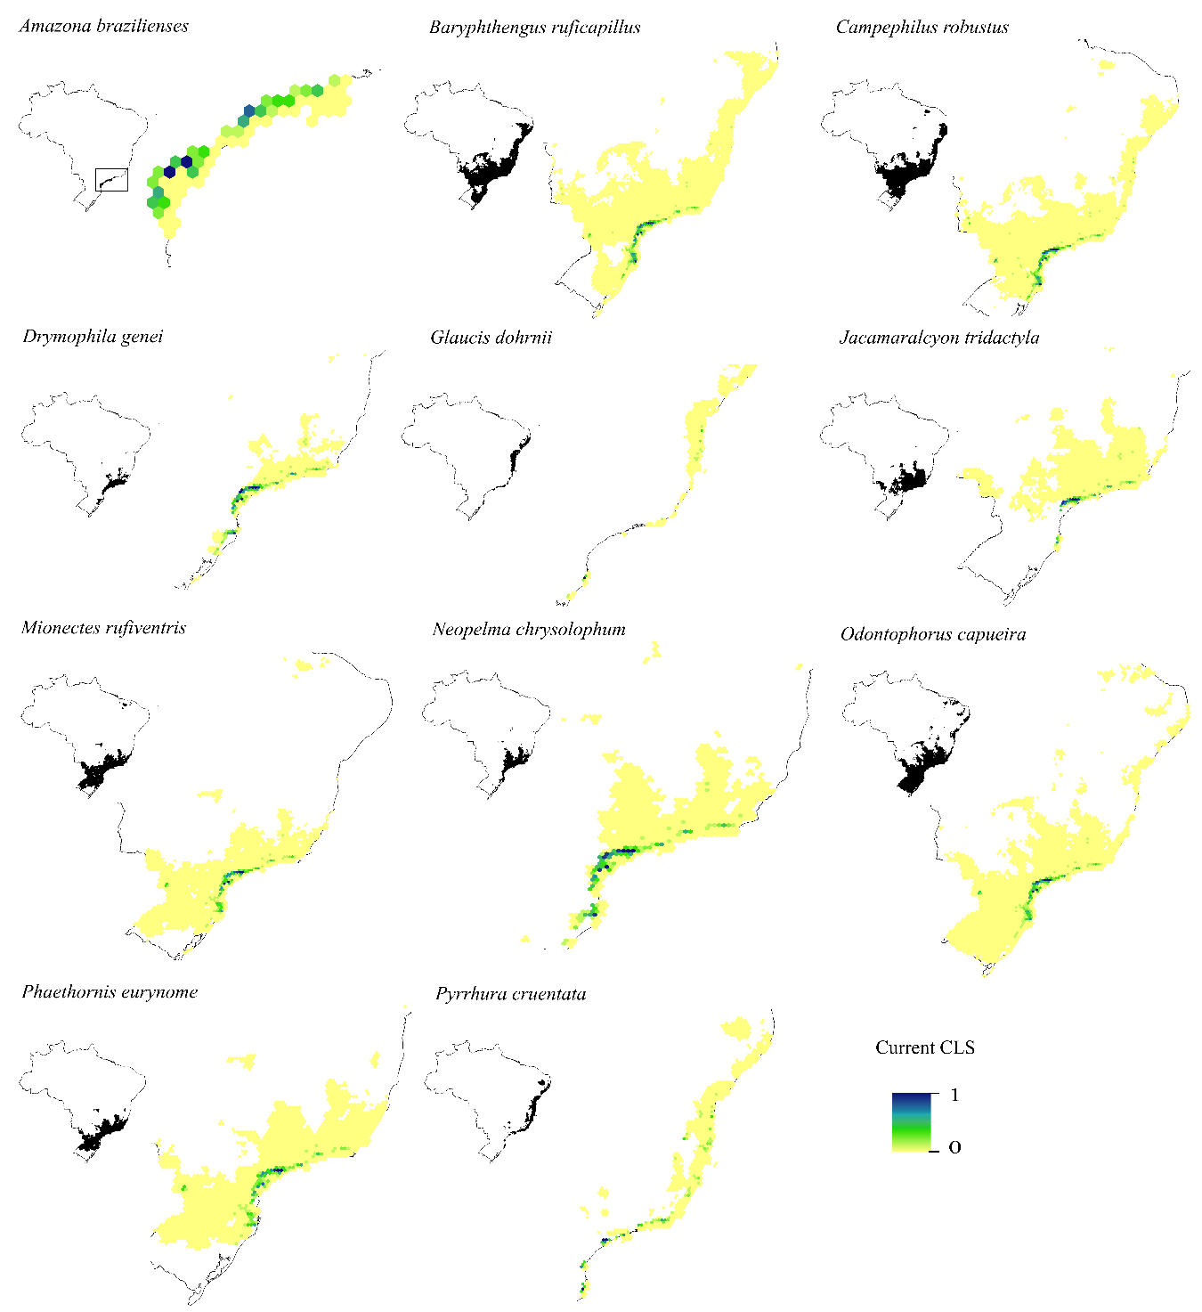

Fig. S3. Pie-charts refer to forest cover proportion. Dark green represents the proportion of landscapes with ≤50% forest cover and light green represents the proportion of landscapes with >50% forest cover.

