Appendix 1. Supplementary tables and figures.

Table S1: General information on the Mexican biosphere reserves.
no | Name | Year of creation | IUCN category |  | Area (ha) | Dominant vegetation
1 | Barranca de Metztitlán | 2000 |  | I and VI | 96,117.76 | Shrubland
2 | Calakmul | 1989 |  | I and VI | 1,370,590.73 | Tropical forest
3 | Chamela-Cuixmala | 1993 |  | I and VI | 43,176.12 | Tropical dry-forest
4 | El Triunfo | 1990 |  | I and VI | 119,276.54 | Cloud forest
5 | La Sepultura | 1995 |  | I and VI | 178,639.22 | Temperate forest
6 | Lacan-Tun | 1992 |  | I and VI | 61,873.96 | Tropical forest
7 | Los Petenes | 1999 |  | I and VI | 282,857.63 | Aquatic vegetation
8 | Los Tuxtlas | 1998 |  | I and VI | 154,884.85 | Tropical forest
9 | Mariposa Monarca | 2000 |  | I and VI | 56,277.67 | Temperate forest
10 | Montes Azules | 1978 |  | I and VI | 331,200.00 | Tropical forest
11 | Ría Celestún | 2000 |  | I and VI | 81,482.33 | Aquatic vegetation
12 | Ría Lagartos | 1999 |  | I and VI | 60,096.87 | Aquatic vegetation
13 | Selva El Ocote | 1982 |  | I and VI | 101,352.24 | Tropical forest
14 | Sian Ka'an | 1986 |  | I and VI | 375,062.90 | Tropical dry-forest
15 | Sierra de Huautla | 1999 |  | I and VI | 60,697.05 | Tropical dry-forest
16 | Sierra de Manantlán | 1987 |  | I and VI | 139,652.98 | Tropical dry-forest
17 | Sierra del Abra Tanchipa | 1994 |  | I and VI | 21,483.33 | Tropical dry-forest
18 | Sierra Gorda | 1997 |  | I and VI | 383,567.45 | Temperate forest
19 | Tehuacán-Cuicatlán | 1998 |  | I and VI | 490,645.28 | Tropical dry-forest
*IUCN category I correspond to the core zone of the biosphere reserve, while *IUCN category VI corresponds to their buffer zone.

Table S2: Description of labor composition, in the year 2000, in the municipalities surrounding the studied biosphere reserves, as indicated by the mean proportion of the population working in the municipalities in different sector labors. The agriculture sector includes: crop production and cattle ranching; the industrial sector: manufactures, electricity, and construction; the business & services sector: trade, transportation, financial, administration, cultural, hotels, property, business support, education and health; and the professional: technician, directors, civil officials. The non-farm occupation corresponds to the sum of industrial, professional, and business & services sectors.
Reserve | Agricultural sector | Industrial sector | Business & services sector | Professional sector | Non-farm occupation | no labor information
Barranca de Metztitlán | 0.38 | 0.29 | 0.31 | 0.00 | 0.62 | 0.02
Calakmul | 0.56 | 0.12 | 0.30 | 0.00 | 0.44 | 0.02
Chamela-Cuixmala | 0.36 | 0.19 | 0.42 | 0.01 | 0.64 | 0.02
El Triunfo | 0.66 | 0.09 | 0.23 | 0.00 | 0.34 | 0.02
La Sepultura | 0.49 | 0.13 | 0.35 | 0.01 | 0.51 | 0.02
Lacandona | 0.76 | 0.06 | 0.16 | 0.00 | 0.24 | 0.02
Los Tuxtlas | 0.64 | 0.09 | 0.25 | 0.00 | 0.36 | 0.02
LPRC | 0.33 | 0.27 | 0.38 | 0.00 | 0.67 | 0.01
Mariposa Monarca | 0.34 | 0.31 | 0.32 | 0.00 | 0.66 | 0.03
Ría Lagartos | 0.47 | 0.16 | 0.35 | 0.01 | 0.53 | 0.02
Selva El Ocote | 0.51 | 0.16 | 0.31 | 0.01 | 0.49 | 0.02
Sian Ka'an | 0.28 | 0.16 | 0.54 | 0.01 | 0.72 | 0.02
Sierra de Huautla | 0.30 | 0.27 | 0.40 | 0.01 | 0.70 | 0.02
Sierra de Manantlán | 0.40 | 0.20 | 0.37 | 0.01 | 0.60 | 0.02
Sierra del Abra Tanchipa | 0.35 | 0.19 | 0.43 | 0.01 | 0.65 | 0.02
Sierra Gorda | 0.50 | 0.20 | 0.26 | 0.00 | 0.50 | 0.04
Tehuacán-Cuicatlán | 0.59 | 0.22 | 0.17 | 0.00 | 0.41 | 0.01

Table S3: The predictor variables and their relationship with forest loss according to the bibliography.
Predictor variable | Type of predictor | Hypothetical effect on forest loss | Mechanisms | Source
Distance to cities | Economic | Directly proportional | Longer distances result in higher transportation costs for agricultural products, increasing their trade price. To compensate for these lower costs, some producers increase the cultivated area promoting deforestation | Angelsen et al. 2010, Ferraro et al. 2011, Pfaff and Robalino 2012
Marginalization | Political | Directly proportional | Marginalization can be considered as a proxy of poverty. Poverty can increase deforestation in the case that population subsist from agriculture and there exist few other opportunities to fulfill their needs so that they increase the cultivated area to increase revenues which promote forest loss | Gesit and Lambin 2003
Non-farm occupation | Economic | Inversely proportional | Non-farm occupation can be considered a proxy of forest transition. Regions where job opportunities in the industrial and services sectors exert less pressure on the forest since reducing the demand for the forest for cultivation, which is the main direct cause of deforestation in tropical regions | Wunder et al 2003, Angelsen and Kaimowitz 1999,Bluffstone 1995, Hoang et al. 2014, Klooster 2003, Stem 2003
Population density | Demographic | Directly proportional | Population density imposes higher pressure on ecosystems. Higher concentration of people demand higher resources, land surface for agriculture activities and induce technological and institutional change (e.g. higher infrastructure development) | Gesit and Lambin 2002, Aide 2013, Laurance et al. 2002
Population growth | Demographic | Directly proportional | Population growth imposes higher pressure on ecosystems. The increase in population over time increase the demands of resources, the land surface for agriculture activities and induce technological and institutional change (e.g. higher infrastructure development) | Gesit and Lambin 2002, Erlich and Holdren 1971, Wittemyer et al 2008
Rural settlement density | Demographic | Directly proportional | Each settlement exerts pressure on the ecosystem. Higher density of settlements increase deforestation | Mas and Cuevas 2015, Tritsch et al. 2016
Subsidies for agriculture | Political | Directly proportional | Higher economic incentives for agriculture activities may promote deforestation because, in order to increase their revenues, the population transform forest areas into agricultural fields | Klepeis and Vance 2009, Schmook and Vance 2009
Unemployment rate | Economic | Directly proportional | The unemployed population may choose to make use of forest resources to compensate for their shortages, thereby increasing deforestation rates. | Call et al. 2017, Tariq et al. 2014

To compare the effect of the different labor sectors on forest loss rate inside the studied biosphere reserves, we performed simple linear models for each non-farm sector and the non-farm occupation indicator. We found that industrial activities account for the higher effect followed by business & services (Table S4).

Table S4: Results of linear models used to test the relationship between forest loss rate inside the studied biosphere reserves and different labor sector variables (Predictor), expressed as the proportion of people in the municipalities surrounding the studied reserves working in each sector. We order the predictors by Akaike Information Criterion (AIC) ascending values. Note that the industrial sector explains a higher proportion of the variance(R²) in forest loss rate than business & services and professional activities. Also, note that the proportion of local people to non-farm occupation was the best predictor (higher R²) of forest loss rate. The significance level of each predictor is indicated by the p.value.
Predictor | AIC | R² | p.value
Non-farm occupation | -4.10 | 0.32 | 0.019
Industrial | -2.46 | 0.25 | 0.043
Business & Services | -0.99 | 0.18 | 0.091
Professional | 1.40 | 0.05 | 0.371

Figure S1: The distribution of the point sample units for the forest loss data (a) and the forest regrowth data (b). Colors indicate the treatment of the sample unit: protected (inside reserves) or unprotected (area not included in any Mexican protected area). Forest loss points (n=423,900) are located in areas covered by forest in 2000 and forest regrowth points (n=331,623) in areas covered by no forest in the same year.
Figure S2: Distribution of the microlandscapes used to evaluate forest fragmentation rate. In the bottom panel, the reserves are represented by green polygons while the purple circles represent microlandscapes (n=1,500). In the upper-right part of the plot, we show an example of a microlandscape and its spatial configuration of forest patches for the years 2000 and 2020. The red square inside the map indicates the location of this microlandscape.
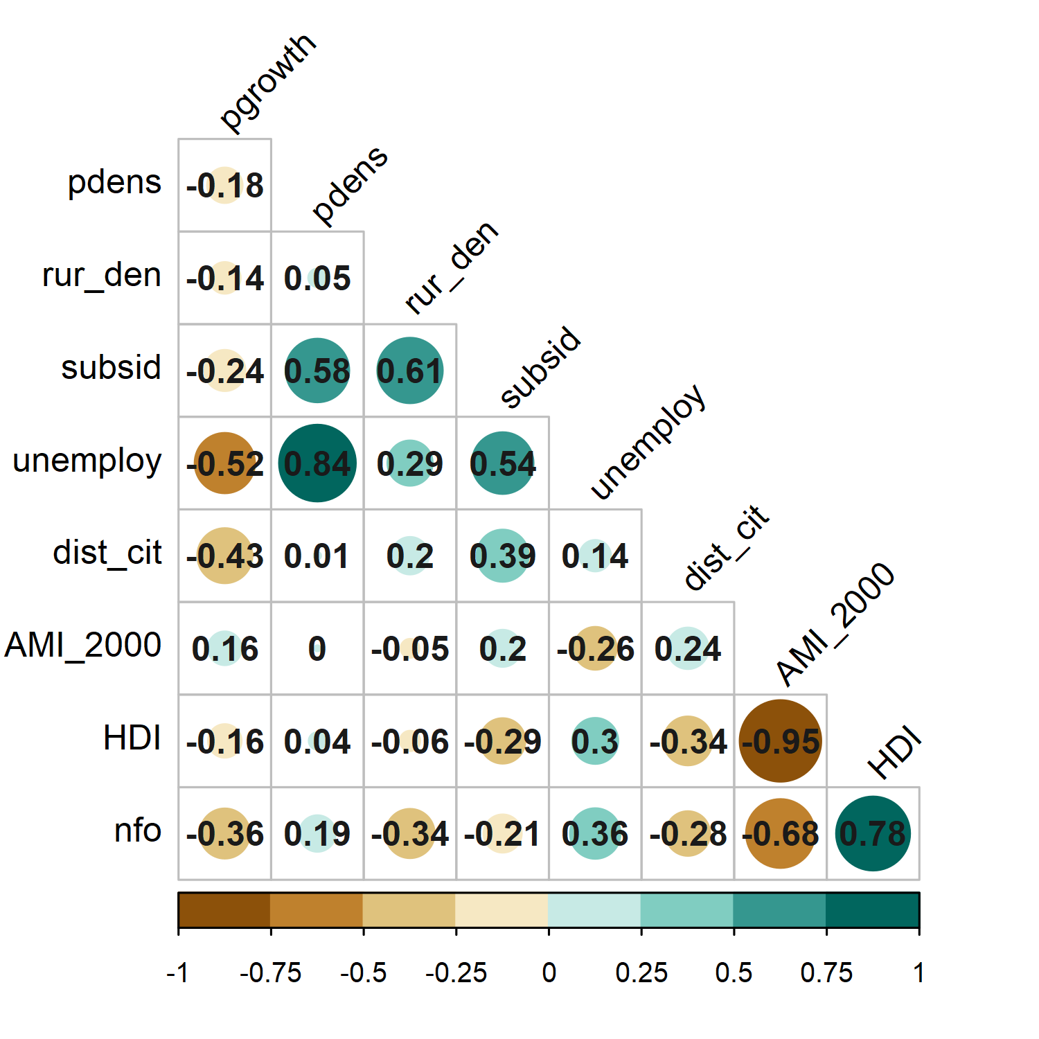
Figure S3: Relationship between socioeconomic variables. The size of the circles represents the magnitude of correlation. Green color denotes positive correlations while orange color negatives. Numbers in the plot represent Pearson correlation coefficients. Pgrwoth: population growth rate, pdens: population density, subsid: governmental subsidies for agriculture, unemploy: unemployment rate, dist_cit: distance to cities, AMI_2000: absolute marginalization index in the year 2000, HDI: human development index, nfo: non-farm occupation.

Figure S4: Predicted response of the distance to cities (a) and the agriculture suitability index (b) on forest regrowth rate. Forest regrowth is higher in localities far from cities with poor conditions for agricultural activities (steeper slopes, high elevations, poor soils).

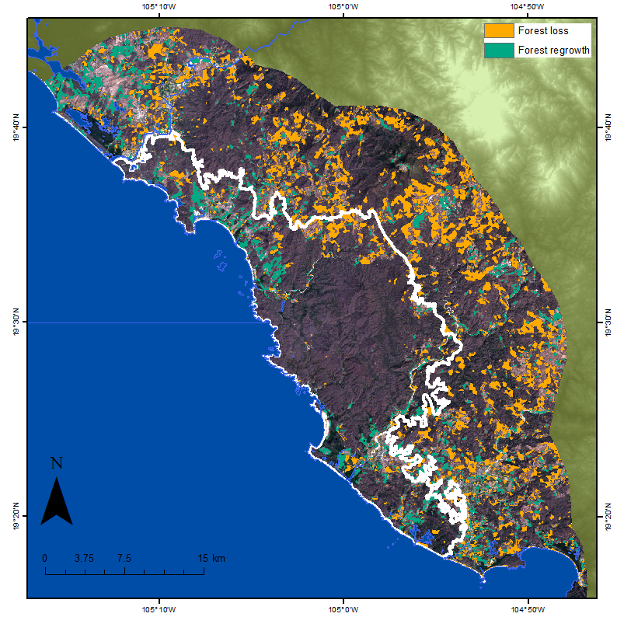
Figure S5: Pattern of forest loss and forest regrowth inside Chamela-Cuixmala Biosphere Reserve (delimited by the white line) and its surrounding (10 km of buffer distance) area during 2000-2020. The formal establishment of the reserve caused the prohibition of some extractive human activities inside its boundaries which promote the regrowth (green areas) of the forest but also increase the agricultural activities outside which is reflected in forest loss (orange areas).

Figure S6: Relationship between the density of rural settlements and forest loss rate (during the period 1985-2000, before the formal establishment of most reserves) inside studied biosphere reserves. Gray points correspond to reserves, the green line corresponds to a linear regression fit.

Supplementary references
Aide, T.M., Clark, M.L., Grau, H.R., López-Carr, D., Marc, A., Redo, D., Bonilla-Moheno, M., Riner, G., Andrade-Núñez, M.J., Muñiz, M., 2013. Deforestation and Reforestation of Latin America and the Caribbean ( 2001-2010 ). Biotropica 45, 262–271.
Angelsen, A., 2010. Policies for reduced deforestation and their impact on agricultural production. Proc. Natl. Acad. Sci. U. S. A. 107, 19639–19644. https://doi.org/10.1073/pnas.0912014107
Angelsen, A., Kaimowitz, D., 1999. Rethinking the causes of deforestation: Lessons from economic models. World Bank Res. Obs. 14, 73–98. https://doi.org/10.1093/wbro/14.1.73
Bluffstone, R.A., 1995. The Effect of Labor Market Performance on Deforestation in Developing Countries under Open Access: An Example from Rural Nepal. J. Environ. Econ. Manage. 29, 42–63. https://doi.org/https://doi.org/10.1006/jeem.1995.1030
Call, M., Mayer, T., Sellers, S., Ebanks, D., Bertalan, M., Nebie, E., Gray, C., 2017. Socio-environmental drivers of forest change in rural Uganda. Land use policy 62, 49–58. https://doi.org/10.1016/j.landusepol.2016.12.012
Ehrlich, P.R., Holdren, J.P., 1971. Impact of Population Growth. Science (80-. ). 171, 1212–1217.
Ferraro, P.J., Hanauer, M.M., Sims, K.R.E., 2011. Conditions associated with protected area success in conservation and poverty reduction. Proc. Natl. Acad. Sci. 108, 13913–13918. https://doi.org/10.1073/pnas.1011529108
Geist, H., Lambin, E., 2003. Is poverty the cause of tropical deforestation? Int. For. Rev. 5, 64–67. https://doi.org/10.1505/ifor.5.1.64.17426
Geist, H.J., Lambin, E.F., 2002. Proximate Causes and Underlying Driving Forces of Tropical Deforestation. Bioscience 52, 143. https://doi.org/10.1641/0006-3568(2002)052[0143:PCAUDF]2.0.CO;2
Hoang, H.T.T., Vanacker, V., Van Rompaey, A., Vu, K.C., Nguyen, A.T., 2014. Changing human-landscape interactions after development of tourism in the northern Vietnamese Highlands. Anthropocene 5, 42–51. https://doi.org/10.1016/j.ancene.2014.08.003
Klepeis, P., Vance, C., 2009. Neoliberal Policy and Deforestation in Southeastern Mexico: An Assessment of the PROCAMPO Program. Econ. Geogr. 79, 221–240. https://doi.org/10.1111/j.1944-8287.2003.tb00210.x
Klooster, D., 2003. Forest Transitions in Mexico: Institutions and Forests in a Globalized Countryside*. Prof. Geogr. 55, 227–237.
Laurance, W.F., Albernaz, A.K.M., Schroth, Götz, Fearnside, P.M., Journal, S., Issue, S., Biotas, I., Jun, M., Laurance, W.F., Albernaz, A.K.M., Schroth, Gotz, Fearnside, P.M., 2002. Predictors of deforestation in the Brazilian Amazon Scott Bergen , Eduardo M . Venticinque and Carlos Da Costa Published by : Wiley Stable URL : https://www.jstor.org/stable/827480 REFERENCES Linked references are available on JSTOR for this article : You. J. Biogeogr. 29, 737–748.
Mas, J.F., Cuevas, G., 2015. Local deforestation patterns in Mexico an approach using geographiccally weighted regression. GISTAM 2015 - 1st Int. Conf. Geogr. Inf. Syst. Theory, Appl. Manag. Proc. 54–60. https://doi.org/10.5220/0005349000540060
Pfaff, A., Robalino, J., 2012. Protecting forests, biodiversity, and the climate: Predicting policy impact to improve policy choice. Oxford Rev. Econ. Policy 28, 164–179. https://doi.org/10.1093/oxrep/grs012
Schmook, B., Vance, C., 2009. Agricultural Policy, Market Barriers, and Deforestation: The Case of Mexico’s Southern Yucatán. World Dev. 37, 1015–1025. https://doi.org/10.1016/j.worlddev.2008.09.006
Stem, C.J., Lassoie, J.P., Lee, D.R., Deshler, D.D., Schelhas, J.W., 2003. Community participation in ecotourism benefits: The link to conservation practices and perspectives. Soc. Nat. Resour. 16, 387–413. https://doi.org/10.1080/08941920309177
Tariq, M., Rashid, M., Rashid, W., 2014. Causes of deforestation and climatic changes in Dir Kohistan. J. Pharm. Altern. Med. 3, 28–37.
Tritsch, I., Le Tourneau, F.M., 2016. Population densities and deforestation in the Brazilian Amazon: New insights on the current human settlement patterns. Appl. Geogr. 76, 163–172. https://doi.org/10.1016/j.apgeog.2016.09.022
Wittemyer, G., Elsen, P., Bean, W.T., Burton, a C.O., Brashares, J.S., 2008. Accelerated Human Popilation Growth at Protected Area Edges. Science (80-. ). 321, 123–126. https://doi.org/10.1126/science.1158900
Wunder, S., 2003. When the Dutch disease met the French connection: oil, macroeconomics and forests in Gabon. Center for International Forestry Research (CIFOR). https://doi.org/10.17528/cifor/001406

