SUPPLEMENTARY INFORMATION
Table S - 1. Potential predictor variables
Data Source | Variable | Variable classification (Borda-Niño et al., 2019)
Land use cover map (Seabra, 2012) | Distance to agricultural areas (DAG) | Socioeconomic
 | Distance to urban areas (DUR) | Socioeconomic
 | Distance to patches smaller than 10ha (D10) | Biophysical
 | Distance to 10-100ha patches (D10-100) | Biophysical
 | Distance to 100-500ha patches (D100-500) | Biophysical
 | Distance to patches bigger than 500ha (D500) | Biophysical
 | Distance to forest edges (DED) | Biophysical
 | Distance to core patches (DCO) | Biophysical
Roads (IBGE, 2016) | Distance to one-way roads (DOR) | Socioeconomic
 | Distance to two-way roads (DTR) | Socioeconomic
 | Distance to main roads (DMR) | Socioeconomic
 | Distance to all roads (DAR) | Socioeconomic
Railroads (INEA, 2016) | Distance to railroads (DRA) | Socioeconomic
Transmission lines (INEA, 2016) | Distance to transmission lines (DTL) | Socioeconomic
Settlements (INCRA, 2015) | Distance to settlements (DSE) | Socioeconomic
Protected Areas (MMA, 2015) | Distance to Strictly Protected Areas (DSPA) | Socioeconomic
 | Distance to Sustainable Protected Areas (DSU) | Socioeconomic
 | Distance to private reserves (DPR) | Socioeconomic
Rivers (INEA, 2016) | Distance to rivers (DRI) | Biophysical
Population (CIAT, 2016) | Population (POP) | Socioeconomic
Fire Probability (INEA, 2016) | Fire probability (HFP, MFP, and LFP) | Biophysical
WorldClim (Hijmans et al. 2005) | Annual Mean Temperature (AMT) | Biophysical
 | Annual Precipitation (APR) | Biophysical
Biophysical maps (INEA, 2016) | Evapotranspiration (EVP) | Biophysical
 | Water Deficit (WDF) | Biophysical
 | Water Surplus (WSU) | Biophysical
Digital Elevation Model (Topodata, 2016) | Elevation (ELE) | Biophysical
 | Slope (SLO) | Biophysical
 | Aspect (ASP) | Biophysical
 | Solar radiation (SOL) | Biophysical
 | Topographic Position Index (TPI) | Biophysical
 | Compound Topographic Index (CTI) | Biophysical
 | Heat Load Index (HLI) | Biophysical
 | Integrated Moisture Index (IMI) | Biophysical
Soil map (Seabra, 2012) | Soil types (S1-S8) | Biophysical
Geomorphology map (Seabra, 2012) | Geomorphology types (G1-G8) | Biophysical
Phytophysiognomy (INEA, 2016) | Phytophysiognomy types (F1-F6) | Biophysical

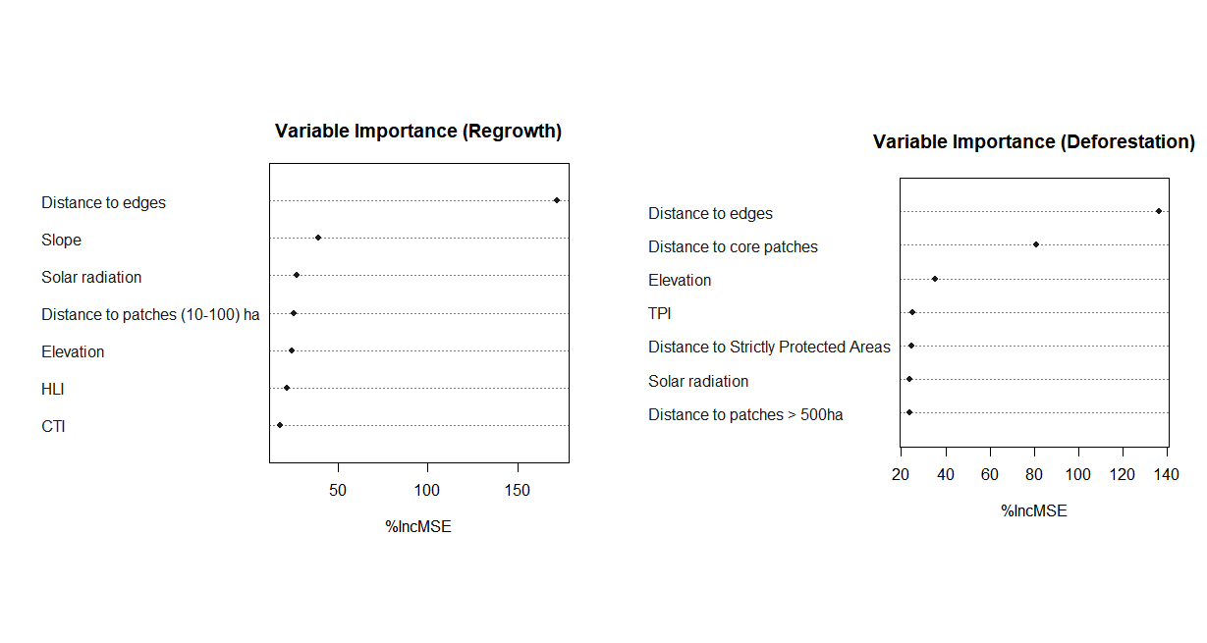
Fig. S - 1. Importance of environmental and socioeconomic factors associated with forest regrowth (a) and deforestation (b) in the SJRB, southeastern Brazil.

Table S - 2. Weight’s predictor for deforestation
Predictor | Weights in plausible models | Weights in all models
Distance to forest edges | 0.7220 | 0.9999
TPI | 0.7220 | 0.9999
Distance to cores | 0.7220 | 0.9977
Solar radiation | 0.7220 | 0.9560
Distance to Strictly Protected Areas | 0.7220 | 0.8698
Elevation | 0.2353 | 0.4169
Distance to patches larger than 500 ha | 0.1612 | 0.3790

Table S - 3. Lowest AICc deforestation model
Predictor variable | Coefficients | Standard Error | Z value | Pr (>|z|)
(intercept) | 2.822e+00 | 6.240e-01 | 4.522 | 6.12e-06 ***
Distance to forest edges | -9.391e-03 | 4.854e-04 | -19.347 | < 2e-16 ***
Distance to core areas | -6.394e-04 | 1.667e-04 | -3.836 | 0.000125 ***
Solar radiation | -1.474e-06 | 5.283e-07 | -2.791 | 0.005258 **
TPI | -1.002e-02 | 1.968e-03 | -5.091 | 3.56e-07 ***
Distance to Strictly Protected Areas | 2.372e-05 | 8.320e-06 | 2.851 | 0.004359 **
Significance level: *** = 0%; ** = 0,001%.

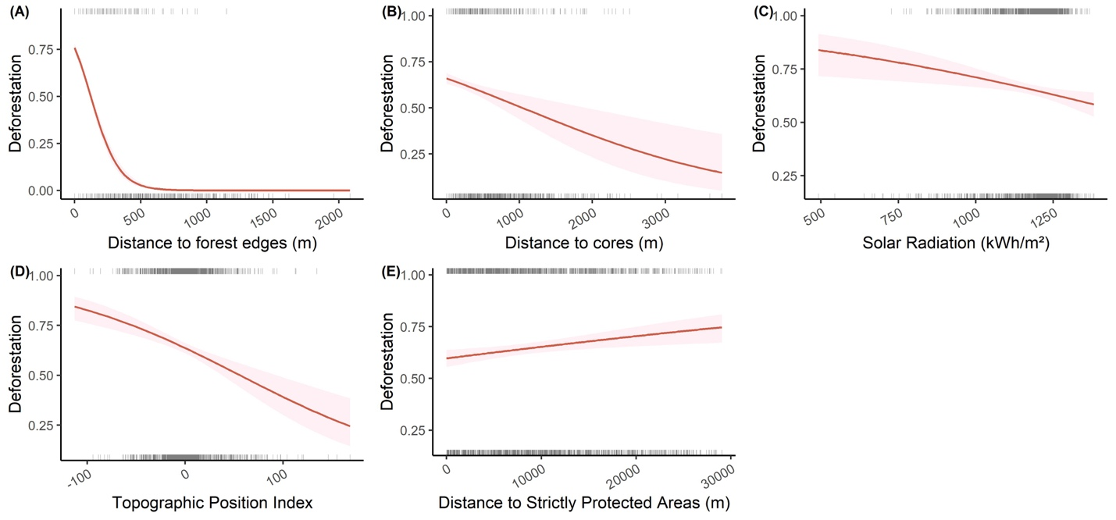

Fig. S - 2. Lowest AICc deforestation model.

Table S - 4. Weight’s predictor for forest regrowth
Predictor | Weights in plausible models | Weights in all models
Distance to forest edges | 0.9036 | 1.0000
Slope | 0.9036 | 1.0000
Elevation | 0.9036 | 0.9995
Solar radiation | 0.9036 | 1.0000
CTI | 0.4774 | 0.5287
HLI | 0.2198 | 0.3159
Distance to patches between 10 and 100 ha | 0.2047 | 0.3010

Table S - 5. Forest regrowth model containing the highest weights variables
Predictor variable | Coefficients | Standard Error | Z value | Pr (>|z|)
(Intercept) | -5.99E+03 | 7.68E+02 | -7.802 | 6.11e-15 ***
Distance to forest edges | -2.69E+00 | 2.25E-01 | -11.970 | < 2e-16 ***
Slope | 2.48E+01 | 3.65E+00 | 6.810 | 9.75e-12 ***
Elevation | -1.94E+00 | 4.07E-01 | -4.763 | 1.91e-06 ***
Solar radiation | 5.05E-03 | 6.10E-04 | 8.284 | < 2e-16 ***
Significance level: *** = 0%.

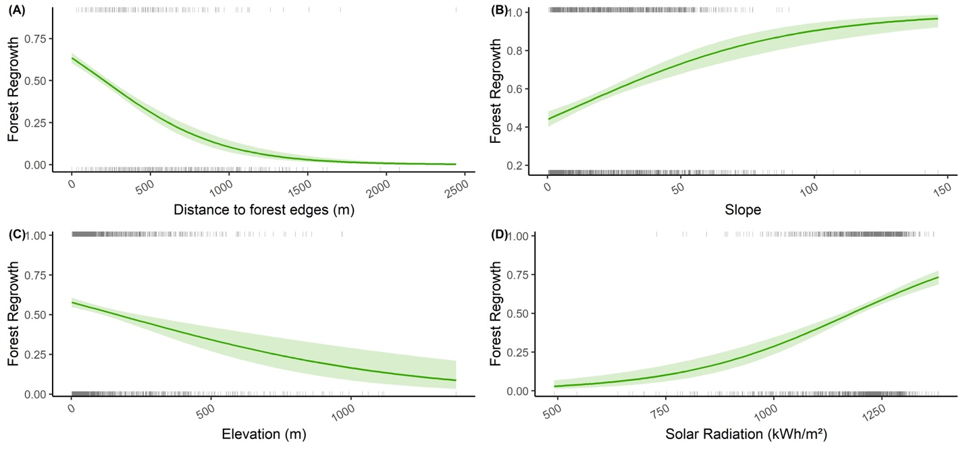
Fig. S - 3. Forest regrowth model containing the highest weights variables

