SUPPLEMENTARY DATA

Table 1. List of rodents of the family Cricetidae endemic, rare, or included in some category of protection in the Official Mexican Standard (NOM-059-SEMARNAT, 2010) or the red list of the International Union for the Conservation of Nature (IUCN, 2019). Endemic to Oaxaca (OAX). Conservation status (NOM-059: A, threatened; Pr, subject to special protection. IUCN: CR, critically endangered; EN, in danger of extinction; NT, near threatened; VU, vulnerable). Rarity: D, demographic; E, ecological; G, geographical.
 | Species | Conservation status |  | Rarity
 |  | NOM-059 | IUCN
1 | Microtus oaxacensis ^{OAX} | A | EN | D, E, G
2 | Microtus quasiater | Pr | NT | E, G
3 | Microtus umbrosus _{OAX} | Pr | EN | D, E, G
4 | Habromys chinanteco ^{OAX} |  | CR | D, E, G
5 | Habromys ixtlani ^{OAX} |  | CR | D, E, G
6 | Habromys lepturus ^{OAX} |  | CR | E, G
7 | Habromys simulatus | Pr | CR | D, E, G
8 | Megadontomys cryophilus ^{OAX} | A | EN | D, E, G
9 | Megadontomys nelsoni | A | EN | D, E, G
10 | Megadontomys thomasi | Pr | EN | G
11 | Peromyscus melanocarpus ^{OAX} |  | EN | E, G
12 | Peromyscus melanurus ^{OAX} |  | EN | G
13 | Reithrodontomys microdon | A |  | D, E
14 | Oryzomys chapmani |  | VU
15 | Oryzomys fulgens | A
16 | Oryzomys melanotis | Pr
17 | Rheomys mexicanus ^{OAX} | Pr | EN | D, E, G
18 | Sigmodon alleni |  | VU

Fig. 1. Histogram of the frequency of the multidimensional diversity values for the pixels. Of the 1,092 cells covering Oaxaca that we examined in this study, most had moderate values and few cells had high values. No cell had the maximum possible value (400).

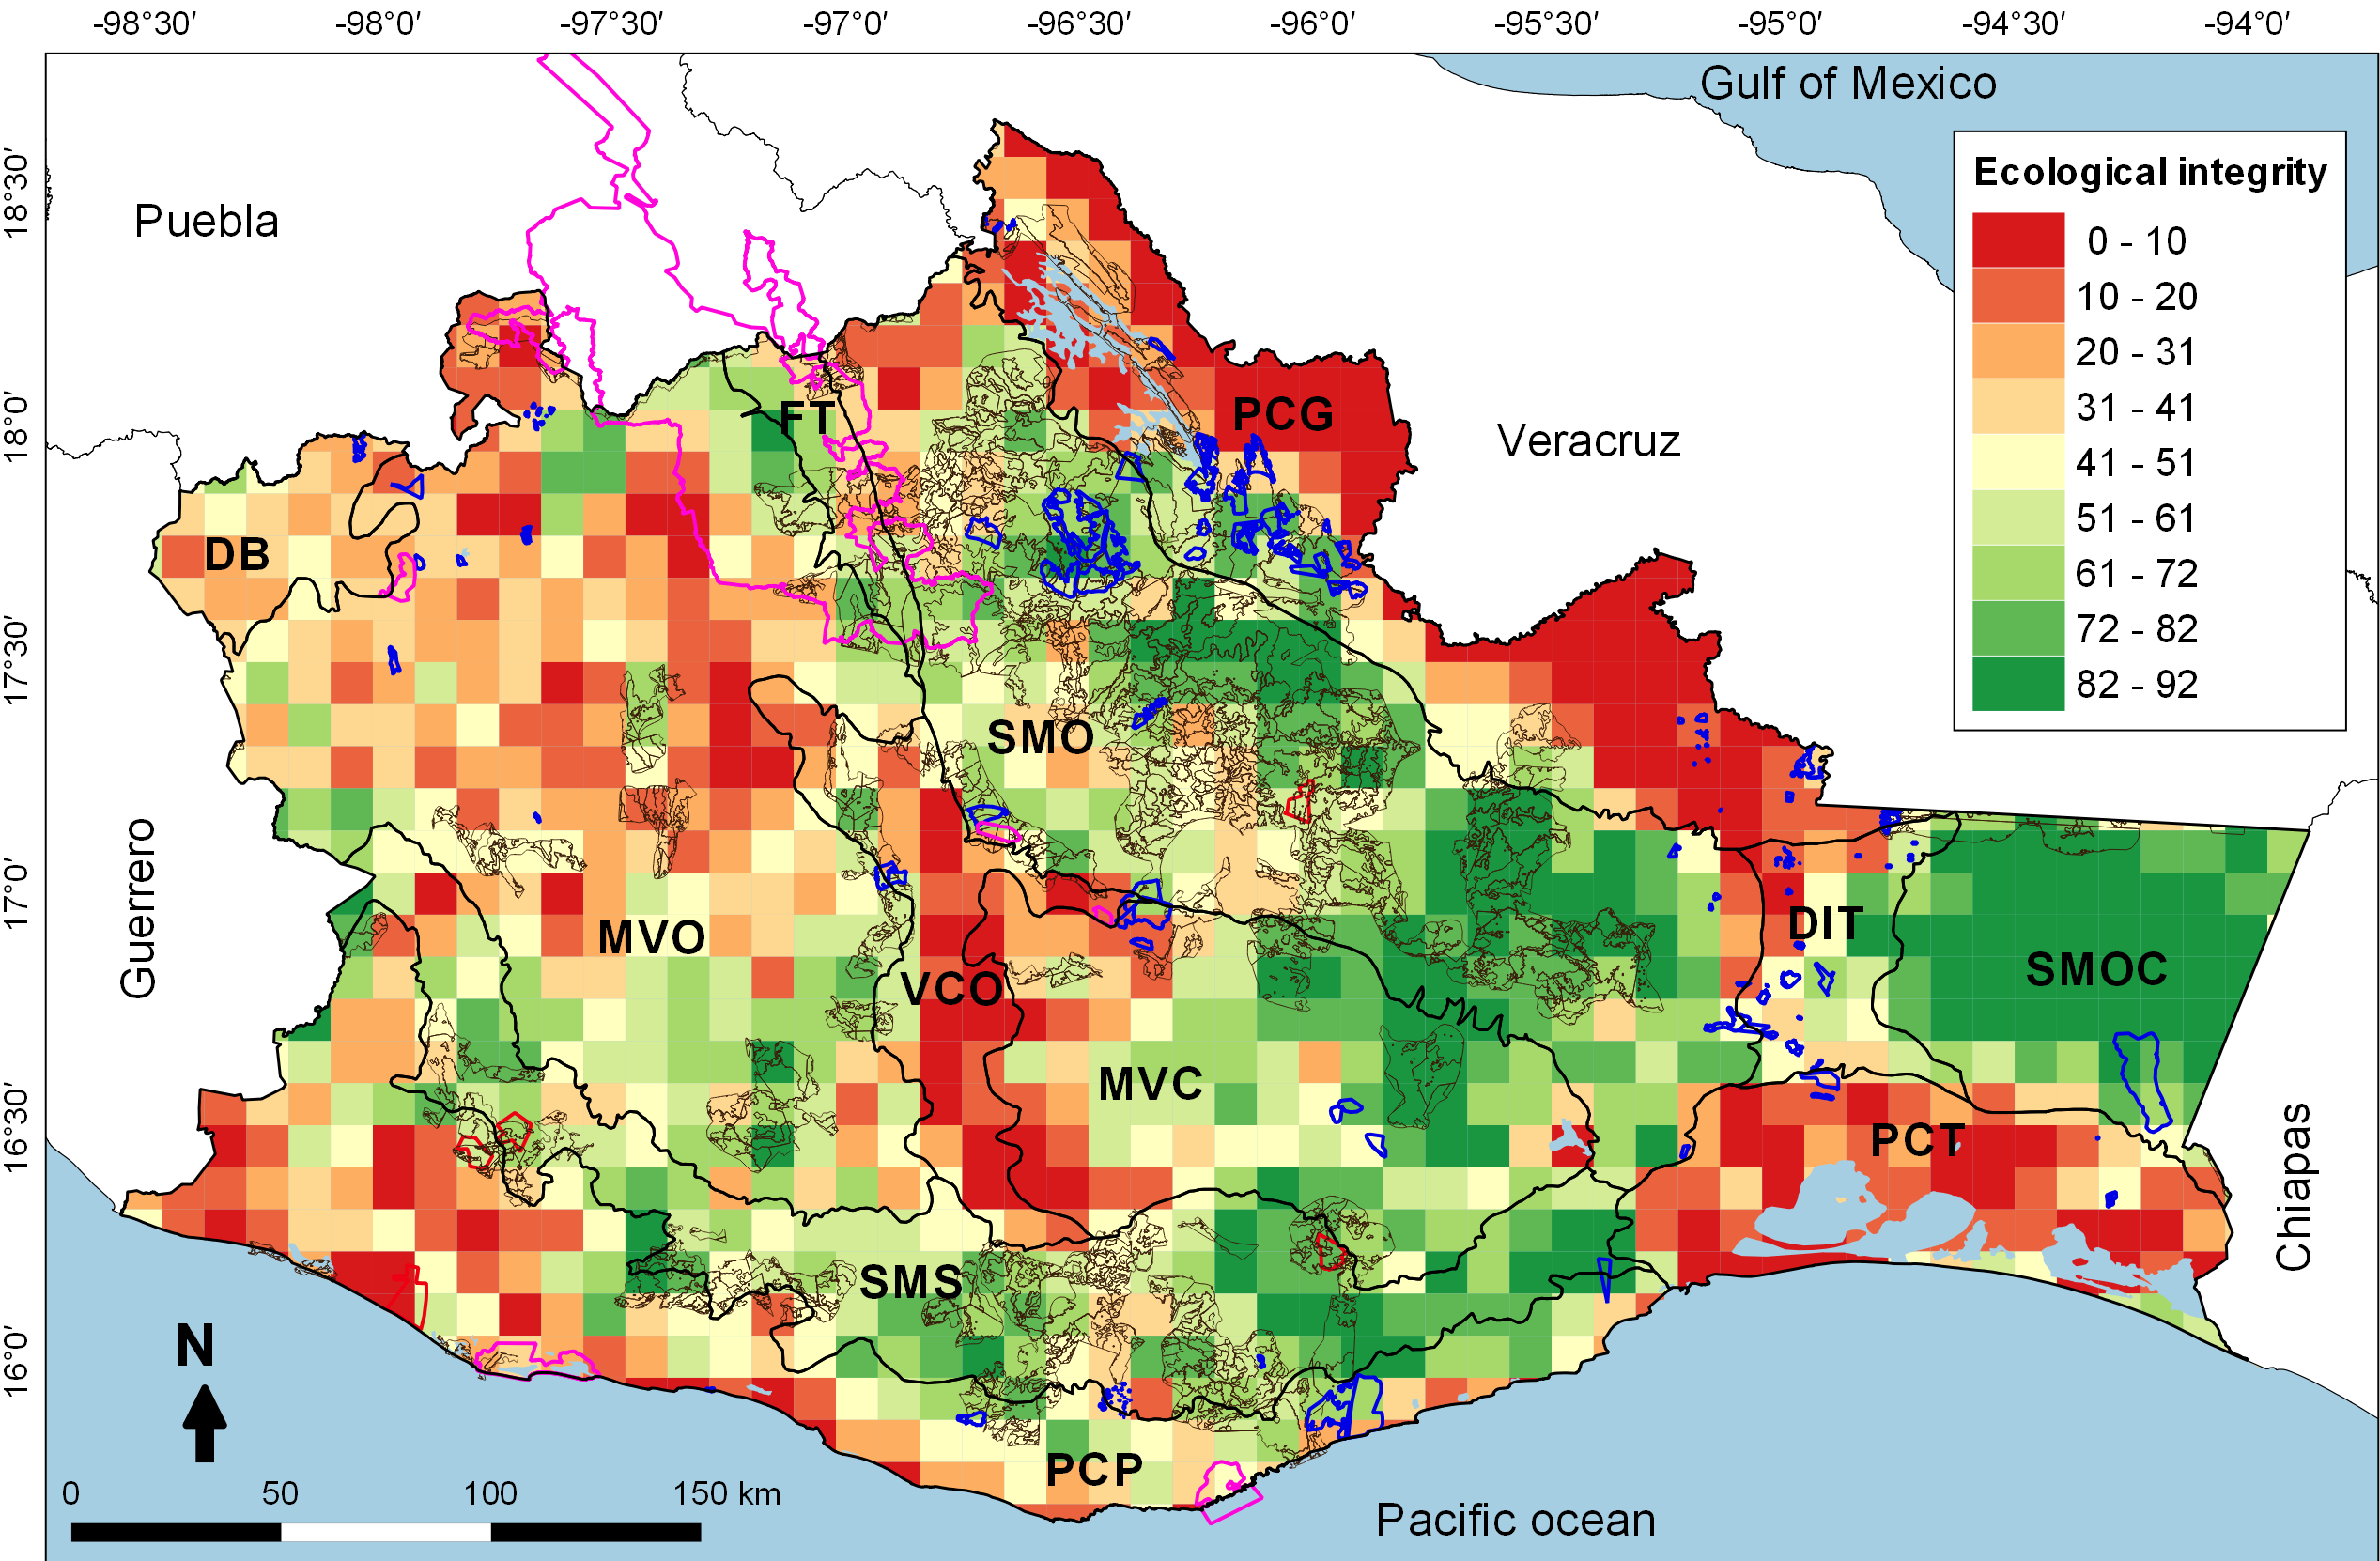

Fig. 2. Ecological integrity in 100 km² cells. The polygons with a pink line correspond to the Protected Natural Areas (PNA), the blue lines to the Voluntarily Conservation Area (VCA), the brown lines to the Payments for Environmental Services (PES) and the red lines to the Environmental Managements Units (EMU) for wildlife conservation in Oaxaca. We studied the following Physiographic subprovinces in Oaxaca: Depresión del Balsas (DB), Montañas y Valles del Occidente (MVO), Fosa de Tehuacán (FT), Sierra Madre de Oaxaca (SMO), Valles Centrales de Oaxaca (VCO), Montañas y Valles del Centro (MVC), Sierra Madre del Sur (SMS), Planicie Costera del Pacífico (PCP), Planicie Costera de Tehuantepec (PCT), Depresión del Istmo de Tehuantepec (DIT), Sierra Madre del Sur de Oaxaca y Chiapas (SMOC), and the Planicie Costera del Golfo (PCG).

Table 2. Areas for multidimensional conservation (AMC) of cricetid mice in the physiographic subprovinces of Oaxaca. * Calculated with respect to the total area of the sub-province. ** Calculated with respect to the total area of the AMC in each subprovince. The initiatives are explained within the text. PNA: Protected Natural Areas, VCA: Voluntary Conservation Area, PES: Payments for Environmental Services.
 | Subprovinces | AMC km² (%*) | AMC in PNA km² (%**) | AMC in VCA km² (%**) | AMC in PES km² (%**) | Total protected area km² (%)
1 | Depresión del Balsas | 171.71 (10.04) | 3.12 (1.82) | - | - | 3.12 (1.82)
2 | Montañas y Valles del Occidente | 4020.82 (20.23) | - | 7.17 (0.18) | 257.01 (6.39) | 264.18 (6.57)
3 | Fosa de Tehuacán | 147.06 (13.80) | 104.68 (71.18) | - | 28.94 (19.68) | 133.62 (90.28)
4 | Sierra Madre de Oaxaca | 3191.08 (19.03) | 47.70 (1.49) | 96.33 (3.02) | 1968.80 (61.70) | 2112.83 (66.21)
5 | Valles Centrales de Oaxaca | 351.49 (10.47) | 6.86 (1.95) | 5.16 (1.47) | 7.46 (2.12) | 19.48 (5.54)
6 | Montañas y Valles del Centro | 1182.09 (14.01) | 0.01 (0) | 6.01 (0.51) | 130.98 (11.08) | 137 (11.59)
7 | Sierra Madre del Sur | 1407.69 (14.84) | - | 8.16 (0.58) | 292.73 (20.80) | 300.89 (21.38)
8 | Planicie Costera del Pacífico | 1266.43 (11.59) | - | 50.13 (3.96) | 197.98 (15.63) | 248.11 (19.59)
9 | Planicie Costera de Tehuantepec | 983.06 (17.84) | - | 14.15 (1.44) | - | 14.15 (1.44)
10 | Depresión del Istmo de Tehuantepec | 198.51 (9.83) | - | 11.85 (5.97) | 0.96 (0.49) | 12.81 (6.46)
11 | Sierra Madre del Sur de Oaxaca y Chiapas | 1006.34 (18.15) | - | - | 36.92 (3.67) | 36. 92 (3.67)
12 | Planicie Costera del Golfo | 1713.39 (18.44) | - | 42.47 (2.48) | 367.34 (21.44) | 409.81 (23.92)
 | Total km² | 15639.67 | 162.37 | 241.43 | 3289.12 | 3692.92

