Supplementary material for “Landscape forest loss decreases bird diversity with strong negative impacts on forest species in a mountain region”

Table S1. List of species and classification into ecological groups according to habitat requirements.
Specie | Habitat requeriment
Aimophila rufescens | Disturbance adapted
Amazilia beryllina | Habitat generalist
Amazilia rutila | Habitat generalist
Amazilia viridifrons | Habitat generalist
Aphelocoma woodhouseii | Disturbance adapted
Arremon brunneinucha | Forest specialist
Attila spadiceus | Habitat generalist
Basileuterus culicivorus | Habitat generalist
Basileuterus rufifrons | Habitat generalist
Camptostoma imberbe | Habitat generalist
Catharus aurantiirostris | Disturbance adapted
Clibanornis rubiginosus | Forest specialist
Colibri thalassinus | Habitat generalist
Columbina inca | Disturbance adapted
Contopus pertinax | Habitat generalist
Crotophaga sulcirostris | Disturbance adapted
Cynanthus latirostris | Disturbance adapted
Dryobates scalaris | Habitat generalist
Empidonax affinis | Habitat generalist
Icteria virens | Disturbance adapted
Icterus graduacauda | Habitat generalist
Lepidocolaptes affinis | Forest specialist
Melanerpes formicivorus | Habitat generalist
Melanotis caerulescens | Habitat generalist
Melozone Kieneri | Habitat generalist
Miniotilta varia | Habitat generalist
Molothrus ater | Disturbance adapted
Myadestes occidentalis | Forest specialist
Myiarchus nuttingi | Habitat generalist
Myioborus pictus | Forest specialist
Myiozetetes similis | Disturbance adapted
Phaethornis mexicanus | Forest specialist
Pheugopedius felix | Habitat generalist
Piaya cayana | Habitat generalist
Piranga erythrocephala | Habitat generalist
Piranga flava | Forest specialist
Pitangus sulphuratus | Disturbance adapted
Psaltriparus minimus | Habitat generalist
Ptiliogonys cinereus | Habitat generalist
Quiscalus mexicanus | Disturbance adapted
Saltator atriceps | Disturbance adapted
Saltator coerulescens | Disturbance adapted
Setophaga graciae | Forest specialist
Sittasomus griseicapillus | Forest specialist
Spinus psaltria | Habitat generalist
Sporophila torqueola | Disturbance adapted
Streptoprocne semicollaris | Habitat generalist
Sturnella magna | Disturbance adapted
Thryophilus sinaloa | Disturbance adapted
Trogon mexicanus | Forest specialist
Turdus assimilis | Forest specialist
Turdus rufopalliatus | Habitat generalist
Tyrannus melancholicus | Disturbance adapted
Vireo gilvus | Habitat generalist
Pachysylvia hypochrysea | Habitat generalist
Xenotrincus mexicanus | Forest specialist

Appendix S1. Multi-scale analysis

We followed the multi-scale analysis protocol proposed by Fahrig (2013) to identify the so-called ‘scale of effect’. For this we calculated forest cover within six different-sized buffers (i.e., landscapes), ranging from 750 to 2000-m radius, every 250 m. The smallest landscape represents the minimum size to cover all the sampling sites (n = 16) surrounding of each village and the largest landscape was established based on the maximum distance where landscapes did not overlap in space. We included both old-growth forest and open-forest to quantify the percentage of forest cover within each landscape. Then, we evaluated the strength of the relationship (R²) between forest cover surrounding all the sampling sites and the bird diversity (considering three diversity orders: ⁰Dα, ¹Dα and ²Dα; Jost, 2006,Tuomisto, 2010), and between forest cover and the logarithm of the proportion of occupied sites, analyzing the complete assemblage and the ecological groups of birds separately. We found that the strength of the relationship between forest cover and both the diversity of the complete assemblage and forest specialist birds was highest in 2000-m radius (Figs. S1 and S2A) for the three diversity orders. For disturbance-adapted species, we found that strength of the relationship between forest cover and the diversity was highest in 750-m radius for ¹Dα and ²Dα, and 2000-m radius for ⁰Dα (Fig. S2B). As to habitat-generalist birds the highest strength of the relationship between forest cover and the diversity was 2000-m radius for ¹Dα and ²Dα, and 750-m radius for ⁰Dα (Fig. S2C). Regarding the strength of the relationship between forest cover and the proportion of occupied sites, we found that the strength was highest at 1500-m radius for the complete assemblage (Fig. S3A), 2000-m radius for forest-specialist birds, 1250 for habitat-generalist birds, and 750-m for disturbance-adapted species (Fig. S3B).

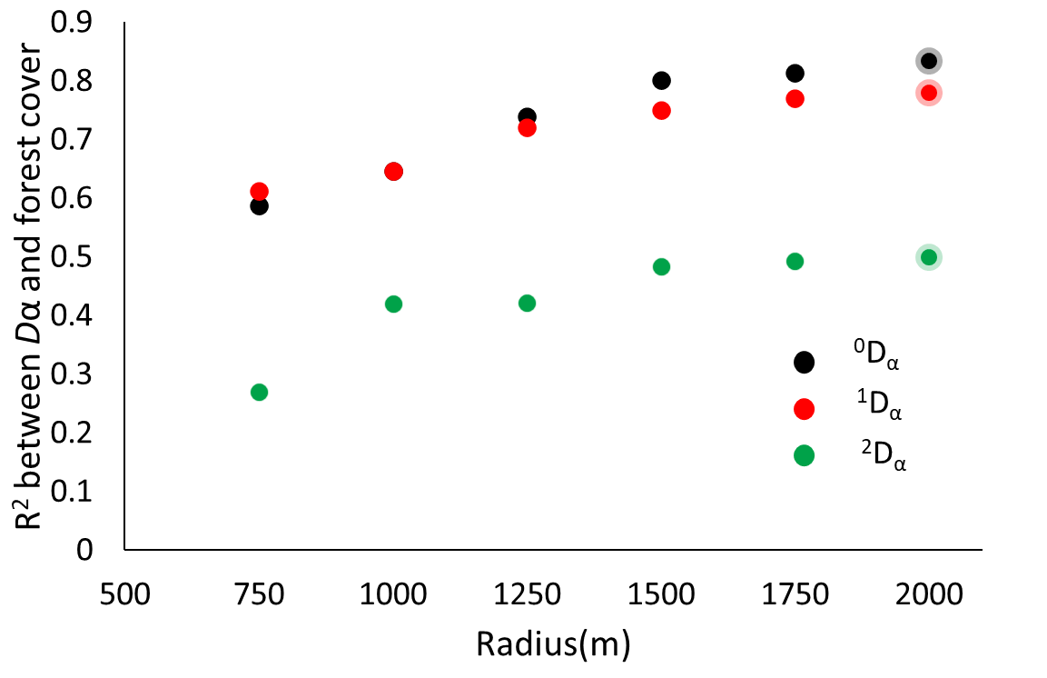
Figure S1. Multi-scale analysis bird responses to forest cover of complete assemblage to identify the scale of effect, i.e. the spatial scale that yields the strongest relationship (i.e. measured as the goodness-of-fit, R²) between bird diversity and forest cover. Species diversity is assessed with Hill numbers, considering three orders of q: 0, species richness (⁰D_{α}); 1, exponential Shannon entropy (¹D_{α}); and 2, inverse Simpson concentration (²D_{α}). The scale of effect is indicated with shaded dots.

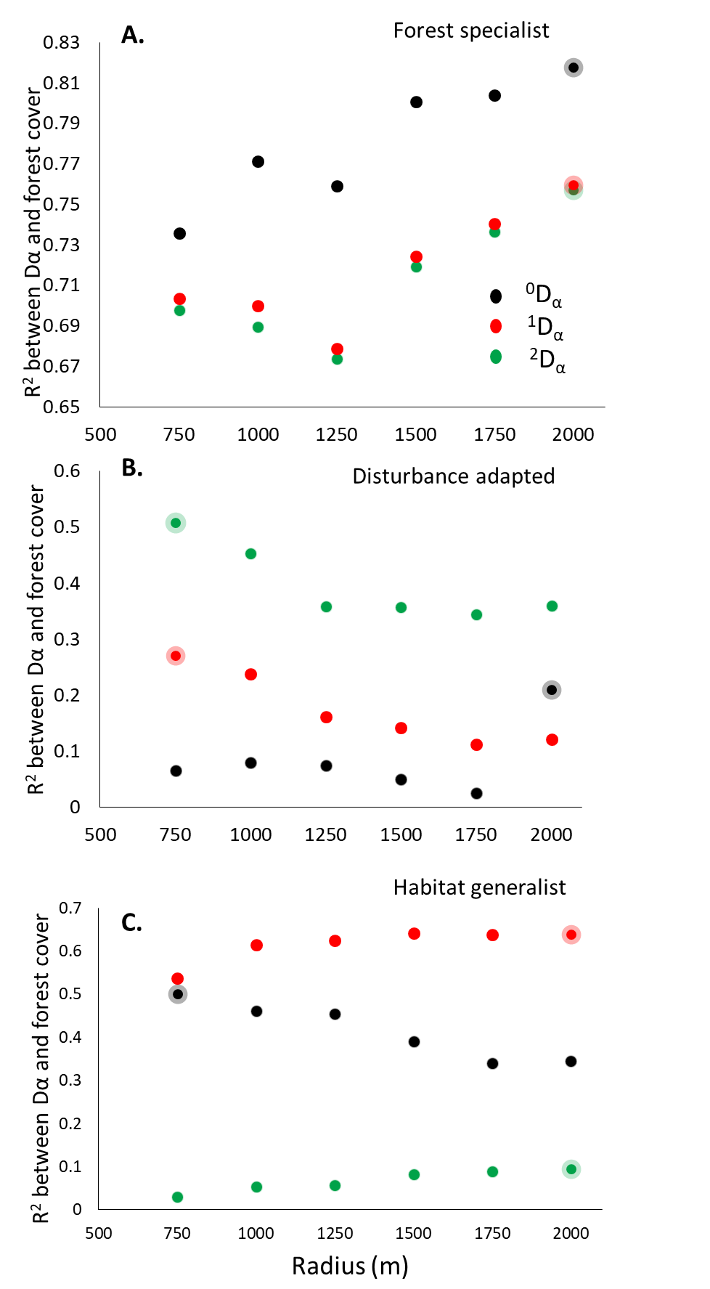
Figure S2. Multiscale analysis of bird ecological groups responses to forest cover to identify the scale of effect, i.e. the spatial scale that yields the strongest relationship (i.e. measured as the goodness-of-fit, R²) between bird diversity and forest cover. Species diversity is assessed with Hill numbers, considering three orders of q: 0, species richness (⁰D_{α}); 1, exponential Shannon entropy (¹D_{α}); and 2, inverse Simpson concentration (²D_{α}). The scale of effect is indicated with shaded dots.

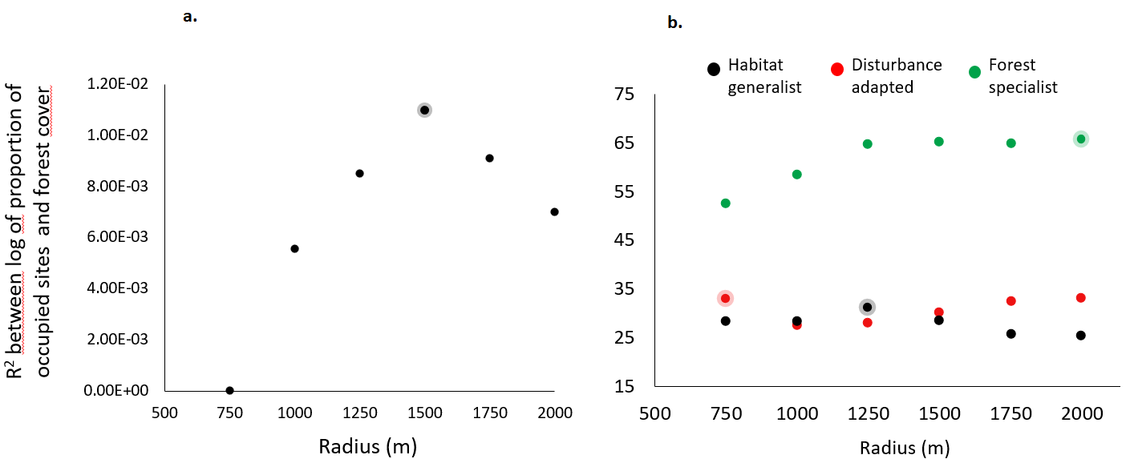
Figure S3. Multiscale analysis to identify the scale of effect, i.e. the spatial scale that yields the strongest relationship (i.e. measured as the R²) between logarithm of the proportion of occupied sites and forest cover, analyzing separately the complete assemblage (a) and ecological groups of birds: forest-specialist, disturbance-adapted and habitat-generalist birds (b). The scale of effect is indicated with shaded dots.

Table S2. ANCOVA analysis results in which was assessed the response of ecological groups of bird to forest cover. F value and P value are the statistics for the interaction between the two covariates (ecological group and forest cover).

Response variable | F value | P value | Ecological group | Slope
⁰D_{α} | 14.896 | 6.22E-05 | Forest specialist | 0.351
 |  |  | Distirbance adapted | -0.060
 |  |  | Habitat generalist | 0.031
¹D_{α} | 19.76 | 8.47E-06 | Forest specialist | 0.277
 |  |  | Distirbance adapted | -0.038
 |  |  | Habitat generalis | 0.088
²D_{α} | 3.172 | 0.0599 | Forest specialist | 0.148
 |  |  | Distirbance adapted | -0.038
 |  |  | Habitat generalist | 0.075
Ocuppied sites | 20.992 | 5.36E-06 | Forest specialist | 0.059
 |  |  | Distirbance adapted | -0.017
 |  |  | Habitat generalist | -0.020

Appendix S2. Diversity analysis considering only old-growth forests
We performed an analysis of the relationship of bird diversity and forest cover considering only old-growth forest to quantify percentage of forest cover at the landscape, to assess of influence of open forests on our previous results. We observed similar effects on bird groups when forest cover was estimated considering open and old-growth forest or only old-growth forest (Fig. S4).

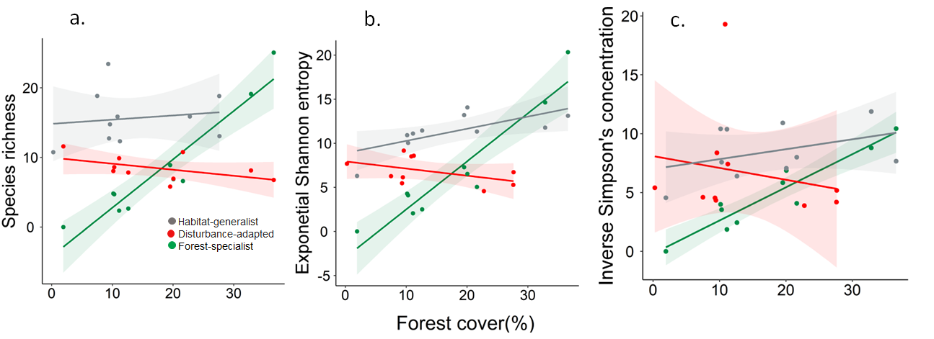
Figure S4. Response of species richness (⁰D_{γ}, A), diversity of common species (¹D_{γ}, Shannon's entropy exponential; B) and diversity of dominant species (²D_{γ}, Simpson's inverse concentration; C) of different ecological bird groups (forest-specialist birds, disturbance-adapted birds, and habitat-generalist birds) to landscape forest cover considering only old-growth forest to quantify percentage of forest cover. In all cases, we showed the accumulated alpha diversity in 16-point counts (i.e., gamma diversity per landscape). The shaded area is the 95% confidence interval of the linear models.

