Supplementary material 1. A participatory approach to map strategic areas for conservation and restoration at a regional scale

Luara Tourinho^{a,*,1}, Sara Maria de Brito Alves^{b}, Felipe Bastos Lobo da Silva^{c}, Marcio Verdi^{d,e}, Nádia Roque^{f}, Abel Augusto Conceição^{g}, Lidyanne Y.S. Aona^{h}, Guilherme de Oliveira^{i}, Alessandra Nasser Caiafa^{i}, Dary M. G. Rigueira^{b}, Tiago Jordão Porto^{c}, Ricardo Dobrovolski^{f}, Bruno Vilela^{f}

ª Programa de Pós-Graduação em Ecologia, Universidade Federal do Rio de Janeiro, Ilha do Fundão, 21941-970, Rio de Janeiro, Brazil.
^{b} Instituto do Meio Ambiente e Recursos Hídricos da Bahia - INEMA, Governo da Bahia. Avenida Luís Viana Filho, 6ª Avenida, nº 600, 41.745-900, Salvador, Bahia, Brazil.
^{c} Secretaria do Meio Ambiente - SEMA, Governo da Bahia. Avenida Luís Viana Filho, 6ª Avenida, nº 600, CAB, CEP 41.745-900, Salvador, Bahia, Brazil.
^{d} Centro Nacional de Conservação da Flora, Instituto de Pesquisa Jardim Botânico do Rio de Janeiro, Rua Pacheco Leão, 915, Jardim Botânico, 22460-030, Rio de Janeiro, Brazil.
^{e} IUCN SSC Brazil Plant Red List Authority, Rua Pacheco Leão, 915, Jardim Botânico, 22460-030, Rio de Janeiro, Brazil.
^{f} Universidade Federal da Bahia, Rua Barão de Jeremoabo, Ondina, 40171–970, Salvador, Bahia, Brazil.
^{g} Universidade Estadual de Feira de Santana, Av. Transnordestina, 44036-900, Feira de Santana, Bahia, Brazil.
^{h} Herbário do Recôncavo da Bahia. Universidade Federal do Recôncavo da Bahia, Centro de Ciências Agrárias, Ambientais e Biológicas, Rui Barbosa, 710, Centro, Cruz das Almas, Bahia, Brazil.
^{i} Universidade Federal do Recôncavo da Bahia, Centro de Ciências Agrárias, Ambientais e biológicas, Rua Rui Barbosa, 710, Centro, Cruz das Almas, Bahia, Brazil.

*Corresponding author. E-mail: loptourinho@gmail.com; Phone: +55 71 988055121
¹Current address: Instituto de Estudos Avançados, Universidade de São Paulo, R. do Anfiteatro, 513, Butantã, São Paulo, 05508-060, SP, Brazil.
Methods

The map algebra processes and analyzes were performed considering spatial data at the WGS84 projection, as most of original data were in this projection. The resulting maps are able to be reprojected to any other projection. All analyzes were developed using the software R 4.0.0 (RCoreTeam, 2020) and QGIS 3.16.9 (QGIS, 2021). The R routines used for most steps of this study are available in GitHub (https://github.com/luaratourinho/Strategic_areas_for_conservation). The data is still private, and the access must be requested if there is interest.

Detail of the PAT-CDSJ

The Territorial Action Plan for the Conservation of Endangered Species and their ecosystems in the Chapada Diamantina-Serra da Jiboia (PAT-CDSJ) is part of the Project “National Strategy for the Conservation of Endangered Species - Pro-Species: Everyone against extinction”, developed by the Ministry of the Environment of Brazil, in collaboration with partner organizations (INEMA et al., 2020). This national project aims to destinate resources to develop prevention, conservation, and management actions to minimize threats and the risk of species extinction for many states of Brazil. In the context of Bahia (BA), the Institute for the Environment and Water Resources (INEMA-BA) and Secretariat of the Environment (SEMA-BA), in partnership with federal, state, municipal public agencies, universities, and local communities elaborated the PAT-CDSJ to create directions and planning actions for the state of Bahia (INEMA et al., 2020). The PAT-CDSJ is recognized by the normative instruction INEMA No. 22.000 of December 17, 2020.
The general objective of the PAT-CDSJ is “to reduce threats to species and associated ecosystems of the Chapada Diamantina and Serra da Jiboia, integrating academia, government and society”. During the elaboration process of this document attended to the meetings representatives of state and municipal governments, non-governmental organizations, as well as local entrepreneurs and sectors related to the main threats to the regional biodiversity and its ecosystems (e.g. tourism, agriculture, use of pesticides, livestock, mining, invasive exotic species, extractivism and illegal trade in plants ornamentals, and urban expansion). This team prepared a list of actions, expected results, and proposed goals and budgets, considering a period of five years for the implementation of all actions. General and specific objectives and their deadlines are available in the planning matrix (INEMA/SEMA/WWF-Brasil, 2020). The study proposed here is part of one of the first actions of the PAT-CDSJ, which encompasses “mapping strategic areas for conservation of the target species of the project” and “identify strategic areas for environmental restoration”, as a start point.
The strategic areas will serve as a basis for many other objectives (INEMA/SEMA/WWF-Brasil, 2020; INEMA et al., 2020), for example: to (i) conduct scientific expeditions to collect botanical and zoological material to gather more information about the threatened species; (ii) conduct research on the biology, taxonomy, ecology and sustainable use of threatened species; (iii) develop an inspection plan to combat deforestation and fires; (iv) register rural properties in the strategic areas, with the objective to build connectivity corridors in legal reserves (RL) and permanently preserved areas (APP); (v) identify places for environmental restoration in strategic areas of the PAT-CDSJ, considering connectivity aspects; (vi) develop and disseminate a guide of conditions for impacting activities in the strategic areas; (vii) identify and spatialize the distribution of invasive exotic species in the strategic areas and define priority locations for management; (viii) identify the main trafficking routes of the target species, (ix) execute environmental education project aimed the sustainable tourism.

Details of the mapping criteria

We chose four criteria for SASC and five criteria for SAER because, generally, the human brain has difficulty dealing with more than seven topics simultaneously according to Information Processing Theory (Miller, 1956). The use of many criteria in the mapping could (i) generate a very complex result, hampering its interpretation; (ii) make it difficult for workshop participants to choose the criteria by consensus; and (iii) facilitate the selection of correlated and redundant criteria, potentially biasing the result. We used microbasin approach to evaluate each criterion in the Planning Units (PUs) because it is consistent with other public policies already established and can also represent a natural ecological barrier for some animal and plant species or populations (e.g. Loyola et al., 2018; Monteiro et al., 2018).
It is important to note that only PUs with caves are priority for conservation of Coarazuphium cessaima and Metagonia diamantina, and for ecological restoration for these two animal species restricted to cave habitats. Therefore, for the individual map of these two species, we placed the value zero for these PUs - however, for the other species these PUs were considered.

Details of the ‘Habitat amount’ criterion

The habitat amount (i.e. percentage of native vegetation) is a strong quality indicator for planning units (or landscape) and integrity of local communities (Banks-Leite et al., 2014; Rigueira et al., 2013). In general, the diversity is high where there is high habitat amount, while the diversity is low where there is low habitat amount. This relationship, however, is exponential, according to the extinction threshold hypothesis (Andrén, 1994). The abrupt drop in landscape quality (i.e. the extinction threshold) can be related to the resilience of populations, communities or a given ecosystem, representing a regime shift between two landscape states (before and after) (Andrén, 1994; Pardini et al., 2010). For most vertebrates, the abrupt reduction of the community integrity occurs around 30% of forest cover, while landscapes above 50% of forest cover can maintain most species of the community (Banks-Leite et al., 2014; Martensen et al., 2012). For plants were identified thresholds between 30 and 40% of the habitat amount (Benchimol et al., 2017; Lima and Mariano-Neto, 2014; Rigueira et al., 2013; Rocha-Santos et al., 2016). It is important to note that most studies that suggest extinction thresholds are related to forests.
Although part of the Territorial Action Plan for the Conservation of Endangered Species and their ecosystems in the Chapada Diamantina-Serra da Jiboia – PAT-CDSJ region occurs in the Atlantic Forest domain, most of PAT-CDSJ occurs in the Caatinga, which does not have data about extinction thresholds in the literature. Thus, during the participatory workshop, scientists and stakeholders agreed on using broad percentage ranges as weight for restoration mapping. We, then, assigned weights to planning units (PUs), as follows: PUs with 20 to 40% of vegetation cover were considered highly relevant (weight 1), PUs between 40 and 60% were considered relevant (weight between 0.8 and 0.9) and PUs out of this range (i.e. <20% and >60%) received a linear weight (decreasing and increasing, respectively) between 0 and 0.7, where the extreme percentages (0 and 100%) received weight 0. We attributed the value zero to extreme percentages and near zero to PUs <20% or >60% as PUs with low habitat amount have high restoration cost, and PUs with high habitat amount do not require restoration interventions.

Details of the ‘Environmental suitability’ criterion

Species Distribution Modeling (SDM) is a tool used to estimate the species environmental suitability (also interpreted as potential distribution or niche), correlating the species occurrence records with environmental variables (Peterson et al., 2011). The records of the occurrence of fauna species were obtained by zoologists who collaborated during workshops of the PAT-DCSJ (INEMA et al., 2020). The occurrence records of plant species were compiled from the database of the Brazilian National Centre for Plant Conservation at the Botanical Garden Research Institute of the Rio de Janeiro (CNCFlora/JBRJ), available in https://geonode.jbrj.gov.br/, a.k.a. IUCN SSC Brazil Plant Red List Authority. These records have been taxonomically reviewed and validated by a network of botanists, working in collaboration with CNCFlora/JBRJ in the assessing process of extinction risk of the Brazilian plants (see more information in Martins et al., 2017, 2018). The occurrence records of plant species that had their extinction risk assessed at the state level, were obtained from the database of the Bahia Institute for the Environment and Water Resources (Instituto do Meio Ambiente e Recursos Hídricos da Bahia, INEMA-BA), and validated by botanists involved in the elaboration of the Bahia Red List.
We also compiled occurrence records of plant species using online database (GBIF, 2021; Jabot, 2021; SpeciesLink, 2021) and considered as valid the records within the species Extension of Occurrence (EOO). For Hybanthus albus (A.St.-Hil.) Baill. – which had its known distribution expanded after the assessment of the extinction risk (Paula-Souza, 2015) and is no longer considered endemic to Brazil (Paula-Souza, 2020) – the occurrence records were validated by the specialist Dr.ª Juliana de Paula-Souza, Universidade Federal de Santa Catarina. We also added occurrence records from recently field expeditions by botanists (some coauthors of this study and collaborators) (Acritopappus harleyi R.M.King & H.Rob., Fulcaldea stuessyi Roque & V.A.Funk, Mandevilla hatschbachii M.F.Sales et al., Micranthocereus streckeri Van Heek & Van Criek., Stylotrichium glomeratum Bautista et al., Trichogoniopsis morii R.M.King & H.Rob., Vellozia canelinha Mello-Silva).
The list of target species of plants was kept original, that is, the list produced during the elaboration of the PAT-CDSJ in 2020 (INEMA et al., 2020), even after the new collections of occurrence records and IUCN assessments. This is a project associated with Brazilian government, which due to the bureaucracy involved, the frequent updating of the list is not feasible.
To reduce the dependence in our sampling, consequently, reducing the spatial bias, we removed occurrence records close to each other less than 1 km (i.e., using the same resolution of the environmental variables used in the ENM), using the package ‘spThin’ in R (Aiello-Lammens et al., 2015). In addition, we removed duplicate coordinates and coordinates outside the species distribution area, for example, coordinates at sea, and centroid of capitals and countries, which often coincide with urban areas, class of land-use that the CR-gap species do not occur . The list of filtered occurrence records is available in the Supplementary Material 3.
Environmental variables normally show high collinearity and to reduce it we applied a Principal Component Analysis (PCA). This analysis is a multivariate technique that converts a set of correlated variables into a smaller set of values of uncorrelated variables (the principal components). “The major advantages of this procedure are the correction of multicollinearity among the original variables, the use of almost all information contained in a large dataset that is captured in the PCs, and the reduction of the number of variables used in the models” (Velazco et al., 2017). Thus, the models were built with the first six axes of the PCs that explained most of the total variance (> 90%) (Table S8, Fig. S9 e S10).
Considering that there are several modeling methods (or algorithms) and that each one generates different predictions of geographic distribution (Diniz-Filho et al., 2009; Elith and Graham, 2009), we used five algorithms. Each algorithm requires a different amount of (pseudo)absence and background (Barbet-Massin et al., 2012; Lobo and Tognelli, 2011). Bioclim requires only presence data (occurrence records); Maximum Entropy (MaxEnt) requires presence data and background; Generalized Linear Model (GLM), Random Forest (RF) and Support Vector Machine (SVM) requires presence data and pseudoabsence. For MaxEnt we generated 10,000 background; for RF and SVM, we generated a number of pseudoabsence equal to presences, per species; and for GLM, we generated a number of pseudoabsence equal to presences times 10 (adapted from Barbet-Massin et al., 2012). We generated model calibration area using a buffer by considering the mean distance among the occurrence records, to incorporate possible accessible areas for the species (adapted from Barve et al., 2011; Sánchez-Tapia et al., 2020).
We evaluated the models generated with more than 20 occurrence records using the cross-validation test, with 10 partitions and the models generated with 10 to 19 records using the bootstrap test, with a proportion of 90% for training and 10% for test (Pearson et al., 2007; Shcheglovitova and Anderson, 2013). We generated the consensus model of the algorithms from the average weighted by the True Skill Statistic (TSS) (Allouche et al., 2006; Hao et al., 2019). We performed all SDM analyzes using the package ‘modleR’ in R (Sánchez-Tapia et al., 2020).
A species can be considered rare when: (i) it has a restricted geographic distribution, usually (micro)endemic species; (ii) it has low abundance, with sparse populations, therefore, difficult to detect; and (iii) it was not sufficiently collected, which may occur with cryptic and/or very small species (Kunin and Gaston, 1997). For rare species with few occurrence records (as is the case of most species of the PAT-CDSJ) the use of the algorithms listed before is ineffective and generates models with low accuracy (Stockwell and Peterson, 2002; Wisz et al., 2008), instead, a widely used algorithm is the Euclidean Distance (ED). For ED, we considered the environmental mean distance method (Siqueira et al., 2009; Vilela et al., 2018). The ED estimates areas with environmental conditions similar to occurrence records, rather than environmental suitability (or potential distribution of species) as the other used algorithms do (Siqueira et al., 2009). However, to be intuitive, we adopted the term ‘environmental suitability’ in general across the main text.

Delimitating and giving names for strategic areas

For delimiting and giving names for strategic areas, we attended two meetings. Most of the participants were members of regional government institutions (e.g. INEMA and SEMA, from the city of Salvador, capital of the state of Bahia) that have been working in the area for a long time, scientists from universities in the state and regions close to or within the limits of the PAT-CDSJ, and managers of protected areas located close to the limits of the PAT-CDSJ (Table S2). Participants delimited the strategic areas according to their knowledge of the socio-environmental characteristics of the region, aggregating the PUs in a strategic area considering: (i) how much the PUs are within a municipality, (ii) the distance among PUs, and (iii) which PU could be placed together into a strategic area aiming to facilitate decision-making on the next actions related to the PAT-CDSJ, based on previous experiences dealing with members of the local government.
Next, strategic areas were named considering local and intuitive characteristics and, when no outstanding characteristics were highlighted, the area assumed the name of the predominant municipalities. For example, “Chapada Central” (i.e. Central Plateau) received this name as the PUs which compose this strategic area are located in the central part of the Chapada Diamantina. The strategic area “Sincorá” received this name as encompass the Serra do Sincorá, a mountain range. “Jiboia Leste” (i.e. East Jiboia) received this name as the PUs which compose this strategic area are located east of this mountain range. The strategic areas with the name of municipalities, such as “Lençóis” has the PUs situated mostly in the municipality Lençóis, and the one named with more the one name of municipalities, such as “Piatã, Rio de Contas”, has the PUs situated mostly in these municipalities highlighted.
After the first meeting that the participants suggested the limits of the strategic areas and their names, they shared the suggestions with other people, who work in other actions of the PAT-CDSJ or even who do not work in the PAT-CDSJ project, but have experience in the region (e.g. other members of INEMA and SEMA). In the second meeting, the participants brought the opinions from the other people they consulted, and finally decided the limits and names of the strategic areas for conservation and restoration.
Table S1. Target species of the Territorial Action Plan for the Conservation of Endangered Species in the Chapada Diamantina-Serra da Jiboia (i.e. Critically endangered and not covered by protection instruments, CR-Gap) and geographic scale in which they were evaluated (IUCN, 2022; MMA, 2014a, 2014b; SEMA, 2017a, 2017b). NA = species not assessed, CR = Critically Endangered, EN = Endangered, VU = Vulnerable. From this list, 24 species are included in the official national and/or state lists of endangered flora (MMA, 2014a; SEMA, 2017a), in the global Redlist (IUCN, 2022), or had their conservation status evaluated by the Centro Nacional de Conservação da Flora do Instituto de Pesquisas Jardim Botânico do Rio de Janeiro (CNCFlora/JBRJ), and three species are in the official national and state lists of endangered fauna (MMA, 2014b; SEMA, 2017b). We considered the highest risk category, considering the state, national, and global assessment, in this order.
Group | Family | Species | Conservation Status
 |  |  | State | National | Global
Fauna/ Araneae | Theraphosidae | Avicularia gamba (Bertani & Fukushima, 2009)* | CR | CR | NA
Fauna/ Coleoptera | Carabidae | Coarazuphium cessaima Gnaspini, Vanin & Godoy 1998 | VU | CR | NA
Fauna/ Araneae | Pholcidae | Metagonia diamantina Machado, Ferreira & Brescovit, 2011 | NA | CR | NA
Flora | Apocynaceae | Mandevilla hatschbachii M.F.Sales et al. | CR | NA | NA
Flora | Aquifoliaceae | Ilex auricula S.Andrews | CR | CR | NA
Flora | Asteraceae | Acritopappus harleyi R.M.King & H.Rob. | VU | CR** | CR
Flora | Asteraceae | Acritopappus pintoi Bautista & D.J.N.Hind | CR | CR | EN
Flora | Asteraceae | Fulcaldea stuessyi Roque & V.A.Funk | VU | CR** | NA
Flora | Asteraceae | Stylotrichium glomeratum Bautista et al. | CR | CR | NA
Flora | Asteraceae | Trichogoniopsis morii R.M.King & H.Rob. | CR | NA | NA
Flora | Cactaceae | Micranthocereus streckeri Van Heek & Van Criek | CR | CR | CR
Flora | Fabaceae | Bauhinia glaziovii Taub. | NA | CR** | CR
Flora | Fabaceae | Ormosia timboensis D.B.O.S.Cardoso, Meireles & H.C.Lima | NA | CR** | CR
Flora | Fabaceae | Senegalia ricoae (Bocage & Miotto) L.P.Queiroz | VU | CR** | CR
Flora | Gesneriaceae | Sinningia macrophylla (Nees & Mart.) Benth. & Hook. ex Fritsch | CR | NA | NA
Flora | Lamiaceae | Oocephalus nubicola (Harley) Harley & J.F.B.Pastore | CR | NA | NA
Flora | Malvaceae | Helicteres rufipila Cristóbal | CR | NA | NA
Flora | Malvaceae | Melochia illicioides K.Schum. | CR | NA | NA
Flora | Malvaceae | Pavonia palmeirensis Krapov. | CR | NA | NA
Flora | Malvaceae | Rayleya bahiensis Cristóbal | CR | NA | NA
Flora | Melastomataceae | Microlicia subalata Wurdack | CR | CR** | NA
Flora | Passifloraceae | Passiflora timböensis T.S.Nunes & L.P.Queiroz | CR | NA | NA
Flora | Plantaginaceae | Philcoxia bahiensis V.C.Souza & Harley | CR | NA | NA
Flora | Turneraceae | Piriqueta flammea (Suess.) Arbo | CR | NA | NA
Flora | Velloziaceae | Vellozia canelinha Mello-Silva | CR | CR | NA
Flora | Violaceae | Hybanthus albus (A.St.-Hil.) Baill. | NA | CR | NA
Flora | Xyridaceae | Xyris fibrosa Kral & Wand. | CR | CR | NA
* Synonym: Ybyrapora gamba (Bertani & Fukushima, 2009).
** Classification attributed by CNCFlora/JBRJ, Brazilian authority in assessing the risk of extinction of flora and IUCN SSC Brazil Plant Red List Authority.
Table S2. List of workshop participants, their institutions and category.
Participants | Institutions | Category
Abel Augusto Conceição | Universidade Estadual de Feira de Santana - UEFS | Scientist
Alessandra Nasser Caiafa | Universidade Federal do Recôncavo da Bahia - UFRB | Scientist
Anna Carolina Ramalho Lins | World Wide Fund for Nature of Brazil - WWF-BR | Stakeholder
Bruno Vilela | Universidade Federal da Bahia - UFBA | Scientist
Carlos A. F. Júnior | Instituto do Meio Ambiente e Recursos Hídricos da Bahia - INEMA | Geoprocessing technician
Cezar Gonçalves | Instituto Chico Mendes de Conservação da Biodiversidade (ICMBio) | Scientist
Cristiana Sousa Vieira | Secretaria de Ciência, Tecnologia e Inovação - SECTI | Stakeholder
Daiane Maria Pires e Silva | Instituto do Meio Ambiente e Recursos Hídricos da Bahia - INEMA | Stakeholder
Danielle Vilar | Nascentes do Paraguaçu Non-governmental Organization (NGO) | Stakeholder
Dary Rigueira | Instituto do Meio Ambiente e Recursos Hídricos da Bahia - INEMA | Stakeholder
Diogo Caribe de Sousa | Instituto do Meio Ambiente e Recursos Hídricos da Bahia - INEMA | Stakeholder
Felipe Bastos Lobo da Silva | Secretaria do Meio Ambiente da Bahia - SEMA | Decision-maker
Guilherme Oliveira | Universidade Federal do Recôncavo da Bahia - UFRB | Scientist
Maria Lenise Silva Guedes | Universidade Federal da Bahia - UFBA | Scientist
Liana Oliveira Duarte de Araujo | Secretaria do Meio Ambiente da Bahia - SEMA | Stakeholder
Lidyanne Aona | Universidade Federal do Recôncavo da Bahia - UFRB | Scientist
Luara Tourinho | Universidade Federal do Rio de Janeiro - UFRJ | Scientist
Mara Angelica dos Santos | Instituto do Meio Ambiente e Recursos Hídricos da Bahia - INEMA | Stakeholder
Marcelo Peres | Instituto do Meio Ambiente e Recursos Hídricos da Bahia - INEMA/ Universidade Católica de Salvador - UCsal | Stakeholder
Marcio Verdi | Centro Nacional de Conservação da Flora do Instituto de Pesquisa Jardim Botânico do Rio de Janeiro - CNCFlora/JBRJ | Scientist
Marcos Fantini | Toca do Lobo Non-governmental Organization (NGO) | Stakeholder
Matheus Andrade | Reserva Particular do Patrimônio Natural (RPPN) Guariru/ Castro Alves/BA | Stakeholder
Nádia Roque | Universidade Federal da Bahia - UFBA | Scientist
Natali Lordello de Oliveira | Instituto do Meio Ambiente e Recursos Hídricos da Bahia - INEMA | Stakeholder
Ricardo Dobrovolski | Universidade Federal da Bahia - UFBA | Scientist
Rosane Oliveira Barreto | Instituto do Meio Ambiente e Recursos Hídricos da Bahia - INEMA | Stakeholder
Sara Maria de Brito Alves | Instituto do Meio Ambiente e Recursos Hídricos da Bahia - INEMA | Decision-maker
Tiago Jordão Porto | Secretaria do Meio Ambiente da Bahia - SEMA | Stakeholder
Vitoria Souza dos Santos | Instituto do Meio Ambiente e Recursos Hídricos da Bahia - INEMA | Stakeholder
Table S3. Pre-selected environmental variables (before applying the PCA) from different databases (sources). Variable legends used in the Fig. S10.
Variables | Sources * | Variable legends
Annual Mean Temperature | Chelsa (Fischer et al., 2008) | Bio 1
Mean Diurnal Range | Chelsa (Fischer et al., 2008) | Bio 2
Isothermality | Chelsa (Fischer et al., 2008) | Bio 3
Temperature Seasonality | Chelsa (Fischer et al., 2008) | Bio 4
Max Temperature of Warmest Month | Chelsa (Fischer et al., 2008) | Bio 5
Min Temperature of Coldest Month | Chelsa (Fischer et al., 2008) | Bio 6
Temperature Annual Range | Chelsa (Fischer et al., 2008) | Bio 7
Mean Temperature of Wettest Quarter | Chelsa (Fischer et al., 2008) | Bio 8
Mean Temperature of Driest Quarter | Chelsa (Fischer et al., 2008) | Bio 9
Mean Temperature of Warmest Quarter | Chelsa (Fischer et al., 2008) | Bio 10
Mean Temperature of Coldest Quarter | Chelsa (Fischer et al., 2008) | Bio 11
Annual Precipitation | Chelsa (Karger et al., 2017) | Bio 12
Precipitation of Wettest Month | Chelsa (Karger et al., 2017) | Bio 13
Precipitation of Driest Month | Chelsa (Karger et al., 2017) | Bio 14
Precipitation Seasonality | Chelsa (Karger et al., 2017) | Bio 15
Precipitation of Wettest Quarter | Chelsa (Karger et al., 2017) | Bio 16
Precipitation of Driest Quarter | Chelsa (Karger et al., 2017) | Bio 17
Precipitation of Warmest Quarter | Chelsa (Karger et al., 2017) | Bio 18
Precipitation of Coldest Quarter | Chelsa (Karger et al., 2017) | Bio 19
Elevation | Worldclim (Fick e Hijmans, 2017) | Bio 20
Nutrient availability | FAO (Fischer et al., 2008) | Bio 21
Nutrient retention capacity | FAO (Fischer et al., 2008) | Bio 22
Rooting conditions | FAO (Fischer et al., 2008) | Bio 23
Workability | FAO (Fischer et al., 2008) | Bio 24
* Data available for download at:
Chelsa (Karger et al., 2017): < https://chelsa-climate.org/>
Worldclim (Fick e Hijmans, 2017): < https://www.worldclim.org/>
FAO (Fischer et al., 2008): <http://www.fao.org/soils-portal/data-hub/soil-maps-and-databases/harmonized-world-soil-database-v12/en/> ; <http://webarchive.iiasa.ac.at/Research/LUC/External-World-soil-database/HTML/SoilQuality.html>

Table S4. Fundamental scale of Saaty (1977), considering the importance between the pairs of criteria, in which, for example, when a criterion has equal relevance in relation to another, the pair receives the value 1, and when it is much more relevant in relation to its pair, it receives the value 9.
Weight | Importance
1 | Equal importance
3 | Little importance of one to the other
5 | Great or essential importance
7 | Very high or demonstrated importance
9 | Absolute importance
2,4,5,8 | Intermediate values

Table S5. Strategic Areas for Species Conservation (SASC), approximate area and perimeter for each SASC and municipalities where the SASC occur.
SASC | Area (km²) | Perimeter (km) | Municipalities
Piatã, Rio de Contas | 3944 | 548 | Abaíra
 |  |  | Érico Cardoso
 |  |  | Boninal
 |  |  | Caturama
 |  |  | Dom Basílio
 |  |  | Jussiape
 |  |  | Livramento de Nossa Senhora
 |  |  | Mucugê
 |  |  | Novo Horizonte
 |  |  | Paramirim
 |  |  | Piatã
 |  |  | Rio de Contas
 |  |  | Rio do Pires
Chapada Central | 417 | 131 | Mucugê
 |  |  | Palmeiras
 |  |  | Seabra
Sincorá | 3229 | 365 | Barra da Estiva
 |  |  | Contendas do Sincorá
 |  |  | Ibicoara
 |  |  | Iramaia
 |  |  | Itaeté
 |  |  | Ituaçu
 |  |  | Jussiape
 |  |  | Mucugê
 |  |  | Tanhaçu
Ibiquera, Nova Redenção, Andaraí | 458 | 103 | Andaraí
 |  |  | Ibiquera
 |  |  | Nova Redenção
Itaeté | 1042 | 262 | Andaraí
 |  |  | Ibicoara
 |  |  | Iramaia
 |  |  | Itaeté
 |  |  | Mucugê
Jiboia Leste | 1060 | 197 | Amargosa
 |  |  | Brejões
 |  |  | Castro Alves
 |  |  | Conceição do Almeida
 |  |  | Elísio Medrado
 |  |  | Itatim
 |  |  | Milagres
 |  |  | Santa Terezinha
 |  |  | São Miguel das Matas
 |  |  | Varzedo
Lençóis | 751 | 175 | Andaraí
 |  |  | Iraquara
 |  |  | Lençóis
Macaúbas | 99 | 49 | Brotas de Macaúbas
 |  |  | Ibitiara
 |  |  | Seabra
Mucugê | 292 | 91 | Mucugê
Nova Itarana | 62 | 43 | Nova Itarana
Seabra | 2119 | 266 | Barra do Mendes
 |  |  | Boninal
 |  |  | Brotas de Macaúbas
 |  |  | Ibitiara
 |  |  | Iraquara
 |  |  | Seabra

Table S6. Strategic Areas for Ecosystem Restoration (SAER), approximate area and perimeter for each SAER and municipalities where the SAER occur.
SAER | Area (km²) | Perimeter (km) | Municipalities
Boa Vista do Tupim | 669 | 186 | Boa Vista do Tupim
 |  |  | Ibiquera
 |  |  | Ruy Barbosa
Lençóis, Andaraí, Itaetê | 921 | 323 | Andaraí
 |  |  | Ibiquera
 |  |  | Itaeté
 |  |  | Lençóis
 |  |  | Mucugê
 |  |  | Nova Redenção
Iraquara | 283 | 120 | Iraquara
 |  |  | Seabra
Jiboia Leste | 1230 | 217 | Amargosa
 |  |  | Brejões
 |  |  | Castro Alves
 |  |  | Conceição do Almeida
 |  |  | Elísio Medrado
 |  |  | Itatim
 |  |  | Milagres
 |  |  | Nova Itarana
 |  |  | Santa Terezinha
 |  |  | São Miguel das Matas
 |  |  | Varzedo
Mucugê | 897 | 210 | Ibicoara
 |  |  | Mucugê
 |  |  | Piatã
Nova Itarana | 62 | 43 | Nova Itarana
Chapada Central | 1541 | 246 | Boninal
 |  |  | Mucugê
 |  |  | Palmeiras
 |  |  | Piatã
 |  |  | Seabra
Piatã | 1569 | 310 | Abaíra
 |  |  | Jussiape
 |  |  | Mucugê
 |  |  | Novo Horizonte
 |  |  | Piatã
 |  |  | Rio de Contas
 |  |  | Rio do Pires
Marcionílio, Planaltino | 147 | 94 | Boa Vista do Tupim
 |  |  | Iaçu
 |  |  | Marcionílio Souza
 |  |  | Nova Itarana
 |  |  | Planaltino
Rio de Contas | 2475 | 363 | Érico Cardoso
 |  |  | Barra da Estiva
 |  |  | Caturama
 |  |  | Dom Basílio
 |  |  | Ibicoara
 |  |  | Ituaçu
 |  |  | Jussiape
 |  |  | Livramento de Nossa Senhora
 |  |  | Mucugê
 |  |  | Paramirim
 |  |  | Rio de Contas
 |  |  | Rio do Pires
Seabra | 2391 | 332 | Barra do Mendes
 |  |  | Boninal
 |  |  | Brotas de Macaúbas
 |  |  | Ibitiara
 |  |  | Iraquara
 |  |  | Novo Horizonte
 |  |  | Seabra
Sincorá | 2696 | 340 | Barra da Estiva
 |  |  | Contendas do Sincorá
 |  |  | Ibicoara
 |  |  | Iramaia
 |  |  | Ituaçu
 |  |  | Jussiape
 |  |  | Mucugê
 |  |  | Tanhaçu

Table S7. Number of occurrence records by species. The list with the geographical coordinates is in the Supplementary Material 3.
Species | Number of occurrence records
Acritopappus harleyi | 4
Acritopappus pintoi | 6
Avicularia gamba | 1
Bauhinia glaziovii | 3
Coarazuphium cessaima | 1
Fulcaldea stuessyi | 2
Hybanthus albus | 22
Ilex auricula | 6
Metagonia diamantina | 1
Micranthocereus streckeri | 1
Ormosia timboensis | 2
Senegalia ricoae | 2
Stylotrichium glomeratum | 3
Vellozia canelinha | 6
Xyris fibrosa | 1
Helicteres rufipila | 2
Mandevilla hatschbachii | 5
Melochia illicioides | 6
Microlicia subalata | 3
Oocephalus nubicola | 24
Passiflora timboensis | 3
Pavonia palmeirensis | 1
Philcoxia bahiensis | 10
Piriqueta flammea | 14
Rayleya bahiensis | 4
Sinningia macrophylla | 4
Trichogoniopsis morii | 7

Table S8. The selection of the principal components of the PCA, their standard deviation, eigenvalues (scores) and cumulative explained variance for each set of variables
Principal Component Importance (PC) | PC1 | PC2 | PC3 | PC4 | PC5 | PC6
Standard deviation | 3.2549 | 2.1817 | 1.6665 | 1.2711 | 1.0893 | 1.0118
Eigenvalues | 0.4414 | 0.1983 | 0.1157 | 0.0673 | 0.0494 | 0.0427
Cumulative explained variance | 0.4414 | 0.6398 | 0.7555 | 0.8228 | 0.8722 | 0.9149

Fig. S1. Classification of phytophysiognomy along the PAT-CDSJ. In total, the PAT-CDSJ has 17 phytophysiognomy classes, in which 15 PUs has100% of the anthropized areas. The legend provides an approximated English translation and the Brazilian original names of the phytophysiognomies.
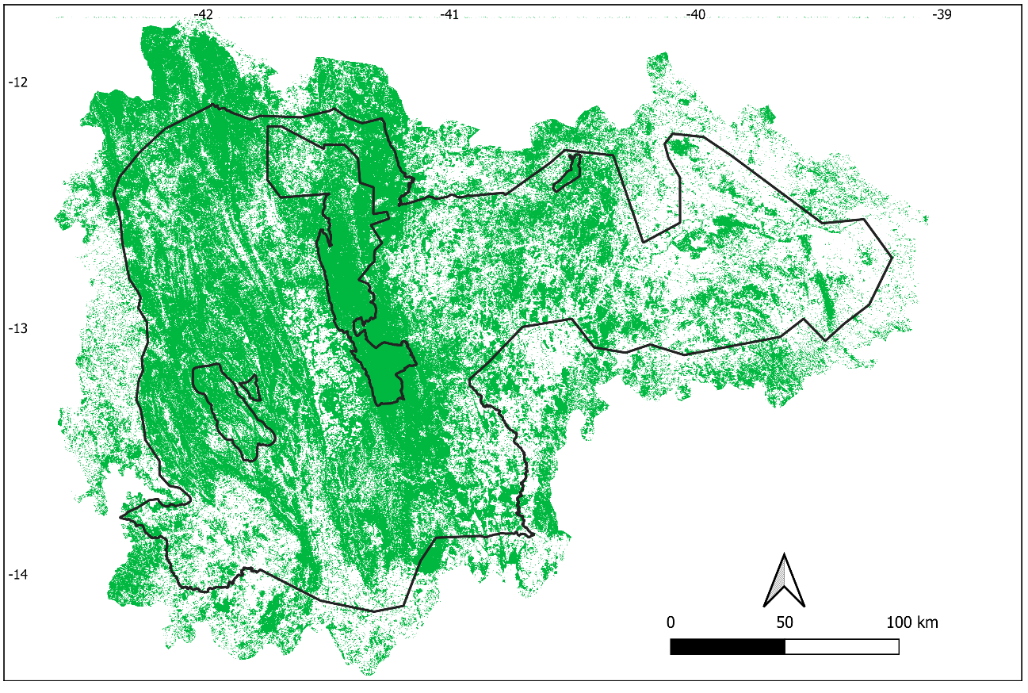
Fig. S2. Remaining of native vegetation (green) within the PAT-CDSJ (delimited by the external black contour) and the adjacent vegetation. The small polygons within the limits of the PAT-CDSJ are protected areas, that are not part of the PAT-CDSJ territory.
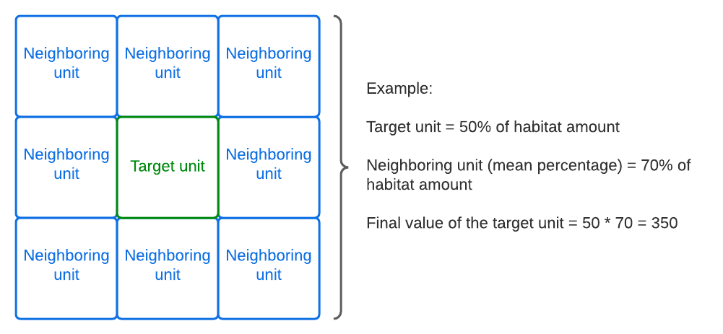
Fig. S3. An example of the final procedure adopted to calculate the ‘Habitat amount’ criterion, considering the neighboring weight. It is important to note that the final net of PU was normalized between 0 to 1. See the result of maps in the Fig. S11.
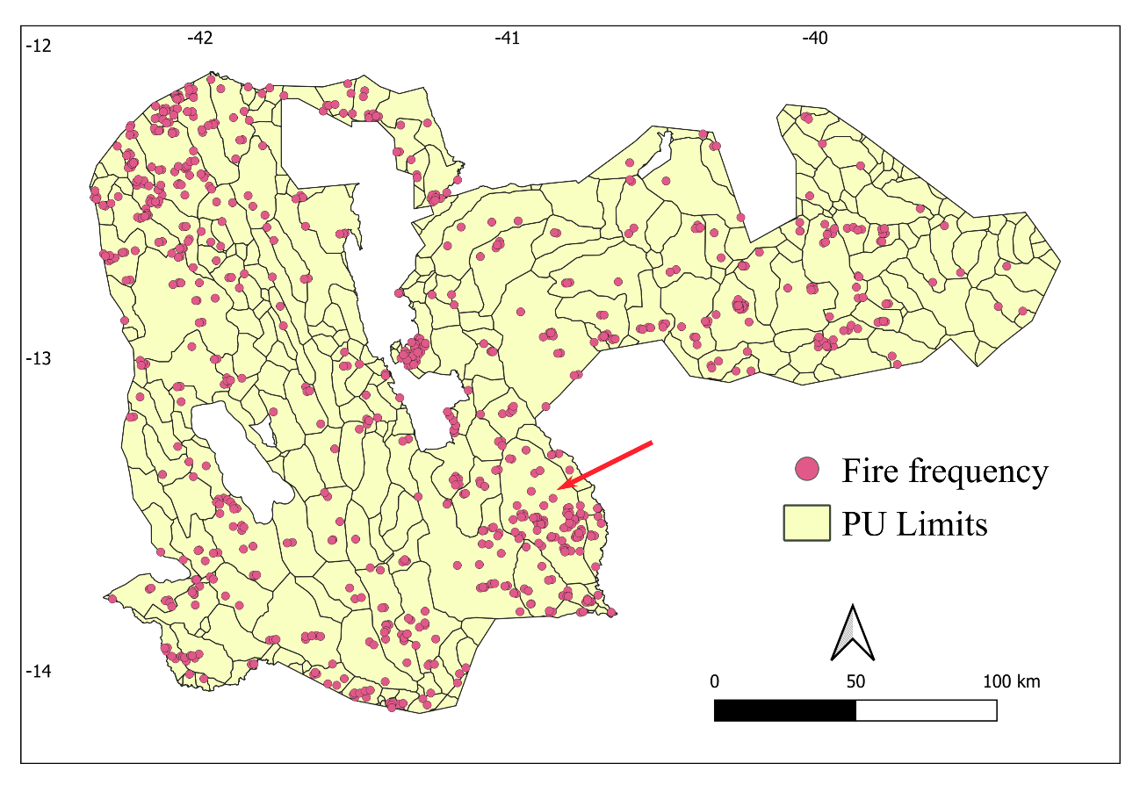
Fig. S4. Fire frequency accumulated between the years 2017 and 2020 (719 in total), over the PU net along the PAT-CDSJ. Of the 314 PUs, 158 had no fire frequency and one PU had 68 fire frequency (maximum value, red arrow).
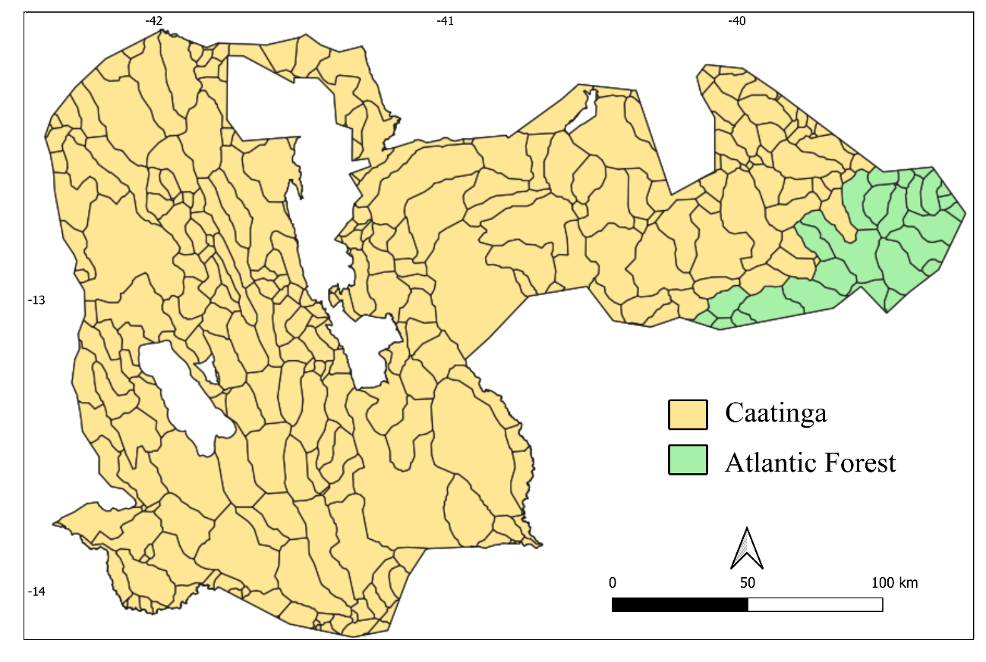
Fig. S5. The two Brazilian domains: Caatinga and Atlantic Forest domain, over the planning unit net (PUs).
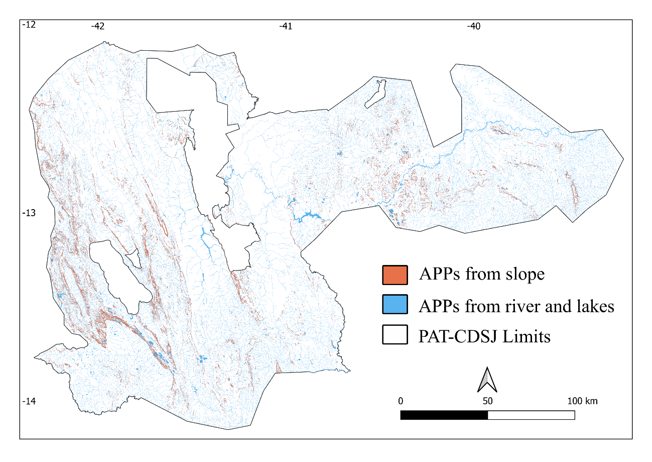
Fig. S6. Permanently Preserved Areas (APP, Brazilian acronym) proxy in the PAT-CDSJ Limits.
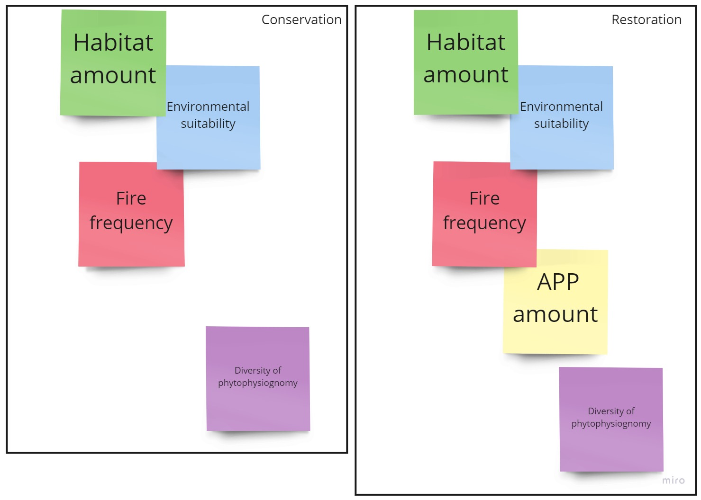
Fig. S7. Panels exposed during the first construction workshop, with the order of relevance of criteria (colored squares) for mapping strategic areas for conservation (left panel) and restoration (right panel) of the PAT-CDSJ.
Fig. S8. Species occurrence records inside of the PAT-CDSJ limits. The 33 planning units (PUs, based on level 6 microbasins) that have occurrence records are highlighted.
Fig. S9. Percentage of variance of each Principal Component Analysis - PCA dimensions (i.e. axes).
Fig. S10. The relationships of the original variables based on the first two Principal Components - PCs (dimensions: Dim 1 and Dim 2 and their percentage of variance). Bio 1 to 19 refer to bioclimatic variables, Bio 20 refers to elevation and Bio 21 to 24 refer to soil quality variables. See the variable legends in Table S3.
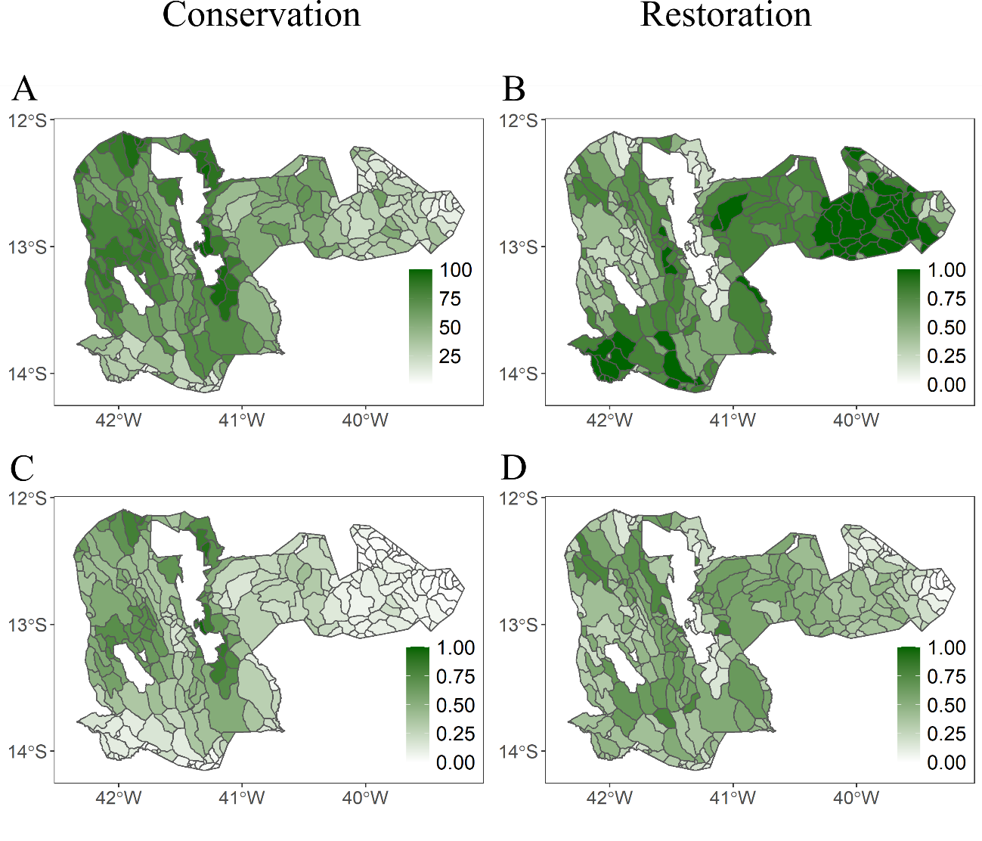
Fig. S11. Steps for ‘Habitat amount’ criterion elaboration for conservation (A and C) and restoration (B and D) mapping. For each PU, habitat amount (i.e. percentage of native vegetation cover), ranging from 0 to 100% (A). Habitat amount after extinction threshold weight (B). Habitat amount results, based on the habitat amount of the target PU multiplied by the average of habitat amount of the neighboring PUs, for use in conservation (C) and restoration (D) mapping.
References
Aiello-Lammens, M.E., Boria, R.A., Radosavljevic, A., Vilela, B., Anderson, R.P., 2015. spThin: An R package for spatial thinning of species occurrence records for use in ecological niche models. Ecography (Cop.). 38, 541–545. https://doi.org/10.1111/ecog.01132
Allouche, O., Tsoar, A., Kadmon, R., 2006. Assessing the accuracy of species distribution models: Prevalence, kappa and the true skill statistic (TSS). J. Appl. Ecol. 43, 1223–1232. https://doi.org/10.1111/j.1365-2664.2006.01214.x
Andrén, H., 1994. Effects of Habitat Fragmentation on Birds and Mammals in Landscapes with Different Proportions of Suitable Habitat: A Review. Oikos 71, 355. https://doi.org/10.2307/3545823
Banks-Leite, C., Pardini, R., Tambosi, L.R., Pearse, W.D., Bueno, A.A., Bruscagin, R.T., Condez, T.H., Dixo, M., Igari, A.T., Martensen, A.C., Metzger, J.P., 2014. Using ecological thresholds to evaluate the costs and benefits of set-asides in a biodiversity hotspot. Science (80-. ). 345, 1041–1045. https://doi.org/10.1126/science.1255768
Barbet-Massin, M., Jiguet, F., Albert, C.H., Thuiller, W., 2012. Selecting pseudo-absences for species distribution models: How, where and how many? Methods Ecol. Evol. 3, 327–338. https://doi.org/10.1111/j.2041-210X.2011.00172.x
Barve, N., Barve, V., Jiménez-Valverde, A., Lira-Noriega, A., Maher, S.P., Peterson, A.T., Soberón, J., Villalobos, F., 2011. The crucial role of the accessible area in ecological niche modeling and species distribution modeling. Ecol. Modell. 222, 1810–1819. https://doi.org/10.1016/j.ecolmodel.2011.02.011
Benchimol, M., Talora, D.C., Mariano-Neto, E., Oliveira, T.L.S., Leal, A., Mielke, M.S., Faria, D., 2017. Losing our palms: The influence of landscape-scale deforestation on Arecaceae diversity in the Atlantic forest. For. Ecol. Manage. 384, 314–322. https://doi.org/10.1016/j.foreco.2016.11.014
Diniz-Filho, J.A.F., Mauricio Bini, L., Fernando Rangel, T., Loyola, R.D., Hof, C., Nogués-Bravo, D., Araújo, M.B., 2009. Partitioning and mapping uncertainties in ensembles of forecasts of species turnover under climate change. Ecography (Cop.). 32, 897–906. https://doi.org/10.1111/j.1600-0587.2009.06196.x
Elith, J., Graham, C.H., 2009. Do they? How do they? WHY do they differ? On finding reasons for differing performances of species distribution models. Ecography (Cop.). 32, 66–77. https://doi.org/10.1111/j.1600-0587.2008.05505.x
GBIF, 2021. Global Biodiversity Information Facility - GBIF Occurrence Download [WWW Document]. URL https://www.gbif.org/ (accessed 12.17.20).
Hao, T., Elith, J., Guillera-Arroita, G., Lahoz-Monfort, J.J., 2019. A review of evidence about use and performance of species distribution modelling ensembles like BIOMOD. Divers. Distrib. 25, 839–852. https://doi.org/10.1111/ddi.12892
INEMA/SEMA/WWF-Brasil, 2020. Matriz de Planejamento do Plano de Ação Chapada Diamantina - Serra da Jiboia [WWW Document]. URL http://www.inema.ba.gov.br/plano-de-acao-territorial-pat-chapada-diamantina-serra-da-jiboia/ (accessed 7.21.21).
INEMA, SEMA, WWF-Brasil, CNCFlora, JBRJ, PRF, ICMBIO, UFBA, UCSal, UFRB, UEFS, INP, Gambá, 2020. Plano de Ação Territorial para a Conservação de Espécies Ameaçadas do Território Chapada Diamantina-Serra da Jiboia - Sumário Executivo.
IUCN, 2022. The IUCN Red List of Threatened Species. Version 2021-1. [WWW Document]. https://doi.org/ISSN 2307-8235
Jabot, 2021. Sistema de gerenciamento de coleções científicas [WWW Document]. Jard. Botânico do Rio Janeiro. URL http://jabot.jbrj.gov.br/ (accessed 9.30.21).
Kunin, W.E., Gaston, K.J., 1997. The Biology of Rarity - causes and consequences of rare-common differences, First. ed. Springer Science, UK. https://doi.org/10.1007/978-94-011-5874-9
Lima, M.M., Mariano-Neto, E., 2014. Extinction thresholds for Sapotaceae due to forest cover in Atlantic Forest landscapes. For. Ecol. Manage. 312, 260–270. https://doi.org/10.1016/j.foreco.2013.09.003
Lobo, J.M., Tognelli, M.F., 2011. Exploring the effects of quantity and location of pseudo-absences and sampling biases on the performance of distribution models with limited point occurrence data. J. Nat. Conserv. 19, 1–7. https://doi.org/10.1016/j.jnc.2010.03.002
Loyola, R., Machado, N., Ribeiro, B.R., Martins, E., Martinelli, G., 2018. Áreas prioritárias para conservação da flora endêmica do estado do Rio de Janeiro, 1st ed. I Graficci Programação Visual, Rio de Janeiro.
Martensen, A.C., Ribeiro, M.C., Banks-Leite, C., Prado, P.I., Metzger, J.P., 2012. Associations of Forest Cover, Fragment Area, and Connectivity with Neotropical Understory Bird Species Richness and Abundance. Conserv. Biol. 26, 1100–1111. https://doi.org/10.1111/j.1523-1739.2012.01940.x
Martins, E., Loyola, R., Martinelli, G., 2017. Challenges and Perspectives for Achieving the Global Strategy for Plant Conservation Targets in Brazil. Ann. Missouri Bot. Gard. 102, 347–356. https://doi.org/10.3417/D-16-00009A
Martins, E., Martinelli, G., Loyola, R., 2018. Brazilian efforts towards achieving a comprehensive extinction risk assessment for its known flora. Rodriguésia 69, 1529–1537. https://doi.org/10.1590/2175-7860201869403
Miller, G., 1956. The magical number seven, plus or minus two: Some limits on our capacity for processing information. Psychol. Rev. 63, 81–97.
MMA, 2014a. Ministério do Meio Ambiente - Portaria MMA nº 443, de 17 de Dezembro de 2014. Diário Of. da União 1.
MMA, 2014b. Ministério do Meio Ambiente. Portaria MMA nº 444, de 17 de Dezembro de 2014. Diário Of. da União da União 1, 121–126.
Monteiro, L., Machado, N., Martins, E., Pougy, N., Verdi, M., Martinelli, G., Loyola, R., 2018. Conservation priorities for the threatened flora of mountaintop grasslands in Brazil. Flora 238, 234–243. https://doi.org/10.1016/j.flora.2017.03.007
Pardini, R., Bueno, A. de A., Gardner, T.A., Prado, P.I., Metzger, J.P., 2010. Beyond the Fragmentation Threshold Hypothesis: Regime Shifts in Biodiversity Across Fragmented Landscapes. PLoS One 5, e13666. https://doi.org/10.1371/journal.pone.0013666
Paula-Souza, J., 2020. Hybanthus in Flora do Brasil 2020 [WWW Document]. Jard. Botânico do Rio Janeiro. URL http://reflora.jbrj.gov.br/reflora/floradobrasil/FB21516
Paula-Souza, J., 2015. Violaceae in Lista de Espécies da Flora do Brasil [WWW Document]. Jard. Botânico do Rio Janeiro. URL http://floradobrasil.jbrj.gov.br/jabot/floradobrasil/FB21516
Pearson, R.G., Raxworthy, C.J., Nakamura, M., Townsend Peterson, A., 2007. Predicting species distributions from small numbers of occurrence records: A test case using cryptic geckos in Madagascar. J. Biogeogr. 34, 102–117. https://doi.org/10.1111/j.1365-2699.2006.01594.x
Peterson, A.T., Soberón, J., Pearson, R.G., Anderson, R.P., Martínez-Meyer, E., Nakamura, M., Araújo, M.B., 2011. Ecological niches and geographic distributions. Princeton University Press, Princeton.
QGIS, 2021. QGIS 3.16. Geographic Information System API Documentation. QGIS Association [WWW Document]. URL http://www.qgis.org
RCoreTeam, 2020. R: A language and environment for statistical computing. R Foundation for Statistical Computing, Vienna, Austria. [WWW Document]. version 4.0.0 (2020-04-24).
Rigueira, D.M.G., Rocha, P.L.B. da, Mariano-Neto, E., 2013. Forest cover, extinction thresholds and time lags in woody plants (Myrtaceae) in the Brazilian Atlantic Forest: resources for conservation. Biodivers. Conserv. 22, 3141–3163. https://doi.org/10.1007/s10531-013-0575-4
Rocha-Santos, L., Pessoa, M.S., Cassano, C.R., Talora, D.C., Orihuela, R.L.L., Mariano-Neto, E., Morante-Filho, J.C., Faria, D., Cazetta, E., 2016. The shrinkage of a forest: Landscape-scale deforestation leading to overall changes in local forest structure. Biol. Conserv. 196, 1–9. https://doi.org/10.1016/j.biocon.2016.01.028
Saaty, T.L., 1977. A scaling method for priorities in hierarchical structures. J. Math. Psychol. 15, 234–281.
Sánchez-Tapia, A., Mortara, S.R., Bezerra Rocha, D.S., Mendes Barros, F.S., Gall, G., de Siqueira, M.F., 2020. modleR: a modular workflow to perform ecological niche modeling in R 1–25. https://doi.org/10.1101/2020.04.01.021105
SEMA, 2017a. Secretaria do Meio Ambiente do Estado da Bahia, 2017a. Portaria SEMA nº 40, de 22 de Agosto de 2017. Diário Of. do Estado 22–27.
SEMA, 2017b. Secretaria do Meio Ambiente do Estado da Bahia, 2017b. Portaria SEMA nº 37, de 16 de Agosto de 2017. Diário Of. do Estado 33–38.
Shcheglovitova, M., Anderson, R.P., 2013. Estimating optimal complexity for ecological niche models: A jackknife approach for species with small sample sizes. Ecol. Modell. 269, 9–17. https://doi.org/10.1016/j.ecolmodel.2013.08.011
Siqueira, M.F. de, Durigan, G., de Marco Júnior, P., Peterson, A.T., 2009. Something from nothing: Using landscape similarity and ecological niche modeling to find rare plant species. J. Nat. Conserv. 17, 25–32. https://doi.org/10.1016/j.jnc.2008.11.001
SpeciesLink, 2021. Specieslink [WWW Document]. URL http://www.splink.org.br/
Stockwell, D.R.B., Peterson, A.T., 2002. Effects of sample size on accuracy of species distribution models. Ecol. Modell. 148, 1–13. https://doi.org/S0304-3800(01)00388-X
Velazco, S.J.E., Galvão, F., Villalobos, F., De Marco Júnior, P., 2017. Using worldwide edaphic data to model plant species niches: An assessment at a continental extent. PLoS One 12, e0186025. https://doi.org/10.1371/journal.pone.0186025
Vilela, B., Nascimento, F.A., Vital, M.V.C., 2018. Impacts of climate change on small-ranged amphibians of the Northern Atlantic forest. Oecologia Aust. 22, 130–143. https://doi.org/10.4257/oeco.2018.2202.03
Wisz, M.S., Hijmans, R.J., Li, J., Peterson, A.T., Graham, C.H., Guisan, A., Elith, J., Dudík, M., Ferrier, S., Huettmann, F., Leathwick, J.R., Lehmann, A., Lohmann, L., Loiselle, B.A., Manion, G., Moritz, C., Nakamura, M., Nakazawa, Y., Overton, J.M.C., Phillips, S.J., Richardson, K.S., Scachetti-Pereira, R., Schapire, R.E., Soberón, J., Williams, S.E., Zimmermann, N.E., 2008. Effects of sample size on the performance of species distribution models. Divers. Distrib. 14, 763–773. https://doi.org/10.1111/j.1472-4642.2008.00482.x

