Supplementary File 3. Sensitivity analysis outcomes following a per-protocol approach

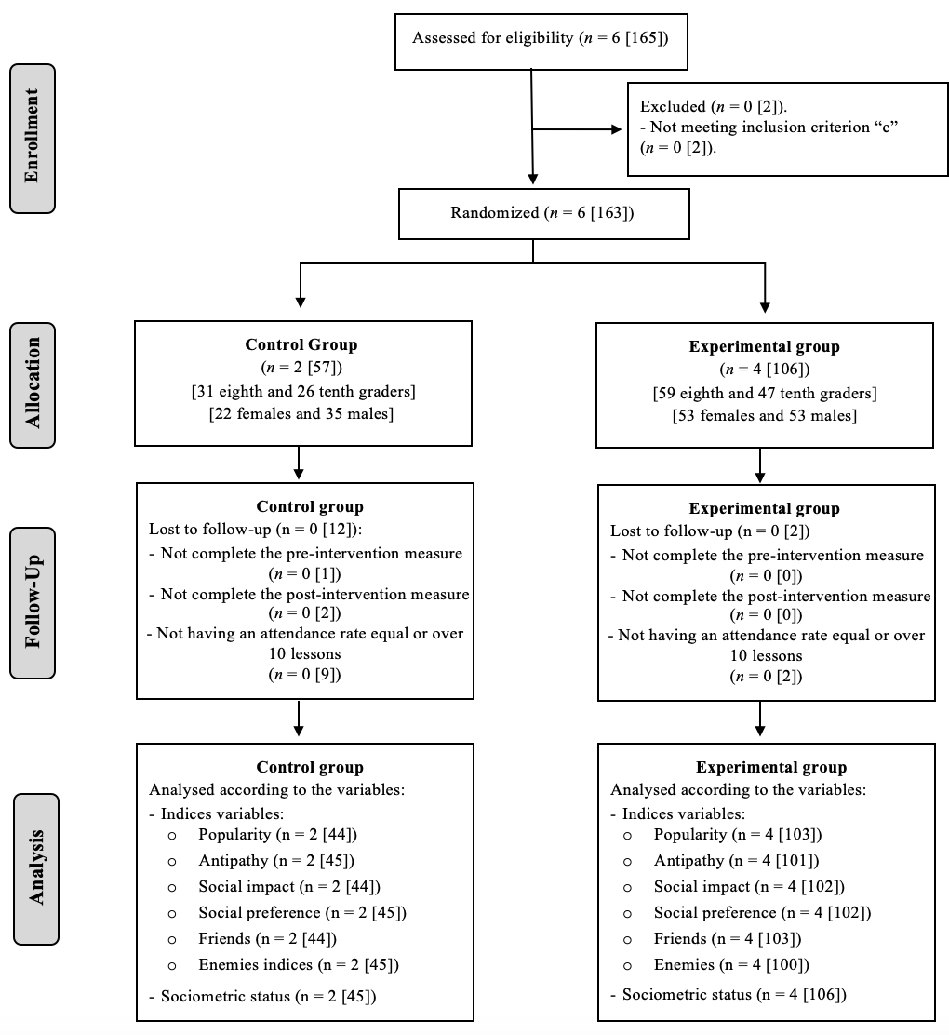
Supplementary File 3. Flow chart of the school classes and students of the present study following a per-protocol approach. All numbers are school classes [students]

Supplementary File 3. Effect of the Sport Education-based teaching units on students’ sociometry scores following a per-protocol approach
 |  | Pre-intervention | Post-intervention | Difference | Multilevel Lineal Model |  |  | Effect sizes
Indices | Group | Mean (SD) | Mean (SD) | Mean (SD) | - 2LL | F | p | d
Peer sociometric nominations received indices
Popularity | CG (n = 44) | 10.44 (5.19) | 10.79 (6.38) | .35 (5.24) | 860.169 | .495 | .483 | -.05
 | EG (n = 103) | 11.42 (6.24) | 11.46 (6.65) | .04 (4.33)
Antipathy | CG (n = 45) | 10.58 (12.92) | 11.08 (13.12) | .50 (5.30) | 922.803 | .869 | .353 | -.07
 | EG (n =101) | 11.68 (14.77) | 11.23 (14.84) | -.45 (5.93)
Social impact | CG (n = 45) | 21.23 (12.98) | 21.72 (13.77) | .49 (7.13) | 1010.194 | .050 | .823 | -.02
 | EG (n = 102) | 22.93 (14.02) | 23.12 (16.02) | .19 (7.75)
Social preference | CG (n = 44) | -.38 (14.77) | -.18 (15.44) | .20 (7.00) | 989.123 | .003 | .954 | .00
 | EG (n = 102) | .30 (17.10) | .42 (16.62) | .12 (7.30)
Friendship and Enmity indices
Friends | CG (n = 44) | 7.39 (3.37) | 6.80 (3.26) | -.59 (3.51) | 780.029 | .011 | .918 | -.03
 | EG (n = 103) | 7.58 (3.94) | 6.88 (4.19) | -.70 (3.47)
Enemies | CG (n = 45) | 3.04 (3.16) | 2.39 (2.77) | -.65 (3.03) | 708.395 | .014 | .904 | .13
 | EG (n = 100) | 2.44 (3.27) | 2.20 (3.56) | -.24 (2.92)
Note. SD = Standard deviation; - 2LL = -2 log-likelihood; d = Cohen’s d effect size; CG = Control Group; EG = Experimental Group.

Supplementary File 3. Students’ sociometric status following a per-protocol approach

