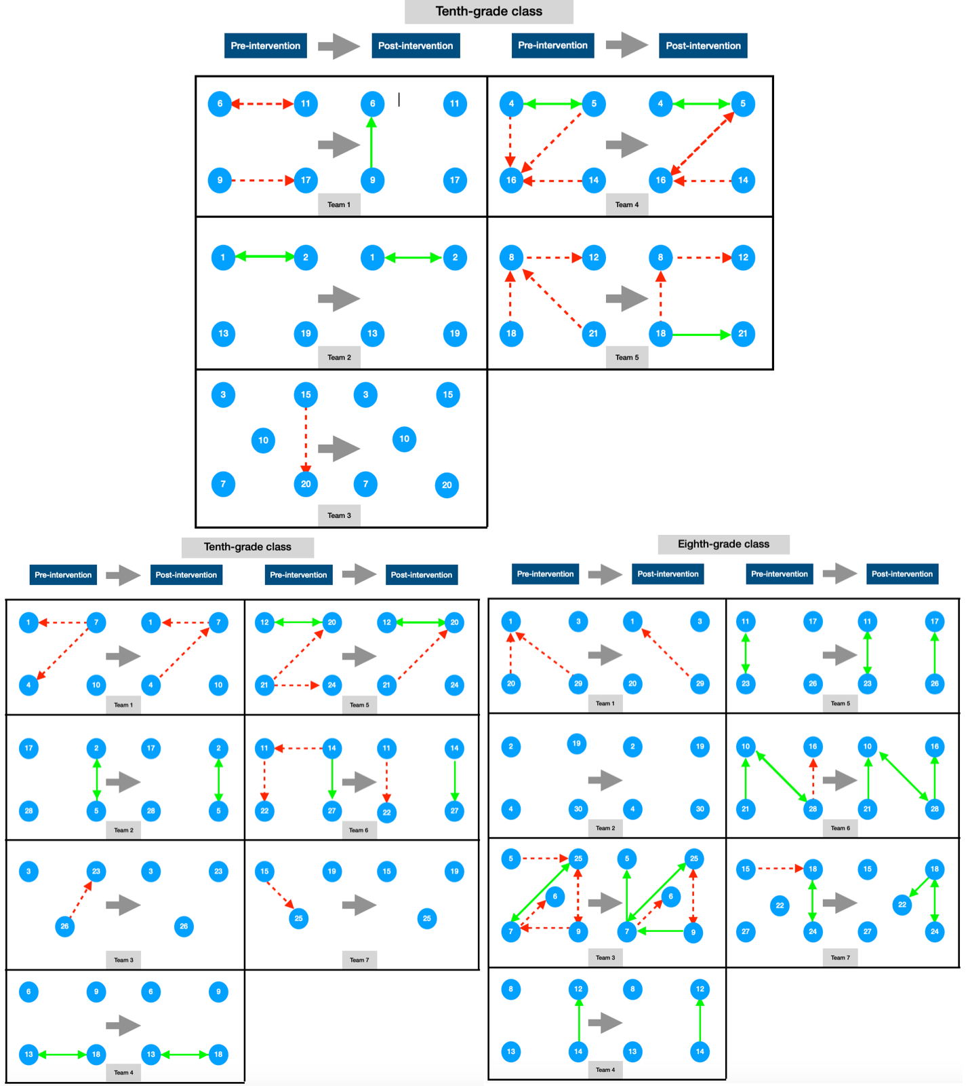
Supplementary File 4. The within-teams sociometric nominations in the other classes. Green and continuous line arrows are positive nominations and red and dashed line arrows are negative nominations. Single-pointed arrows indicate one-way relationships, while double-headed arrows indicate reciprocal relationships. Nominations emitted to students who were on another team have been removed for a better understanding of the figure.

