Appendix A – Results
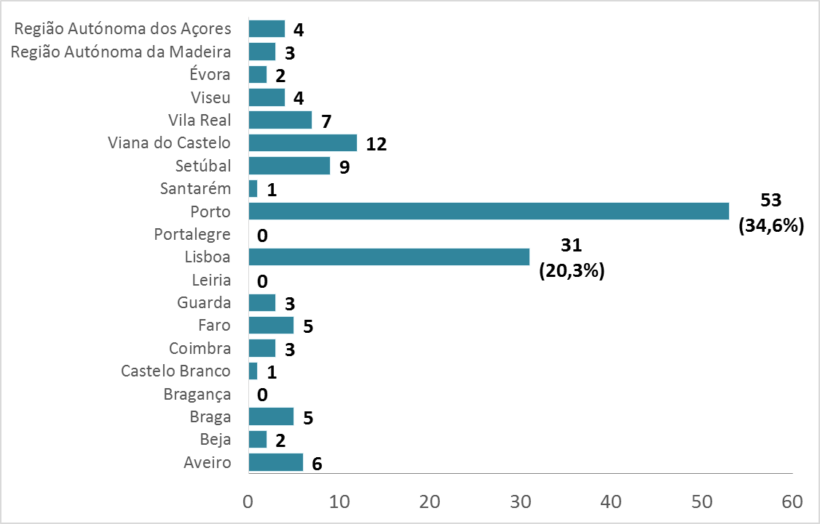
Figure S1 – District of provenience of the specimens of MAC sent to DST between February 2003 and February 2016.
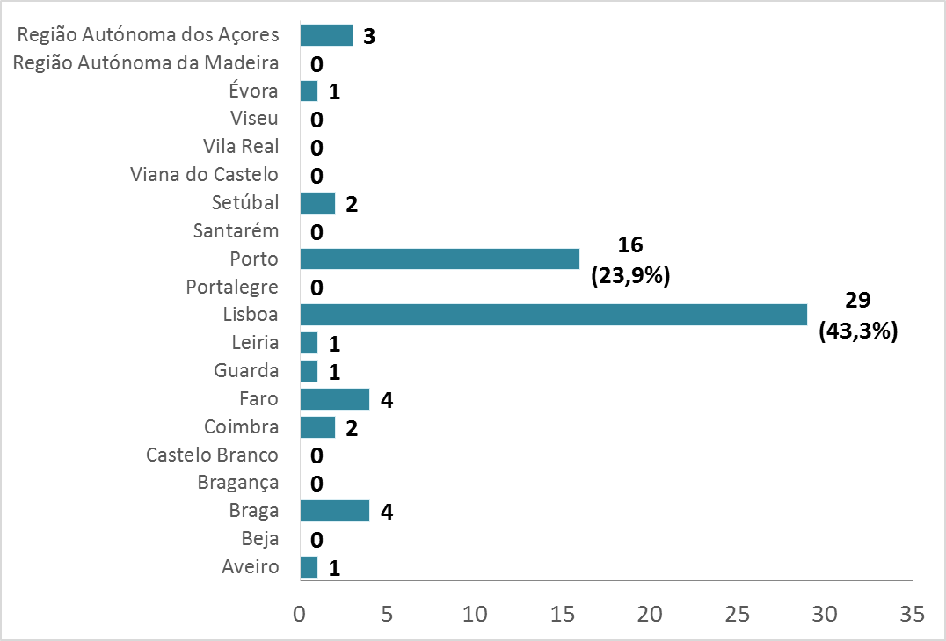
Figure S2 – District of provenience of the specimens of RGM sent to DST during February 2003 to February 2016.

 |  |  | M. ABSCESSUS
 |  |  | AMI |  |  | CIP |  |  | SMX |  |  | LNZ |  |  | CEF |  |  | DOX |  |  |  | TOB
 |  |  | S | I | R | S | I | R | S | I | R | S | I | R | S | I | R | S | I |  | R | S | I | R
CLA | S |  | 17 | 3 | 0 | 2 | 5 | 13 | 2 | 0 | 15 | 5 | 0 | 5 | 1 | 0 | 0 | 1 | 0 |  | 0 | 0 | 0 | 1
 | I |  | 0 | 1 | 0 | 0 | 1 | 0 | 0 | 0 | 0 | 0 | 0 | 0 | 0 | 0 | 0 | 0 | 0 |  | 0 | 0 | 0 | 0
 | R |  | 3 | 1 | 0 | 0 | 0 | 3 | 0 | 0 | 4 | 2 | 1 | 0 | 0 | 1 | 0 | 0 | 0 |  | 1 | 0 | 0 | 0
AMI | S |  |  |  |  | 1 | 5 | 20 | 1 | 0 | 24 | 11 | 2 | 5 | 1 | 0 | 0 | 0 | 0 |  | 0 | 0 | 0 | 0
 | I |  |  |  |  | 1 | 3 | 0 | 1 | 0 | 1 | 0 | 0 | 0 | 1 | 1 | 0 | 1 | 0 |  | 1 | 0 | 0 | 1
 | R |  |  |  |  | 0 | 0 | 0 | 0 | 0 | 0 | 0 | 0 | 0 | 0 | 0 | 0 | 0 | 0 |  | 0 | 0 | 0 | 0
CIP | S |  |  |  |  |  |  |  | 1 | 0 | 1 | 0 | 0 | 0 | 1 | 0 | 0 | 1 | 0 |  | 0 | 0 | 0 | 0
 | I |  |  |  |  |  |  |  | 1 | 0 | 4 | 2 | 0 | 1 | 1 | 0 | 0 | 0 | 0 |  | 0 | 0 | 0 | 1
 | R |  |  |  |  |  |  |  | 0 | 0 | 19 | 9 | 2 | 4 | 0 | 0 | 0 | 0 | 0 |  | 0 | 0 | 0 | 0
SMX | S |  |  |  |  |  |  |  |  |  |  | 0 | 0 | 1 | 1 | 0 | 0 | 1 | 0 |  | 0 | 0 | 0 | 0
 | I |  |  |  |  |  |  |  |  |  |  | 0 | 0 | 0 | 0 | 0 | 0 | 0 | 0 |  | 0 | 0 | 0 | 0
 | R |  |  |  |  |  |  |  |  |  |  | 11 | 2 | 4 | 1 | 1 | 0 | 0 | 0 |  | 1 | 0 | 0 | 0
 |  |  | M. CHELONAE
CLA | S |  | 12 | 0 | 0 | 3 | 3 | 6 | 1 | 0 | 11 | 1 | 3 | 0 | 0 | 0 | 0 | 0 | 0 | 0 |  | 0 | 0 | 0
 | I |  | 0 | 1 | 0 | 0 | 1 | 0 | 0 | 0 | 1 | 0 | 0 | 0 | 1 | 0 | 0 | 0 | 0 | 1 |  | 0 | 0 | 1
 | R |  | 0 | 2 | 0 | 0 | 0 | 2 | 0 | 0 | 1 | 0 | 0 | 0 | 1 | 0 | 0 | 0 | 0 | 1 |  | 0 | 0 | 1
AMI | S |  |  |  |  | 5 | 5 | 8 | 2 | 0 | 16 | 6 | 4 | 0 | 0 | 0 | 0 | 0 | 0 | 1 |  | 0 | 0 | 0
 | I |  |  |  |  | 0 | 2 | 2 | 0 | 0 | 3 | 0 | 0 | 0 | 2 | 1 | 0 | 0 | 0 | 2 |  | 0 | 0 | 2
 | R |  |  |  |  | 0 | 0 | 0 | 0 | 0 | 0 | 0 | 0 | 0 | 0 | 0 | 0 | 0 | 0 | 0 |  | 0 | 0 | 0
CIP | S |  |  |  |  |  |  |  | 1 | 0 | 4 | 3 | 1 | 0 | 0 | 0 | 0 | 0 | 0 | 0 |  | 0 | 0 | 0
 | I |  |  |  |  |  |  |  | 1 | 0 | 6 | 1 | 1 | 0 | 1 | 1 | 0 | 0 | 0 | 1 |  | 0 | 0 | 1
 | R |  |  |  |  |  |  |  | 0 | 0 | 9 | 2 | 2 | 0 | 1 | 0 | 0 | 0 | 0 | 2 |  | 0 | 0 | 1
SMX | S |  |  |  |  |  |  |  |  |  |  | 1 | 0 | 0 | 0 | 0 | 0 | 0 | 0 | 0 |  | 0 | 0 | 0
 | I |  |  |  |  |  |  |  |  |  |  | 0 | 0 | 0 | 0 | 0 | 0 | 0 | 0 | 0 |  | 0 | 0 | 0
 | R |  |  |  |  |  |  |  |  |  |  | 5 | 4 | 0 | 2 | 1 | 0 | 0 | 0 | 3 |  | 0 | 0 | 2
 |  |  | M. FORTUITUM
CLA |  | S | 5 | 1 | 0 | 6 | 0 | 0 | 5 | 0 | 0 | 4 | 0 | 0 | 0 | 0 | 0 | 0 | 0 |  | 0 | 0 | 0 | 0
 |  | I | 2 | 0 | 0 | 2 | 0 | 0 | 2 | 0 | 0 | 1 | 0 | 0 | 0 | 0 | 0 | 0 | 0 |  | 0 | 0 | 0 | 0
 |  | R | 2 | 0 | 0 | 2 | 0 | 0 | 1 | 0 | 1 | 0 | 0 | 0 | 2 | 0 | 0 | 0 | 0 |  | 1 | 0 | 0 | 0
AMI |  | S |  |  |  | 10 | 0 | 0 | 9 | 0 | 1 | 5 | 0 | 0 | 2 | 1 | 0 | 0 | 0 |  | 1 | 0 | 0 | 0
 |  | I |  |  |  | 1 | 0 | 0 | 0 | 0 | 0 | 0 | 0 | 0 | 0 | 0 | 0 | 0 | 0 |  | 0 | 0 | 0 | 0
 |  | R |  |  |  | 0 | 0 | 0 | 0 | 0 | 0 | 0 | 0 | 0 | 0 | 0 | 0 | 0 | 0 |  | 0 | 0 | 0 | 0
CIP |  | S |  |  |  |  |  |  | 9 | 0 | 1 | 5 | 0 | 0 | 2 | 1 | 0 | 0 | 0 |  | 1 | 0 | 0 | 0
 |  | I |  |  |  |  |  |  | 0 | 0 | 0 | 0 | 0 | 0 | 0 | 0 | 0 | 0 | 0 |  | 0 | 0 | 0 | 0
 |  | R |  |  |  |  |  |  | 0 | 0 | 0 | 0 | 0 | 0 | 0 | 0 | 0 | 0 | 0 |  | 0 | 0 | 0 | 0
SMX |  | S |  |  |  |  |  |  |  |  |  | 5 | 0 | 0 | 1 | 1 | 0 | 0 | 0 |  | 0 | 0 | 0 | 0
 |  | I |  |  |  |  |  |  |  |  |  | 0 | 0 | 0 | 0 | 0 | 0 | 0 | 0 |  | 0 | 0 | 0 | 0
 |  | R |  |  |  |  |  |  |  |  |  | 0 | 0 | 0 | 1 | 0 | 0 | 0 | 0 |  | 1 | 0 | 0 | 0
Table S1 – Cross-susceptibility and/or cross-resistance of the most frequently tested antibiotics in RGM. S, Susceptibility; R, Resistance; I, Intermediate Resistance; CLA, Clarithromycin; AMI, Amikacin; CIP, Ciprofloxacin; SMX, Sulfamethoxazole; LNZ, Linezolid; CEF, Cefoxitin; DOX, Doxycycline; TOB, Tobramycin.

 |  | SXT |  | Total
 |  | S | R
CIP | S | 12 | 7 | 19
 | R | 0 | 28 | 28
 | I | 2 | 10 | 12
Total |  | 14 | 45 | 59
 |  | SXT
 |  | S | R | Total
CIP | S | 12 | 7 | 19
 | R+I | 2 | 38 | 40
Total |  | 14 | 45 | 59
Table S2 – Cross-tabulation of the susceptibility profiles to ciprofloxacin and sulfamethoxazole in RGM. SXT, sulfamethoxazole; CIP, ciprofloxacin; S, susceptible; R, resistant; I, intermediate resistant.

 | Districts
RGM species | Lisboa | Porto | Total | Proportions
M. abscessus | 11 | 3 | 14 | 0.500
M. chelonae | 5 | 7 | 12 | 0.429
M. fortuitum +  M. mucogenicum +  M. peregrinum | 1 | 1 | 2 | 0.071
Total | 17 | 11 | 28
Table S3 – Contingency table 3x2 for chi-square test of homogeneity of Resistance Response to Sulfamethoxazole in RGM from Porto and Lisbon’s districts.

 | Districts
RGM species | Lisbon | Oporto | Total | Proportions
M. abscessus | 7 | 4 | 11 | 0.647
M. chelonae | 4 | 2 | 6 | 0.353
Total | 11 | 6 | 17
Table S4 – Contingency table 2x2 for chi-square test of homogeneity of Resistance Response to Ciprofloxacin in RGM from Porto and Lisbon’s districts.

 |  | CLA
 |  | S | R | Total | Proportions
Pre ISO | N | 95 | 2 | 97 | 0.021
 | Y | 49 | 7 | 56 | 0.125
Total |  | 144 | 9 | 153
Table S5- Crosstabulation of the susceptibility profile to clarithromycin in MAC isolates and the presence/absence of previous MAC isolates sent to DST in the past. CLA, clarithromycin; S, susceptible; R, resistance; PreISO, presence/absence of MAC isolates previously sent to DST; N, no; Y, yes. p1=0.021 (2.1%), p2= 0.125 (12.5%); Relative Risk (RR)= p2/p1= 5.95

