Supplementary Material

Decision tree: Database and variables

Patients (Pts) | Nº | Deceased | Lethality
Total pts | 36,366 | 9,123 | 25.1
Pts single admission | 32,782 | 8,031 | 24.5
Pts with readmissions | 3,584 | 1,092 | 30.6
Hospital stay ≤ 1 day | 2,207 | 1,648 | 74.7
Hospital stay >1 and ≤ 15 days | 27,844 | 5,832 | 20.9
Hospital stay > 15 days | 6,315 | 1,644 | 26.0
Total admissions | 40,696 | 9,123 | 22.4
Patient Admissions and Days of Hospitalization

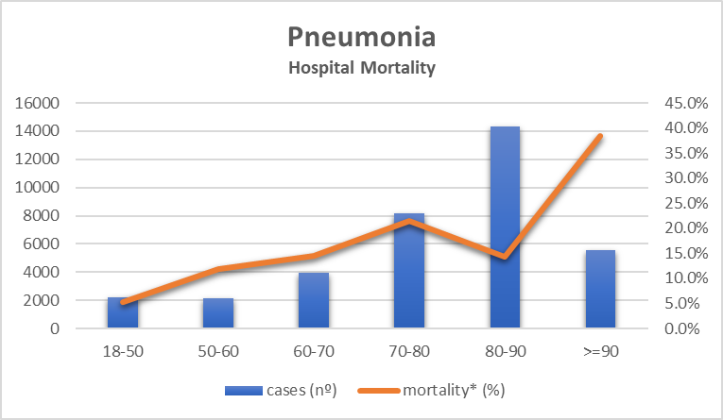
*mortality (lethality – proportion of pneumonia pts deceased)
Pneumonia hospital mortality age distribution

Microbiology | Cases (%) | Hospital Mortality (%)
Pneumococcus | 1,328 (41.2) | 12.3
Miscellaneous gram-negative | 533 (16.6) | 23.6
MRSA positive | 460 (14.3) | 43.0
Hemophilus influenzae | 248 (7.7) | 6.0
MRSA negative | 223 (6.9) | 27.8
Klebsiella pneumoniae | 224 (7.0) | 25.9
Streptococcus spp | 136 (4.2) | 23.5
Atypical bacteria | 45 (1.4) | 6.7
Other | 23 (0.7) | 26.1
Total microbiologic identifications | 3,220 (8.9) | 20.6
Microbiologic negative isolates | 33,146 (91.1) | 25.5
Microbiologic Data

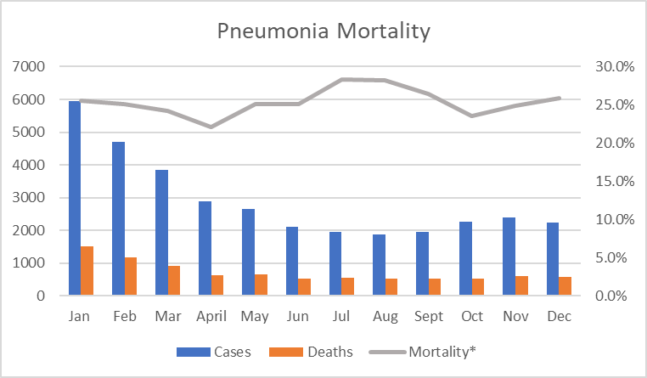
*Hospital Mortality (Lethality) – proportion of deceased pneumonia patients
Pneumonia admissions and mortality by month

Microbiologic seasonal distribution

Pneumonia etiology by age group

