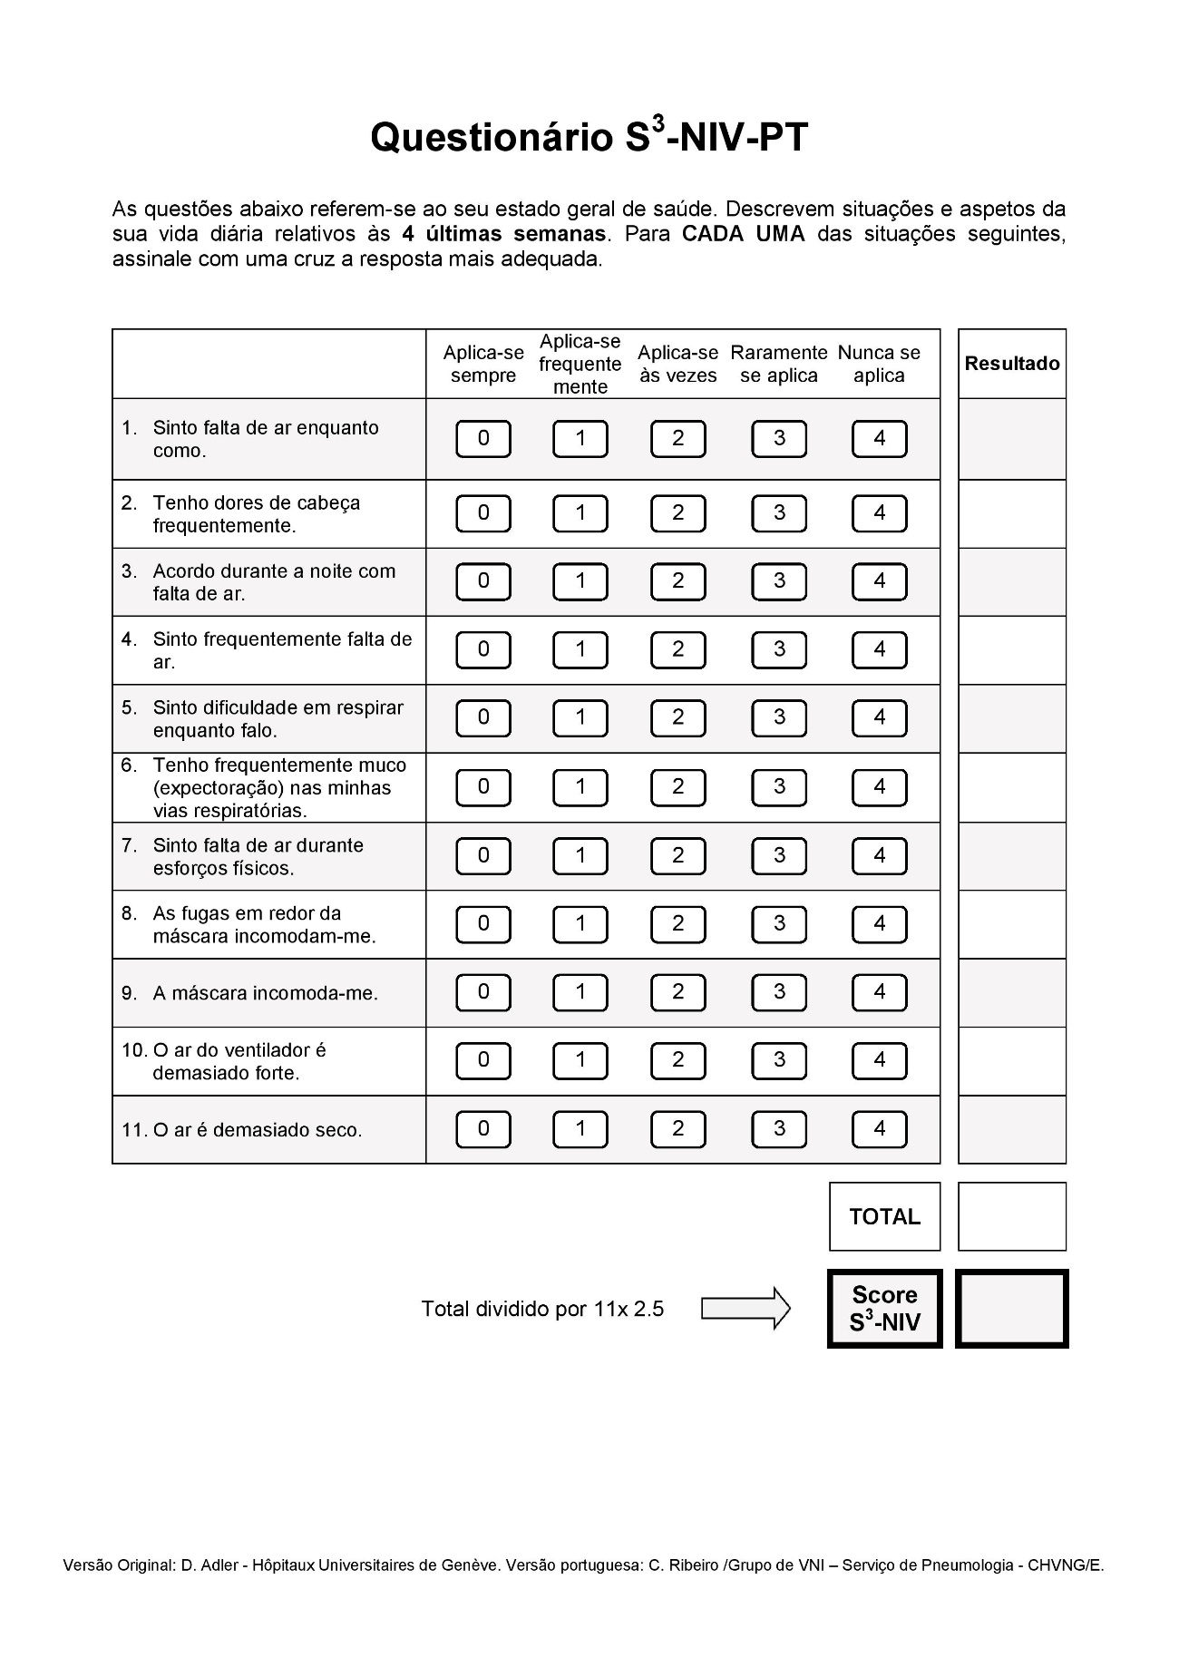
Supplementary Figure 1. Portuguese version of the S3-NIV questionnaire. The total score can be computed as the average of all answered items multiplied by 2.5. The lowest possible score (0) corresponds to the highest impact of disease and treatment, while the highest possible score (10) corresponds to the lowest impact of disease and treatment. The “Respiratory Symptoms” subscore is calculated as the average of answered items 1, 4, 5, 6 and 7 multiplied by 2.5 and the “Sleep & Side Effects” subscore is calculated as the average of answered items 2, 3, 8, 9, 10 and 11 multiplied by 2.5

