Appendix C

EFFECTIVENESS AND SAFETY OF A NEW HELMET CPAP CONFIGURATION ALLOWING TIDAL VOLUME MONITORING
IN PATIENTS WITH COVID-19
Chiara Chiapperoª, Giovanni Misseri^{b}, Alessio Matteiª, Mariachiara Ippolito^{c}, Carlo Albera^{a,d}, Emanuele Pivetta^{e}, Andrea Cortegiani^{c,f}, Cesare Gregoretti^{b,c}

ª Pneumology, Cardiovascular and Thoracic Department, AOU Città della Salute e della Scienza di Torino - Molinette hospital, Turin, Italy

^{b} Fondazione “Giglio”, Cefalù, Italy

^{c} Department of Surgical, Oncological and Oral Science (Di.Chir.On.S.). University of Palermo, Italy

^{d} University of Turin, School of Medicine, Department of Medical Sciences

^{e} Division of Emergency Medicine and High Dependency Unit, Department of General and Specialized Medicine, AOU Città della Salute e della Scienza di Torino - Molinette hospital, Turin, Italy

^{f} Department of Anaesthesia, Intensive Care and Emergency, Policlinico Paolo Giaccone, Palermo, Italy

Corresponding author: Andrea Cortegiani, MD, Department of Surgical, Oncological and Oral Science (Di.Chir.On.S), University of Palermo. Department of Anaesthesia, Intensive Care and Emergency, Policlinico Paolo Giaccone, Palermo, Italy. Via del Vespro 129, 90127 Palermo, Italy.

Email: andrea.cortegiani@unipa.it; Phone: +390916552730

Contents
Table C.1. Treatments
Figure C.1. Tidal volume trend of included patients
Table C.2. Secondary endpoints results - Adverse events not related to the helmet configuration
Table C.3. Respiratory parameters at the start and at the end of helmet CPAP weaning
Table C.4. Respiratory parameters of patients died in RICU (patients with do-not-intubate decision)
Table C.5. Respiratory parameters of intubated patients
  - Table C.6. Comparison of respiratory parameters of helmet CPAP success (S, n=23) and helmet CPAP failure (death and/or intubation) (F, n=12) at admission in RICU (T0), and after 6 hours (T6), and after 24 hours (T24)

Treatment | All patients  (n=35) | h-CPAP  success  (n=23) | h-CPAP failure  (n=12) | p-value
Helmet CPAP N. (%) | 35 (100) | 23 (100) | 12 (100) | 1.00
CPAP cmH₂O (IQR) | 12 (10-12) | 10 (10-12) | 12 (10.5-14.5) | 0.06
Prone position N. (%): | 24 (68.6) | 16 (69.6) | 8 (66.7) | 1.00
>6 h/die | 13 | 11 | 2
<6 h/die | 6 | 3 | 3
Prone position failure | 5 | 2 | 3
Hydroxychloroquine N. (%) | 33 (94.3) | 22 (95.7) | 11 (91.7) | 1.00
Corticosteroids N. (%): | 26 (74.3) | 19 (82.6) | 7 (58.3) | 0.22
Dexamethasone | 11 | 6 | 5
Methylprednisolone | 15 | 13 | 2
Darunavir/cobicistat N. (%) | 19 (54.3) | 11 (47.8) | 8 (66.7) | 0.47
Remdesivir N. (%) | 3 (8.6) | 2 (8.7) | 1 (8.33) | 1.00
Tocilizumab N. (%) | 22 (62.9) | 13 (56.5) | 9 (75.0) | 0.46
Heparin N. (%) | 21 (60) | 12 (52.2) | 9 (75.0) | 0.28
Azithromycin N. (%) | 8 (22.9) | 7 (30.4) | 1 (8.3) | 0.22
Antibiotics N. (%) | 33 (94.3) | 22 (95.7) | 11 (91.7) | 1.00
Dialysis N. (%): | 4 (11.5) | 2 (8.7) | 2 (16.7) | 0.59

Table C.1. Treatments
CPAP Continuous Positive Airway Pressure

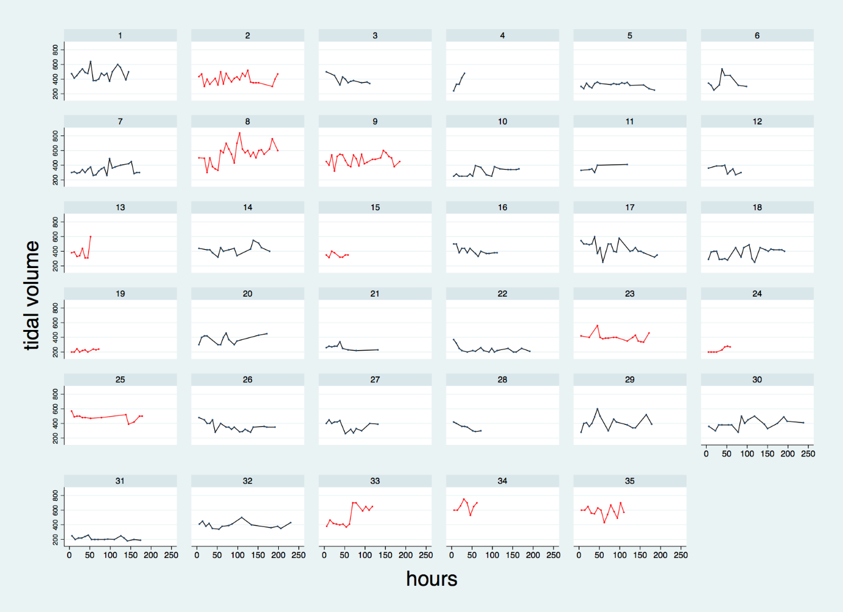

Figure C.1. Tidal volume trend of included patients
V_{t} trend of the 35 patients recorded three times a day until the start of the weaning, then once a day. Black line for patients who successfully completed h-CPAP; red line for patients who failed h-CPAP (intubation or death).

Adverse event
Deep Vein Thrombosis N. (%) | 0 (0)
Cardiovascular events N. (%): | 15 (42.9)
Hypotension | 0
Bradycardia | 13
Atrial fibrillation | 2
Pulmonary embolism N. (%) | 3 (8.6)
Other complications N. (%) | 11 (31.4)
Blood stream infection | 5
Acute kidney injury | 2
Immune thrombocytopenia | 1
Epileptic seizure | 1
Major bleeding | 1
Perforated diverticulitis | 1
Pneumothorax and/or pneumomediastinum N. (%) | 0 (0)

Table C.2. Secondary endpoints results - Adverse events not related to the helmet configuration

 | Parameters at the start of weaning  Median (IQR) (n=23) | Parameters at the end weaning  Median (IQR) (n=23)
pH | 7.44 (7.42-7.51) | 7.47 (7.45-7.51)
PaCO₂, mmHg | 39 (36-44) | 39 (35-42)
PaO₂:FiO₂, mmHg | 276 (245-310) | 322 (284-378)
HCO₃⁻, mmol/l | 28 (24-30) | 28 (25-30)
RR, bpm | 20 (17-24) | 18 (15-22)
BORG | 0 (0-1) | 0 (0)
FiO₂ | 0.6 (0.5-0.7) | 0.6 (0.4-0.6)
CPAP, cmH₂O | 10 (10-12) | 10 (8-10)
V_{t}, ml | 360 (290-400) | 350 (300-400)
ml/kg IBW | 5.2 (4.8-5.9) | 5.3 (4.0-5.9)

Table C.3. Respiratory parameters at the start and at the end of helmet CPAP weaning
PaCO₂ arterial partial pressure of carbon dioxide, PaO₂ arterial partial pressure of oxygen, FiO₂ fractional inspired oxygen, HCO₃⁻ bicarbonate, RR respiratory rate, BORG Modified Borg Dyspnoea Scale (MBS), Vt Tidal volume, IBW Ideal Body Weight

Deaths in RICU
Median (IQR)
(n=3)
pH | 7.40 (7.39-7.44)
PaCO₂, mmHg | 33 (30-34)
PaO_{2:}FiO₂, mmHg | 73 (70-91)
HCO₃⁻, mmol/l | 20.0 (17.5-23.5)
RR, bpm | 24 (23-25)
BORG | 3 (2-3)
FiO₂ | 0.7 (0.7-0.9)
CPAP, cmH₂O | 12 (11-12)
V_{t}, ml | 650 (610-675)
ml/kg IBW | 10.5 (9.3-10.5)

Table C.4. Respiratory parameters of patients died in RICU (patients with do-not-intubate decision)

PaCO₂ arterial partial pressure of carbon dioxide, PaO₂ arterial partial pressure of oxygen, FiO₂ fractional inspired oxygen, HCO₃⁻ bicarbonate, RR respiratory rate, BORG Modified Borg Dyspnea Scale (MBS), V_{t} Tidal volume, IBW Ideal Body Weight

Parameters pre-intubation
Median (IQR) (n=9)
PaCO₂ mmHg | 35 (34-43)
PaO_{2:}FiO₂ mmHg | 100 (66-130)
RR bpm | 30 (26-30)
BORG | 3 (3-5)
FiO₂ | 0.80 (0.60-0.85)
CPAP cmH₂O | 13 (11-14)
V_{t} ml | 455 (355-500)
ml/kg IBW | 6.5 (5.8-7.9)

Table C.5. Respiratory parameters of intubated patients
PaCO₂ arterial partial pressure of carbon dioxide, PaO₂ arterial partial pressure of oxygen, FiO₂ fractional inspired oxygen, RR respiratory rate, BORG Modified Borg Dyspnea Scale (MBS), Vt Tidal volume, IBW Ideal Body Weight.

 | T0 |  |  | T6 |  |  | T24 |  |  | ∆T0-T6  p-value |  | ∆T0-T24  p-value
 | S | F | p-value | S | F | p-value | S | F | p-value | S | F | S | F
PaCO₂, mmHg (IQR) | 32 (29-36) | 32 (29-36.5) | 0.93 | 35 (31-38) | 34 (31-36.5) | 0.45 | 35 (35-42) | 38 (31.5-40) | 0.99 | 0.02 | 0.18 | <0.001 | 0.01
PaO_{2:}FiO₂, mmHg (IQR) | 133 (104-178) | 98 (81.5-165.5) | 0.18 | 226 (134-280) | 162 (136-184) | 0.08 | 257 (181-319) | 171 (133-225) | 0.02 | 0.001 | 0.03 | <0.001 | 0.03
RR, bpm (IQR) | 32 (28-35) | 32.5 (28-40) | 0.50 | 28 (23-30) | 26.5 (20.5-34) | 0.93 | 25 (20-28) | 25 (20-30) | 0.60 | 0.001 | 0.01 | <0.001 | 0.003
BORG (IQR) | 3 (2-3) | 3 (2-5) | 0.30 | 2 (1-3) | 2.5 (2-4) | 0.24 | 1 (0-2) | 2 (1-2) | 0.08 | 0.001 | 0.01 | <0.001 | 0.01
CPAP, cmH₂O (IQR) | / | / | / | 10 (10-12) | 12 (10.5-14.5) | 0.06 | 12 (10-15) | 12 (10-13) | 0.88 | / | / | / | /
V_{t}, ml/IBW (IQR) | / | / | / | 5,6 (4,5-6,5) | 6,2 (5,7-8,1) | 0.12 | 5,7 (4,8-6,3) | 5,9 (4,0-7,6) | 0.65 | / | / | / | /
V_{t}, ml (IQR) | / | / | / | 360 (290-440) | 427 (358-553) | 0.14 | 390 (300-420) | 390 (305-478) | 0.96 | / | / | / | /
Ve L/m (IQR) | / | / | / | 9  (7.5-12) | 10.2  (7.7-14.8) | 0.42 | 8.4  (7.8-10.1) | 9.8 (6.9-10.5) | 0.51 | / | / | / | /

  - Table C.6. Comparison of respiratory parameters of helmet CPAP success (S, n=23) and helmet CPAP failure (death and/or intubation) (F, n=12) at admission in RICU (T0), and after 6 hours (T6), and after 24 hours (T24)
CPAP continuous positivie airway pressure, IBW ideal body weight, PaCO₂ arterial partial pressure of carbon dioxide, PaO₂ arterial partial pressure of oxygen, FiO₂ fractional inspired oxygen, RR respiratory rate, BORG Modified Borg Dyspnea Scale (MBS), V_{t} Tidal volume, Ve minute volume

