 | Endpoint not met |  | Endpoint met
Score | n= | % | n= | %
0 | 107 | 87.0% | 16 | 13.0%
1 | 89 | 65.0% | 48 | 35.0%
2–3 | 103 | 50.7% | 100 | 49.3%
≥4 | 17 | 25.8% | 49 | 74.2%

Supplementary Table 1: Comparison of events per each R4 category within the total population.

R4 components | Sensitivity | Specificity | AUC
Age (≥63) | 47% | 75% | 0.62
Low eGFR (<60) | 24% | 88% | 0.56
ROX-24 (≤5.2) | 78% | 32% | 0.63
History of hypertension | 51% | 69% | 0.60
History of diabetes | 36% | 75% | 0.56
Any comorbidity | 21% | 90% | 0.56
R4 category (# of criteria) | Sensitivity | Specificity | AUC
1 (0) | 100% | 0% | 0.72
2 (1) | 92% | 34%
3 (2–3) | 70% | 62%
4 (≥4) | 23% | 95%
Supplementary Table 2: Sensitivity and specificity for the primary endpoint by each R4 score criterion individually and by the proposed R4 score categories.

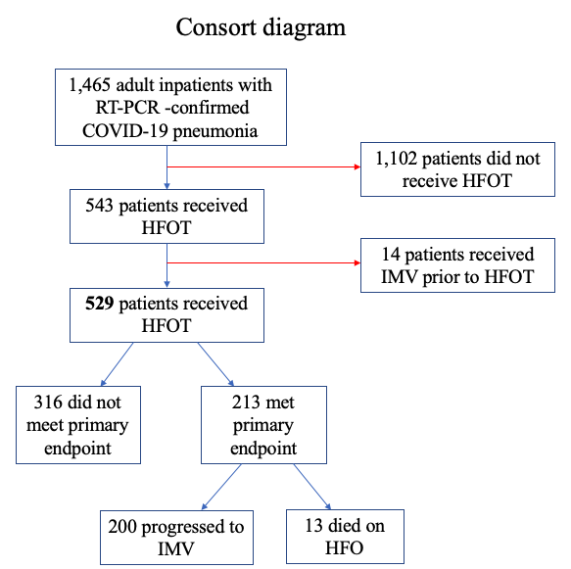

Supplementary Figure 1: Consort diagram of the population included in the analysis. Red lines imply exclusion from analysis.

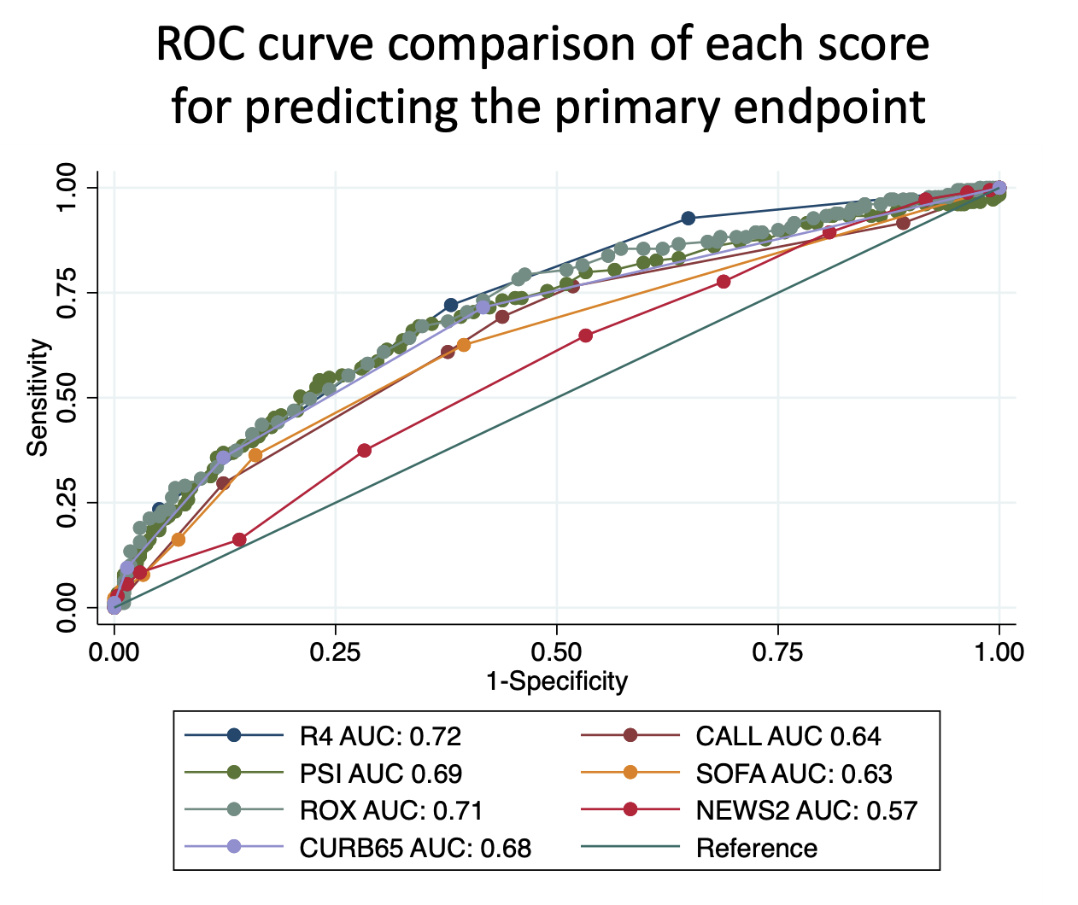
Supplementary Figure 2: Receiver operating characteristic (ROC) curve for the R4 score compared to other traditional scores for predicting our primary endpoint. Using Bonferroni-adjusted chi², other traditional scores performed similarly to the R4 score (p= 0.001, 0.206, 0.005, 0.647, 0.001, and 0.113 for CALL, PSI, SOFA, ROX, NEWS2, and CURB-65, respectively).

