Supplementary files

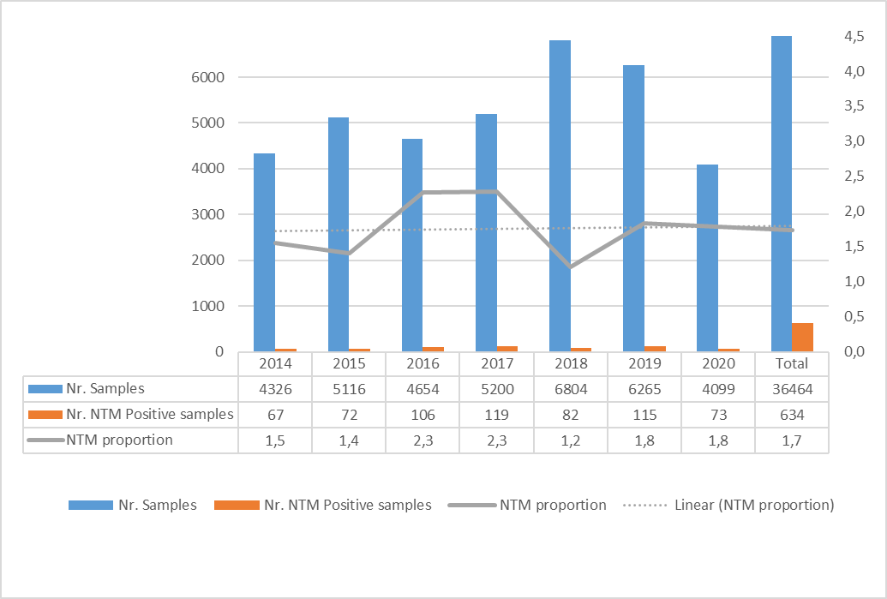
Supplementary figure 1. Number of positive NTM isolations in Portugal during 2014-2020.

Supplementary table 1. Distribution of NTM positive cases by age and gender.
Age group | NTM positive Patients (n) | Gender male (%) | Definite cases (n)  (all NTM) | Most Prevalent NTM  (%)
< 15 yr | 4 | 75 | 0 | M. gordonae (50)
15-19 yr | 3 | 0 | 1 | MABC** (33.3)
20-24 yr | 9 | 33.3 | 2 | MAC* (44.4)
25-29 yr | 8 | 37.5 | 3 | MABC** (62.5)
30-34 yr | 25 | 64.0 | 3 | MAC* (40.0)
35-39 yr | 21 | 52.4 | 2 | MAC* (52.4)
40-44 yr | 42 | 59.5 | 2 | MAC* (28.,6)
45-49 yr | 58 | 72.4 | 6 | MAC* (46.5)
50-54 yr | 63 | 60.3 | 7 | MAC* (38.0)
55-59 yr | 91 | 56.0 | 13 | MAC* (45.0)
60-64 yr | 92 | 57.6 | 10 | MAC* (41.3)
≥65 yr | 500 | 59.0 | 43 | MAC* (41.6)
unkown | 28 | 44.8 | 1 | MABC** (20.6)
Total | 944 | 58.6 | 93 | MAC* (40,7)
* MAC – Mycobacterium avium complex
**MABC - Mycobacterium abscessus-chelonae complex

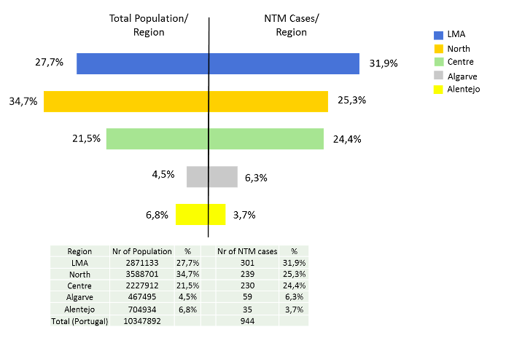
Supplementary figure 2 Demography of the NTM cases analyzed; comparison of the total number of population (left side of the figure) with the number of NTM cases (right side of the figure) by region.

Supplementary table 2. Number of patients infected with MAC (Mycobacterium avium complex), MABC (Mycobacterium abscessus-chelonae complex) and M. fortuitum by gender and region of isolation.

 | MAC N (%) | MABC N (%) | M. fortuitum N (%)
Total | 385 (40.8%) | 91 (9.6%) | 59 (6.3%)
Age category
< 15 yr | 0 (0%) | 1 (1.1%) | 0 (0%)
15-34 yr | 14 (3.6%) | 8 (8.8%) | 3 (5.1%)
35-64 yr | 152 (39.5%) | 27 (28.6%) | 22 (37.3%)
≥ 65 yr | 211 (54.8%) | 49 (53.8%) | 33 (55.9%)
Unknown | 8 (0.26%) | 6 (6.6%) | 1 (1.7%)
% male | 205 (53.2%) | 50 (54.9%) | 38 (64.4%)
Region
North | 148 (38.4%) | 16 (17.6%) | 9 (15.3%)
Centre | 87 (22.6%) | 18 (19.8%) | 14 (23.7%)
LMA | 97 (25.2%) | 29 (31.9%) | 19 (32.2%)
Alentejo | 13 (3.4%) | 5 (5.5%) | 1 (1.7%)
Algarve | 12 (3.1%) | 10 (11%) | 8 (13.6%)
Açores | 7 (1.8%) | 3 (3.3%) | 6 (10.2%)
Madeira | 2 (0.5%) | 1 (1.1%) | 0 (0%)
Unknown | 19 (4.9%) | 9 (9.9%) | 2 (3.4%)

Supplementary table 3. Distribution of the most prevalent NTM species by case classification and region of isolation.
 | North | Centre | LMA | Alentejo | Algarve | Açores | Madeira
Total infections (N) | 239 | 230 | 301 | 35 | 59 | 19 | 7
MAC* N (%) | 148 (61.9) | 87 (37.8) | 97 (32.2) | 13 (37.1) | 12 (20.3) | 7 (36.8) | 2 (28.6)
MABC** N (%) | 16 (6.7) | 18 (7.8) | 29 (9.6) | 5 (14.3) | 10 (16.9) | 3 (15.8) | 1 (14.3)
M. fortuitum N (%) | 9 (3.8) | 14 (6.1) | 19 (6.3) | 1 (2.9) | 8 (13.6) | 6 (31.6) | 0
Definite Cases (N) | 33 | 14 | 28 | 3 | 5 | 6 | 1
* MAC – Mycobacterium avium complex
**MABC - Mycobacterium abscessus-chelonae complex

