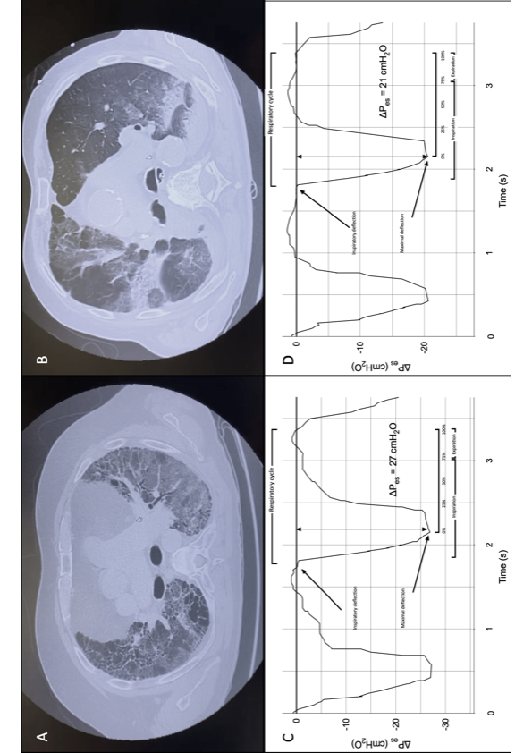**Supplementary materials**

**eFigure 1.**

**eFigure 1.** Panel A. CT scan images of a patient with AE-IPF showing UIP pattern with superimposed ground-glass. Panel B. CT scan images of a patient with ARDS showing diffuse ground glass opacities and consolidations. Panel C. Graphical representation Pes swings waveform during AE-IPF. Panel D. Graphical representation Pes swings waveform during ARDS. The beginning of the inspiratory phase was identified at the time of Pes initial decay, while the end of inspiration was considered at the point of Pes that elapsed 25% of time from its maximum deflection to return to baseline.

*CT = computed tomography; AE-IPF = acute exacerbation of idiopathic pulmonary fibrosis; ARDS = acute respiratory distress syndrome; Pes = esophageal pressure*

**eFigure 2.**



**eFigure 2.** Correlation between PEEP values and change in both dynCRS and PaO2/FiO2 ratio in ARDS (panel A and B, respectively). PEEP levels were directly correlated with both PaO2/FiO2 ratio (r=0.24, p=0.5) and dynCRS (r=0.65, p=0.04), although statistical significance was found only for this latter.