Supplemental materials

Data Collection
Clinical data at the diagnosis included: age, sex, BMI, smoking habitus, professional exposure to organic and/or inorganic dust, familiar history of interstitial lung diseases, disease onset (chronic -at least three months of duration- or acute-< 3 months of duration), presence of cough, fever, and dyspnoea. The MRC score and GAP index were also recorded. Comorbidities (hematologic diseases, lung transplant, HSCT, presence of gastroesophageal reflux , hypertension, cardiopathy) and medical treatments were recorded as well. Bronchoalveolar lavage (BAL) data and histological features on lung biopsies when available were also included.

Visual CT analysis
Each CT scan was evaluated in consensus by a chest radiologist and expert pulmonologist.
In order to score the extent of interstitial lung disease, the parenchyma was subdivided into six anatomical levels as described by Edey et al. (7). The anatomical levels were level 1- aortic arch; level 2- carina; level 3- pulmonary venous confluence; level 4- a point in the midway between the level 3 and the level 5; level 5- 1cm above the right hemidiaphragm dome; level 6- 2 cm below the right hemidiaphragm dome. Images were scored estimating the extent of the disease at nearest of 5%, so that from the six sections Global Disease Score was the average of each section. Each finding was analyzed accordingly to the nomenclature of Fleischner Society Glossary.
Emphysema was scored as present (1) or absent (0) for each level, and then summed in order to obtain a value ranging from 0 to 6.
Traction bronchiectasis were score from 0 to 3 (0: absent; 1: mild; 2: moderate; 3:severe), and then a summed value was obtained.
As, PPFE consists in a dense pleural and subpleural fibrosis due to intra-alveolar fibrosis and septal elastosis, which diffuses into the parenchyma with dense aggregations; to quantify it, the densely fibrotic parenchyma adjacent to the pleura, and suggestive of PPFE was equally scored in the context of the six sections (nearest to 5%).
Finally, to quantify the thickening of the fissures by the elastotic process, in the axial plane, all the insertions of the three fissures (upper and lower of the major fissure in both lungs, minor fissure in the right lung) were analyzed. Being the insertion of each fissure triangular shaped, the Heron’s formula was adopted to quantify the fissure elastotic thickening. The threshold density, for each fissure insertion was 25 HU, in order to avoid cases of fatty infiltration.
AP/T (anteroposterior/transverse index) to calculate the flattening of the thorax were recorded for each patient (flat chest index)

Table S1 – Radiological Semi-quantitative Analysis
 | PPFE  (n = 22) |  | PPFE-ILD  (n = 19) |  | PPFE-airways disease  (n = 12) |  | p-value
Global Disease Score  Mean (SD) |  |  |  |  |  |  | < 0.001
 | 20.78 | (16.03) | 38.77 | (17.74) | 16.38 | (7.56)
Median (IQR) | 12.5 | (10.0 – 27.5) | 36.7 | (25.0 – 55.0) | 15.3 | (10.9 – 20.4)
Final reticulation score
Mean (SD) | 11.44 | (26.73) | 40.20 | (22.12) | 32.67 | (32.26) | < 0.001
Median (IQR) | 0.0 | (0.0 – 0.0) | 40.0 | (24.0 - 48.0) | 31.0 | (0.0 - 67.0)
Final HC score, mean (SD)
Mean (SD) | 5.34 | (17.63) | 32.28 | (27.59) | 0.00 | (0.00) | < 0.001
Median (IQR) | 0.0 | (0.0 - 0.0) | 33.3 | (0.0 - 60.0) | 0.0 | (0.0 - 0.0)
Final GG score, mean (SD)
Mean (SD) | 3.36 | (12.09) | 35.26 | (20.62) | 1.94 | (6.74) | < 0.001
Median (IQR) | 0.0 | (0.0 - 0.0) | 33.3 | (25.0 - 50.0) | 0.0 | (0.0 – 0.0)
Final subpleural fibrosis score
Mean (SD) | 82.40 | (26.10) | 57.07 | (25.02) | 78.61 | (25.56) | 0.004
Median (IQR) | 100.0 | (60.0 - 100.0) | 56.7 | (40.0 - 80.0) | 90.0 | (50.0 - 100.0)
Summed TB score, mean (SD)
Mean (SD) | 2.45 | (4.32) | 7.11 | (3.80) | 1.67 | (2.31) | < 0.001
Median (IQR) | 0.0 | (0.0 - 6.0) | 7.0 | (4.0 - 10.0) | 0.5 | (0.0 – 2.5)
Emphysema, n (%)
0 | 18 | (81.82) | 18 | (94.74) | 11 | (91.67) | 0.387
2 | 1 | (4.55) | 0 | (0.00) | 0 | (0.00)
3 | 2 | (9.09) | 0 | (0.00) | 0 | (0.00)
4 | 0 | (0.00) | 0 | (0.00) | 1 | (8.33)
5 | 0 | (0.00) | 1 | (5.26) | 0 | (0.00)
6 | 1.00 | (4.55) | 0 | (0.00) | 0 | (0.00)
Mean (SD) | 0.6 | (1.5) | 0.3 | (1.2) | 0.3 | (1.2) | 0.446
Median (IQR) | 0.0 | (0.0 – 0.0) | 0.0 | (0.0-0.0) | 0.0 | (0.0-0.0)
Abbreviations: HC honeycombing; GG ground glass; TB traction bronchiectasis

Table S2 – Fissural involvement quantification
 | PPFE  (n = 22) |  | PPFE-ILD  (n = 19) |  | PPFE-airways disease  (n = 12) |  | p-value
Right Superior Fissure
Mean (SD) | 161.46 | (137.31) | 185.74 | (233.00) | 112.42 | (79.84) | 0.743
Median (IQR) | 139.1 | (20.3 – 235.3) | 119.9 | (53.4 – 229.8) | 98.6 | (64.4 - 189.0)
Right Inferior Fissure
Mean (SD) | 94.08 | (37.16) | 126.80 | (73.32) | 83.56 | (20.20) | 0.765
Median (IQR) | 97.2 | (55.5 - 129.6) | 153.5 | (53.4 – 171.3) | 83.6 | (69.3 - 97.8)
Little Fissure
Mean (SD) | 162.66 | (146.60) | 106.73 | (78.00) | 198.04 | (169.58) | 0.750
Median (IQR) | 164.9 | (37.3 – 288.1) | 95.0 | (42.5 – 171.0) | 252.4 | (7.9 - 333.7)
Left Sup Fissure
Mean (SD) | 92.39 | (83.34) | 103.80 | (122.79) | 40.37 | (22.88) | 0.410
Median (IQR) | 56.4 | (24.9 – 173.4) | 68.7 | (21.2 – 111.2) | 41.9 | (17.4 – 67.2)
Left Inf Fissure
Mean (SD) | 152.79 | (148.67) | 48.46 | (20.36) | 104.16 | (79.83) | 0.124
Median (IQR) | 94.1 | (42.4 - 321.9) | 39.2 | (35.1 - 70.8) | 82.5 | (37.4 - 192.6)
Fissural Ticketing Entity (mm²)
Mean (SD) | 64.0 | (57.9) | 210.5 | (88.4) | 100.3 | 65.8 | 0.001
Median (IQR) | 64.6 | (13.7-245.2) | 211.4 | (87.7-441.4) | 103.8 | (19.0-282.4)

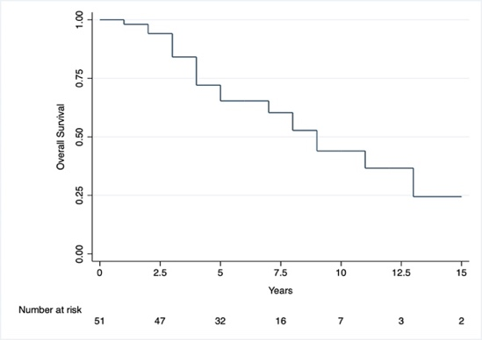 B)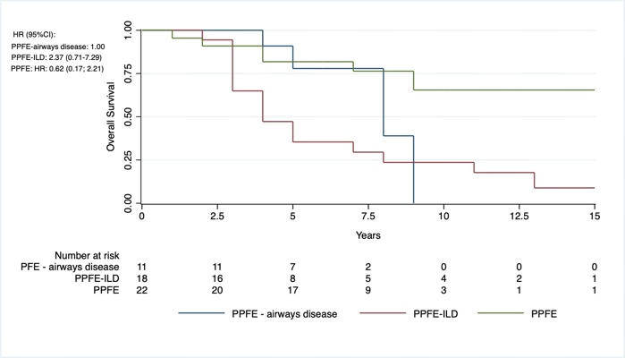
Kaplan-Meier Overall Survival – A) Overall Survival (n = 53) – median: 9 years (95%CI: 7-13); B) Overall Survival per Groups: PPFE (n = 22) median: 9 (95%CI: 9-13); PPFE-ILD (n = 19) median: 4 years (95%CI: 3-8); PPFE-airways disease (n = 12) median: 8 years (95%CI: 5 – 9) – Log-rank

