Supplementary Material

Alpha-1 antitrypsin deficiency and Pi*S and Pi*Z SERPINA1 variants are associated with asthma exacerbations

Running title: Alpha-1 antitrypsin and asthma exacerbations

This supplementary information file contains the following items:
Table of contents | Pages
Supplementary Appendix
e-Appendix 1: AAT quantification, genomic DNA extraction, genotyping, and quality control. | 2
e-Appendix 2: Sensitivity analyses and assessment of alternative outcomes in the discovery phase. | 4
Supplementary Figures
e-Figure 1. Quality control of genotype data from all populations. | 5
Supplementary Tables
e-Table 1. Sensitivity analysis for different covariates included in regression models assessing the association with asthma exacerbations in the discovery phase (CAATDPUL), adjusting by age, sex, and principal components. | 6
e-Table 2. Multiple regression analysis for different outcomes related to asthma control, severity, allergic component, and pulmonary function, adjusting by age, sex, and principal components, in individuals included in the discovery phase (CAATDPUL). | 7
References | 8

SUPPLEMENTARY APPENDIX

e-Appendix 1: AAT quantification, genomic DNA extraction, genotyping, and quality control.
In the CAATDPUL study, AAT protein levels were measured in blood samples by immune-nephelometry (immunological antigen-antibody reaction), in the clinical analysis laboratory of University Hospital of La Palma (Canary Islands, Spain), and AATD was established when AAT concentration was below 80 mg/dl.⁵ Genomic DNA was extracted from 5-10 dried blood spots, of 3 mm diameter, using the PureLink Genomic DNA Mini Kit (ThermoFisher, Carlsbad, USA), following the manufacturer’s recommendations.
In the GEMAS study, genome-wide genotyping data were available for 288 subjects, as described elsewhere.⁶ Genomic DNA extraction was performed in an additional set of 149 subjects (recruited between 2021 and 2022) starting from 200 µl of peripheral blood sample, with the Illustra Blood genomicPrep Mini Spin Kit (GE Healthcare, Amersham, UK), following the manufacturer’s instructions. Therefore, a total of 437 subjects from the GEMAS study were included in the present work. For the MEGA cohort, genotype data were also available for a total of 168 patients.⁶
Genome-wide genotyping was conducted with the Global Screening Array v3.0 (Illumina) at the Genotyping National Centre (CeGEN) in Madrid (Spain). Quality control of genotype data was conducted for CAATDPUL following the same procedures applied in GEMAS and MEGA, as previously described⁶. Allele calling was performed with the Infinium GSA v3.0 Manifest File (GRCh37; version of Aug 12, 2019) using GenomeStudio 2.0 software. Results obtained after each step of the quality control (QC) procedure are shown in e-Figure 1.
For CAATDPUL population, genotype datasets from different batches were merged, and QC was performed with all batches together. Datasets for GEMAS and MEGA populations (replication phase) were analyzed together, following the same standard procedures used for the discovery population. The statistical programs R 3.6.3⁷ and PLINK v1.9⁸ were used in both cases.
The SNP QC analyses allowed the exclusion of SNPs not assigned to autosomal and sexual chromosomes, duplicated, or monomorphic. Moreover, the rs28929474 and rs17580 variants were confirmed to be in HWE using mid p-values.⁹ Also, genetic variants with a genotyping call rate lower than 95% were removed this step.
Samples with a genotyping call rate lower than 95%, individuals that showed discordance between genetic and reported sex based on chromosome X homozygosity rate estimates, and related individuals according to Pi-hat value>0.2 were also discarded. For each pair of related individuals, in the case that there were differences in disease status between related individuals, cases individuals were selected. However, in the case that there were not differences in disease status between related individuals, the individual with the highest call rate was retained. In addition, a principal component analysis (PCA) was performed to identify genetic outliers based on the six times the standard deviation of the three first principal components and graphical outliers.
Other filtering criteria included the exclusion of individuals simultaneously analyzed from CAATDPUL and GEMAS, which were included to measure genotyping accuracy between data for rs28929474 and rs17580 using genomic DNA extracted from dried blood spots or from fresh blood. Moreover, four individuals with rs28929474 and rs17580 genotypes that differs from those previously reported by qPCR and five individuals that were carriers of low-frequency SERPINA1 variants were also excluded¹. Finally, non-European individuals and those without asthma were not considered in the analyses.

e-Appendix 2: Sensitivity analyses and assessment of alternative outcomes in the discovery phase.
Given the association of SERPINA1 variants with COPD, sensitivity analyses excluding 34 subjects with chronic airflow obstruction were conducted. In multivariate analyses, the smoking history, body mass index (BMI), and inhaled corticosteroids (ICS) were also included in the regression models as covariates, to assess if the associations were confounded by these factors. As alternative outcomes to asthma exacerbations, we assessed asthma control test (ACT) (dichotomized as uncontrolled asthma [ACT≤19] and controlled asthma [ACT>19], the severity of disease (dichotomized as mild/ intermittent and moderate/severe), hospitalizations in the past year, and pulmonary function measurements. Eosinophil (cells/μl) and IgE (IU/ml) variables were considered as proxies of the allergic component of asthma and assessed as outcomes, after their dichotomization as described elsewhere.^{10,11} For continuous variables related to pulmonary function, normality was analyzed with the Shapiro-Wilk test, and the Box-Cox normalization method was applied for variables deviating from the normal distribution. Outliers were removed considering a factor of 1.5 times the interquartile range. For categorical variables (ACT, severity level, IgE, eosinophils, and hospitalizations), logistic regression models were used. All analyses were adjusted by sex, age, and PCs.

SUPPLEMENTARY FIGURES

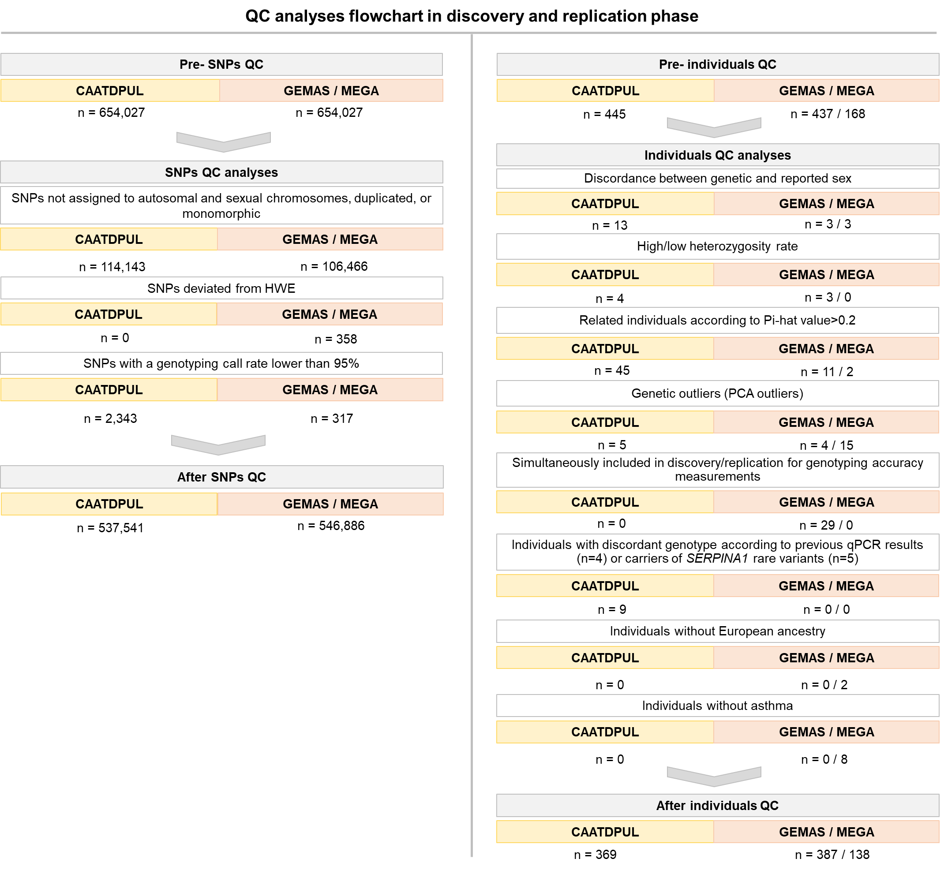
e-Figure 1. Quality control of genotype data from all populations.

SUPPLEMENTARY TABLES

e-Table 1. Sensitivity analysis for different covariates included in regression models assessing the association with asthma exacerbations in the discovery phase (CAATDPUL), adjusting by age, sex, and principal components.
Variant / Genotype / AAT level | Models including smoking |  |  | Models including BMI |  |  | Models including ICS use
Variant / Genotype / AAT level | OR (95% CI) | p-value |  | OR (95% CI) | p-value |  | OR (95% CI) | p-value
rs17580 (Pi*S) | 2.47 (1.41-4.15) | 0.001 |  | 2.36 (1.39-4.02) | 0.001 |  | 2.79 (1.60-4.87) | 2.90x10⁻⁴
rs28929474 (Pi*Z) | 3.41 (1.50-7.76) | 0.004 |  | 3.51 (1.55-7.92) | 0.003 |  | 4.99 (2.01-12.43) | 5.49x10⁻⁴
Pi*MS | 2.01 (1.06-3.81) | 0.032 |  | 1.92 (1.03-3.59) | 0.041 |  | 2.44 (1.26-4.75) | 0.009
Pi*MZ | 2.67 (1.08-6.57) | 0.033 |  | 2.63 (1.08-6.42) | 0.033 |  | 4.39 (1.63-11.83) | 0.004
Pi*SS | 8.79 (0.92-84.15) | 0.059 |  | 8.77 (0.92-83.55) | 0.059 |  | 12.36 (1.29-118.88) | 0.029
Pi*SZ | NA | NA |  | NA | NA |  | NA | NA
AATD | 4.80 (1.46-15.77) | 0.010 |  | 5.15 (1.57-16.83) | 0.007 |  | 7.33 (2.02-26.64) | 0.002
AAT levels | 0.73 (0.57-0.92) | 0.008 |  | 0.71 (0.56-0.90) | 0.005 |  | 0.67 (0.52-0.86) | 0.002
Statistically significant p-values after Bonferroni correction are in boldface. Abbreviations: AAT: Alpha-1 antitrypsin; AATD: Alpha-1 antitrypsin deficiency; BMI: Body mass index; CI: Confidence interval; ICS: Inhaled corticosteroid use; NA: Not available (beta coefficient or standard deviation >10); OR: Odds ratio.

e-Table 2. Multiple regression analysis for different outcomes related to asthma control, severity, allergic component, and pulmonary function, adjusting by age, sex, and principal components, in individuals included in the discovery phase (CAATDPUL).
Variant/Genotype/AAT level | rs17580 (Pi*S) |  | rs28929474 (Pi*Z) |  | Pi*MS |  | Pi*SS |  | Pi*MZ |  | Pi*SZ |  | AATD |  | AAT levels
Outcome | OR (95%CI) / β ± SD | p-value | OR (95%CI) / β ± SD | p-value | OR (95%CI) / β ± SD | p-value | OR (95%CI) / β ± SD | p-value | OR (95%CI) / β ± SD | p-value | OR (95%CI) / β ± SD | p-value | OR (95%CI) / β ± SD | p-value | OR (95%CI) / β ± SD | p-value
ACT level | 1.03  (0.62-1.72) | 0.913 | 2.45  (1.09-5.54) | 0.031 | 0.66  (0.35-1.27) | 0.213 | 5.52  (0.58-52.51) | 0.137 | 1.98  (0.81-4.85) | 0.136 | 5.53  (0.63-48.63) | 0.123 | 4.91  (1.34-18.09) | 0.017 | 0.87  (0.70-1.09) | 0.227
Severity level | 0.67  (0.40-1.13) | 0.132 | 0.55  (0.24-1.23) | 0.143 | 0.44  (0.23-0.85) | 0.014 | 1.47  (0.23-9.31) | 0.682 | 0.39  (0.15-1.00) | 0.049 | 1.05  (0.21-5.34) | 0.957 | 0.52  (0.17-1.57) | 0.247 | 1.09  (0.88-1.36) | 0.432
Hospitalizations | 1.81  (0.49-6.73) | 0.375 | 0.74  (0.08-6.63) | 0.788 | 1.49  (0.27-8.14) | 0.647 | NA | NA | NA | NA | 17.44  (1.35-225.13) | 0.028 | 3.44  (0.36-32.50) | 0.281 | 1.32  (0.75-2.32) | 0.340
Eosinophil (high vs. low) | 0.96  (0.57-1.61) | 0.875 | 1.08  (0.49-2.39) | 0.844 | 1.17  (0.63-2.20) | 0.615 | 0.65  (0.10-4.22) | 0.649 | 1.43  (0.58-3.51) | 0.435 | 0.43  (0.07-2.45) | 0.340 | 1.00  (0.35-2.92) | 0.992 | 1.00  (0.80-1.24) | 0.978
IgE (high vs. low) | 1.06  (0.59- 1.90) | 0.845 | 1.06  (0.38-2.91) | 0.914 | 1.45  (0.70-2.98) | 0.314 | 0.41  (0.04-4.22) | 0.453 | 1.40  (0.42-4.71) | 0.584 | 0.66  (0.11-4.04) | 0.657 | 0.62  (0.18-2.13) | 0.446 | 1.12  (0.87-1.44) | 0.394
FEV₁ (% predicted) | 0.09±0.12 | 0.478 | 0.18±0.19 | 0.337 | 0.29±0.15 | 0.054 | -0.43±0.43 | 0.323 | 0.33±0.21 | 0.115 | -0.20±0.39 | 0.614 | 0.21±0.26 | 0.410 | -0.09±0.05 | 0.089
FVC (% predicted) | 1.50±1.67 | 0.372 | 0.06±2.65 | 0.980 | 2.97±2.03 | 0.146 | -1.37±5.96 | 0.818 | 1.25±3.02 | 0.680 | -1.94±5.38 | 0.719 | 1.51±3.44 | 0.661 | -0.64±0.72 | 0.377
FEV₁/FVC (% predicted) | -0.09±0.12 | 0.444 | 0.31±0.19 | 0.108 | 0.02±0.15 | 0.909 | -0.54±0.43 | 0.204 | 0.41±0.22 | 0.061 | -0.05±0.39 | 0.900 | 0.08±0.25 | 0.749 | -0.03±0.05 | 0.337
MMEF (% predicted) | -0.08±0.13 | 0.513 | 0.35±0.20 | 0.080 | 0.08±0.16 | 0.603 | -0.70±0.45 | 0.126 | 0.48±0.22 | 0.032 | -0.11±0.41 | 0.788 | 0.03±0.27 | 0.916 | -0.04±0.06 | 0.464
Logistic regressions (ACT level, severity level, hospitalizations, eosinophil, and IgE) are summarized by odds ratio and 95% confidence interval. Linear regressions related to pulmonary function are summarized by beta ± standard deviations. Statistically significant p-values after Bonferroni correction are in boldface. The cutoff point for high/low levels of eosinophil levels and IgE levels was defined as 300 cells/μl and 165 IU/ml, respectively. Abbreviations: AAT: Alpha-1-antitrypsin; AATD: Alpha-1-antitrypsin deficiency; ACT: Asthma control test; FEV₁: Forced expiratory volume in the first second; FVC: Forced vital capacity; IgE: Immunoglobulin E; MMEF: Maximal mid-expiratory flow; NA: Not available (beta coefficient or standard deviation >10).

REFERENCES
- Hernández-Pérez JM, Ramos-Díaz R, Vaquerizo-Pollino C, Pérez JA. Frequency of alleles and genotypes associated with alpha-1 antitrypsin deficiency in clinical and general populations: Revelations about underdiagnosis [published online ahead of print, 2022 Mar 25]. Pulmonology. 2022;S2531-0437(22)00030-7.
- Hernández Pérez JM, Blanco I, Jesús Sánchez Medina A, Díaz Hernández L, Antonio Pérez Pérez J. Serum Levels of Glutamate-Pyruvate Transaminase, Glutamate-Oxaloacetate Transaminase and Gamma-Glutamyl Transferase in 1494 Patients with Various Genotypes for the Alpha-1 Antitrypsin Gene. J Clin Med. 2020;9(12).
- Perez-Garcia J, Hernández-Pérez JM, González-Pérez R, et al. The Genomics and Metagenomics of Asthma Severity (GEMAS) Study: Rationale and Design. J Pers Med. 2020;10(3).
- Muñoz X, Álvarez-Puebla MJ, Arismendi E, et al. The MEGA Project: A Study of the Mechanisms Involved in the Genesis and Disease Course of Asthma. Asthma Cohort Creation and Long-Term Follow-Up. Arch Bronconeumol. 2018;S0300-2896(18)30009-7.
- Cortes-Lopez R, Barjaktarevic I. Alpha-1 Antitrypsin Deficiency: a Rare Disease? Curr Allergy Asthma Rep. 2020;20(9):51. doi:10.1007/s11882-020-00942-4
- Herrera-Luis E, Ortega VE, Ampleford EJ, et al. Multi-ancestry genome-wide association study of asthma exacerbations. Pediatr Allergy Immunol. 2022;33(6):e13802.
- R Core Team (2020). R: A language and environment for statistical computing. R Foundation for Statistical Computing, Vienna, Austria. URL https://www.R-project.org/.
- Purcell S, Neale B, Todd-Brown K, et al. PLINK: a tool set for whole-genome association and population-based linkage analyses. Am J Hum Genet. 2007;81(3):559-575.
- Graffelman J, Moreno V. The mid p-value in exact tests for Hardy-Weinberg equilibrium. Stat Appl Genet Mol Biol. 2013;12(4):433-448.
- Yun JH, Lamb A, Chase R, et al. Blood eosinophil count thresholds and exacerbations in patients with chronic obstructive pulmonary disease. J Allergy Clin Immunol. 2018;141(6):2037-2047.e10.
- You C, Ran G, Wu X, et al. High immunoglobulin E level is associated with increased readmission in children with bronchopneumonia. Ther Adv Respir Dis. 13:1753466619879832.

