APPENDIX A. SUPPLEMENTARY TABLES
Table A1. Grouping of chronic conditions. Modified Magnan criteria
CCS | Names of Chronic Condition Categories (Magnan modified)
100 | Acute myocardial infarction
92;93;94;124;126;134;253 | Allergy, ENT and other upper resp disorders
59;62;64 | Anemia and other non-cancer heme disorders
115 | Aneurysm
651 | Anxiety disorders
128 | Asthma
205 | Back problem
652;654;655;656 | Behavior disorders
47 | Benign neoplasm
164 | Benign prostatic hypertrophy (BPH)
167 | Breast non-cancer
97;104 | Cardiomyopathy and Structural Heart Disease
109;110;111;112;113 | Cerebrovascular Disease
6 | Chronic Hepatitis
8;252 | Chronic Infectious and Parasitic Diseases
151 | Chronic Liver Disease (excluding chronic hepatitis)
127 | Chronic obstructive pulmonary disease and bronchiectasis
152 | Chronic pancreatitis
157;158 | Chronic renal failure
198;199;200 | Chronic skin ulcer
105;106;107 | Conduction disorder or cardiac dysrhythmia
213 | Congenital Heart Disease
108 | Congestive heart failure
101 | Coronary atherosclerosis
56 | Cystic fibrosis
86;87;88;89;90;91 | Degenerative eye problem (glauc/eye)
136 | dental and mouth
49;50 | Diabetes mellitus
144;146;149;154;155 | Diverticulosis, diverticulitis, enterocolitis, intestinal malabsorption
83 | Epilepsy
138;139;140;141;153 | Esophageal disorder and GI ulcers
168;169;170;171;175;181;183;186 | Female infertitlity and GU anatomic disorders (eg prolapse, endometriosis)
54 | Gout or other crystal arthropathy
96 | Heart valve disorder
5 | Human immunodeficiency virus
53 | Hyperlipidemia
98;99 | Hypertension
57;63 | Immunity disorder
156;159;161;162;163 | Kidney and Vesicoureteral Disorders (excluding renal failure)
210 | Lupus
165;166 | Male GU excluding BPH
11 to 44 | Malignant neoplasm
52;58 | Malnutrition-obesity-includes disorders of metabolism
173 | Menopause and perimenoapuse
84 | Migraines
670 | Miscellaneous mental disorders
650;657 | Mood disorders (bipolar an depressive disorders) and depression
80 | Multiple sclerosis
214;215;216;217;224 | Non-cardiac congenital disorder
117;121 | Non-thrombotic, non-athlerosclerotic vascular disease
653 | Organic brain problem (dementia)
203;204 | Osteoarthritis
77;78;81;85;95;227 | Other central and peripheral nervous system disorders
122;130;131;132;133 | Other chronic lung disease
48;51;174 | Other endocrine
201;206;208;209;211;212;225;236 | Other musculoskeletal including osteoporosis
82 | Paralysis
79 | Parkinson's disease
114;247;248 | Peripheral atherosclerosis
658 | Personality disorder
103 | Pulmonary heart disease
259 | Residual codes; unclassified
202 | Rheumatoid arthritis
659 | Schizophrenia and Psychotic Disorders
663 | Screening and history of mental health and substance abuse
61 | Sickle cell anemia
7;9 | STI
660;661 | Substance-use Disorders
116;118 | Thrombosis and Embolism
1 | Tuberculosis

Table A2. The fifteen most prevalent chronic diseases at time of index discharge (N=15,109)
Chronic disease categories (Magnan; see Table A1) | N | %
Hypertension | 12355 | 81.8%
Conduction disorder or cardiac dysrhythmia | 10333 | 68.4%
Hyperlipidemia | 7199 | 47.6%
Heart valve disorder | 5891 | 39.0%
Diabetes mellitus | 5723 | 37.9%
Coronary atherosclerosis | 4302 | 28.5%
Chronic renal failure | 4235 | 28.0%
Degenerative eye problem (glauc/eye) | 3955 | 26.2%
Cardiomyopathy and Structural Heart Disease | 3434 | 22.7%
Osteoarthritis | 3274 | 21.7%
Other musculoskeletal including osteoporosis | 3286 | 21.7%
Pulmonary heart disease | 3265 | 21.6%
Chronic obstructive pulmonary disease and bronchiectasis | 3231 | 21.4%
Malnutrition-obesity-includes disorders of metabolism | 3092 | 20.5%
Cerebrovascular Disease | 2615 | 17.3%

Table A3. Baseline characteristics (age and Charlson index) at time of first discharge after admission for heart failure by year
 | 2011 | 2012 | 2013 | 2014 | 2015 | p-trend*
Age at discharge,  mean ± SD | 79.4 ± 10.4 | 80 ± 10 | 80.1 ± 10.2 | 80.3 ± 10 | 80.8 ± 9.9 | 1.83E-07
Died during hospitalization | 83.8 ± 9.3 | 85.1 ± 8.7 | 84.5 ± 8.4 | 84.5 ± 9.7 | 86.1 ± 7.9 | 0.0294
Alive at discharge | 79.1 ± 10.4 | 79.6 ± 9.9 | 79.7 ± 10.3 | 80,0 ± 10 | 80.4 ± 9.9 | 6.56E-07
Men | 76.7 ± 10.9 | 77.4 ± 10.5 | 77.4 ± 10.9 | 77.7 ± 10.3 | 78.2 ± 10.4 | 5.35E-05
Women | 82.1 ± 9.2 | 82.4 ± 8.8 | 82.7 ± 8.8 | 82.7 ± 9,0 | 83.2 ± 8.7 | 5.42E-04
Overall Charlson Index, mean ± SD | 3 ± 2 | 3.1 ± 1.9 | 3.1 ± 2 | 3.2 ± 2.1 | 3.3 ± 2.1 | 2.89E-07
Died during hospitalization | 3.7 ± 2.4 | 3.5 ± 2.2 | 4 ± 2.7 | 4 ± 2.6 | 3.9 ± 2.4 | 0.0377
Alive at discharge | 3,0 ± 1.9 | 3.1 ± 1.9 | 3.1 ± 2 | 3.1 ± 2 | 3.2 ± 2 | 1.62E-06
Men | 3.3 ± 2.1 | 3.5 ± 2.1 | 3.5 ± 2.2 | 3.6 ± 2.2 | 3.7 ± 2.2 | 7.70E-05
Women | 2.7 ± 1.8 | 2.7 ± 1.7 | 2.7 ± 1.7 | 2.8 ± 1.8 | 2.9 ± 1.8 | 4.87E-04
*Linear model with age as the dependant variable and year (numerical) as the independent variable. (N = 16272 patients).
p-trend: a summary statistic for trends over time. P-trend was calculated including calendar year as a continuous variable in the models

Table A4. Incidence of heart failure. Statistics of variation
 |  | Women |  |  |  |  | Men
 |  | 2011 | 2012 | 2013 | 2014 | 2015 | 2011 | 2012 | 2013 | 2014 | 2015
Rates  (Overall) | Incidence, crude rate, per 1000 | 2.51 | 2.73 | 2.56 | 2.61 | 2.9 | 2.86 | 2.88 | 2.84 | 2.96 | 3.13
 | Incidence, standardized rate, per 1000 | 2.26 | 2.42 | 2.23 | 2.23 | 2.45 | 3.64 | 3.66 | 3.54 | 3.63 | 3.8
Statistics of variation | Max. standardized rate | 2.81 | 2.72 | 2.40 | 2.71 | 3.01 | 4.20 | 4.30 | 4.08 | 4.31 | 4.26
 | Min. standardized rate | 1.77 | 2.04 | 1.20 | 1.39 | 1.88 | 3.00 | 2.39 | 1.96 | 2.17 | 2.86
 | Variation Ratio | 1.59 | 1.34 | 1.99 | 1.95 | 1.60 | 1.40 | 1.80 | 2.09 | 1.99 | 1.49
 | Systematic component of variation | 0.06 | 0.04 | 0.09 | 0.08 | 0.04 | 0.05 | 0.07 | 0.06 | 0.05 | 0.07

Table A5. Classification of unplanned hospitalizations after index discharge by primary diagnosis
Hospitalizations within 30 days after discharge
Hospitalizations for heart failure |  |  |  |  |  |  | Potentially avoidable
Primary diagnosis (CCS) |  | Total |  | Men |  | Women | Total | Men |  | Women
Heart failure |  | 936 (100%) |  | 467 (100%) |  | 469 (100%) | 418 (45%) | 163 (35%) |  | 255 (54%)
Hospitalizations for Cardiovascular reasons (other than heart failure) |  |  |  |  |  |  | Potentially avoidable
Primary diagnosis (CCS) |  | Total |  | Men |  | Women | Total | Men |  | Women
Cardiac dysrhythmias |  | 110 (28.2%) |  | 44 (22.1%) |  | 66 (34.6%) | - | - |  | -
Coronary atherosclerosis and other heart disease |  | 52 (13.3%) |  | 36 (18.1%) |  | 16 (8.4%) | 52 (100%) | 36 (100%) |  | 16 (100%)
Acute cerebrovascular disease |  | 51 (13.1%) |  | 26 (13.1%) |  | 25 (13.1%) | 3 (5.9%) | 3 (11.5%) |  | 0 (0%)
Acute myocardial infarction |  | 30 (7.7%) |  | 16 (8%) |  | 14 (7.3%) | 30 (100%) | 16 (100%) |  | 14 (100%)
Heart valve disorders |  | 28 (7.2%) |  | 14 (7%) |  | 14 (7.3%) | - | - |  | -
Hypertension with complications and secondary hypertension |  | 15 (3.8%) |  | 6 (3%) |  | 9 (4.7%) | 9 (60%) | 5 (83.3%) |  | 4 (44.4%)
Other diagnosis |  | 104 (26.7%) |  | 57 (28.6%) |  | 47 (24.6%) | - | - |  | -
Total |  | 390 (100%) |  | 199 (100%) |  | 191 (100%) | 94 (24.1%) | 60 (30.2%) |  | 34 (17.8%)
Hospitalizations for other reasons |  |  |  |  |  |  | Potentially avoidable
Primary diagnosis (CCS) |  | Total |  | Men |  | Women | Total | Men |  | Women
Chronic obstructive pulmonary disease and bronchiectasis |  | 101 (7.9%) |  | 80 (12.1%) |  | 21 (3.4%) | 101 (100%) | 80 (100%) |  | 21 (100%)
Other lower respiratory disease |  | 99 (7.8%) |  | 55 (8.3%) |  | 44 (7.2%) | 9 (9.1%) | 6 (10.9%) |  | 3 (6.8%)
Respiratory failure; insufficiency; arrest (adult) |  | 81 (6.4%) |  | 37 (5.6%) |  | 44 (7.2%) | - | - |  | -
Pneumonia (except that caused by TB or STD) |  | 73 (5.7%) |  | 41 (6.2%) |  | 32 (5.2%) | 67 (91.8%) | 36 (87.8%) |  | 31 (96.9%)
Acute and unspecified renal failure |  | 68 (5.3%) |  | 34 (5.1%) |  | 34 (5.5%) | - | - |  | -
Urinary tract infections |  | 62 (4.9%) |  | 18 (2.7%) |  | 44 (7.2%) | 62 (100%) | 18 (100%) |  | 44 (100%)
Other diagnosis |  | 798 (62.2%) |  | 398 (60%) |  | 400 (64.6%) | 135 (16.9%) | 42 (10.6%) |  | 93 (23.3%)
Total |  | 1282 (100%) |  | 663 (100%) |  | 619 (100%) | 374 (29.2%) | 182 (27.5%) |  | -
Hospitalizations within 365 days after discharge
Hospitalizations for heart failure |  |  |  |  |  |  | Potentially avoidable
Primary diagnosis (CCS) | Total |  | Men |  | Women |  | Total |  | Men |  | Women
Heart failure | 4700 (100%) |  | 2369 (100%) |  | 2331 (100%) |  | 1992 (42.4%) |  | 741 (31.3%) |  | 1251 (53.7)
Hospitalizations for Cardiovascular reasons (other than heart failure) |  |  |  |  |  |  | Potentially avoidable
Primary diagnosis (CCS) | Total |  | Men |  | Women |  | Total |  | Men |  | Women
Cardiac dysrhythmias | 512 (26.3%) |  | 236 (23%) |  | 276 (30.1%) |  | - |  | - |  | -
Acute cerebrovascular disease | 257 (13.2%) |  | 131 (12.8%) |  | 126 (13.7%) |  | 24 (9.3%) |  | 16 (12.2%) |  | 8 (6.3%)
Coronary atherosclerosis and other heart disease | 247 (12.7%) |  | 158 (15.4%) |  | 89 (9.7%) |  | 247 (100%) |  | 158 (100%) |  | 89 (100%)
Acute myocardial infarction | 166 (8.5%) |  | 86 (8.4%) |  | 80 (8.7%) |  | 166 (100%) |  | 86 (100%) |  | 80 (100%)
Heart valve disorders | 108 (5.6%) |  | 55 (5.4%) |  | 53 (5.8%) |  | - |  | - |  | -
Peri-; endo-; and myocarditis; cardiomyopathy (except that caused by TB or STD) | 84 (4.3%) |  | 55 (5.4%) |  | 29 (3.2%) |  | - |  | - |  | -
Peripheral and visceral atherosclerosis | 82 (4.2%) |  | 51 (5%) |  | 31 (3.4%) |  | - |  | - |  | -
Other diagnosis | 489 (25.1%) |  | 255 (24.8%) |  | 234 (25.5%) |  | 52 (10.6%) |  | 28 (11%) |  | 24 (10.3%)
Total | 1945 (100%) |  | 1027 (100%) |  | 918 (100%) |  | 489 (25.1%) |  | 288 (28%) |  | 201 (21.9%)
Hospitalizations for other reasons |  |  |  |  |  |  | Potentially avoidable
Primary diagnosis (CCS) | Total |  | Men |  | Women |  | Total |  | Men |  | Women
Chronic obstructive pulmonary disease and bronchiectasis | 751 (9.5%) |  | 619 (14.7%) |  | 132 (3.6%) |  | 751 (100%) |  | 619 (100%) |  | 132 (100%)
Other lower respiratory disease | 663 (8.4%) |  | 311 (7.4%) |  | 352 (9.6%) |  | 60 (9%) |  | 30 (9.6%) |  | 30 (8.5%)
Pneumonia (except that caused by TB or STD) | 554 (7%) |  | 306 (7.3%) |  | 248 (6.8%) |  | 535 (96.6%) |  | 294 (96.1%) |  | 241 (97.2%)
Respiratory failure; insufficiency; arrest (adult) | 496 (6.3%) |  | 242 (5.8%) |  | 254 (6.9%) |  | - |  | - |  | -
Acute bronchitis | 380 (4.8%) |  | 124 (3%) |  | 256 (7%) |  | 380 (100%) |  | 124 (100%) |  | 256 (100%)
Urinary tract infections | 312 (4%) |  | 117 (2.8%) |  | 195 (5.3%) |  | 308 (98.7%) |  | 115 (98.3%) |  | 193 (99%)
Acute and unspecified renal failure | 260 (3.3%) |  | 139 (3.3%) |  | 121 (3.3%) |  | - |  | - |  | -
Other diagnosis | 4498 (56.8%) |  | 2367 (56%) |  | 2131 (57.8%) |  | 573 (12.7%) |  | 220 (9.3%) |  | 353 (16
Total | 7914 (100%) |  | 4225 (100%) |  | 3689 (100%) |  | 2607 (32.9%) |  | 1402 (33.2%) |  | 1205 (32.7%)

Table A6. Trends in event rates after index discharge by year.
 |  | Men |  |  |  |  |  | Women
 |  | OR (IC 95%) |  |  |  |  |  | OR (IC 95%)
 |  | 2011 | 2012 | 2013 | 2014 | 2015 | p-trend | 2011 | 2012 | 2013 | 2014 | 2015 | p-trend
Mortality | ≤30 days | 1 (ref.) | 0.75 (0.51, 1.09) | 0.99 (0.7,  1.4) | 1.06 (0.75, 1.49) | 0.71 (0.49, 1.02) | 0.396 | 1 (ref.) | 0.79 (0.57, 1.1) | 0.82 (0.59, 1.14) | 0.69 (0.49, 0.97) | 0.92 (0.67, 1.25) | 0.505
 | ≤365 days | 1 (ref.) | 0.79 (0.66, 0.95) | 0.82 (0.68, 0.98) | 0.9 (0.76, 1.07) | 0.8 (0.67, 0.95) | 0.106 | 1 (ref.) | 0.81 (0.68, 0.97) | 0.93 (0.78, 1.1) | 0.88 (0.74, 1.05) | 0.84 (0.7, 0.99) | 0.174
Unplanned hospitalizations ≤ 30 days | Any cause | 1 (ref.) | 0.91 (0.76, 1.08) | 0.92 (0.78, 1.1) | 0.94 (0.79, 1.11) | 0.88 (0.75, 1.05) | 0.281 | 1 (ref.) | 1.08 (0.9, 1.28) | 0.98 (0.81, 1.17) | 1.01 (0.85, 1.21) | 1.02 (0.86, 1.22) | 0.898
 | Main cause HF | 1 (ref.) | 0.97 (0.72, 1.31) | 0.98 (0.72, 1.33) | 0.92 (0.68, 1.25) | 0.91 (0.67, 1.22) | 0.462 | 1 (ref.) | 1.16 (0.87, 1.56) | 0.9 (0.66, 1.24) | 1.16 (0.86, 1.56) | 1.15 (0.86, 1.54) | 0.408
 | HF Potentially avoidable | 1 (ref.) | 1.06 (0.66, 1.71) | 0.99 (0.61, 1.61) | 0.72 (0.42, 1.21) | 0.87 (0.53, 1.43) | 0.261 | 1 (ref.) | 1.01 (0.69, 1.47) | 0.66 (0.43, 1) | 0.85 (0.57, 1.27) | 0.99 (0.69, 1.44) | 0.745
Unplanned hospitalizations ≤ 365 days | Any cause | 1 (ref.) | 0.95 (0.85, 1.06) | 0.93 (0.83, 1.04) | 0.93 (0.84, 1.04) | 0.9 (0.81,  1) | 0.058 | 1 (ref.) | 0.91 (0.82, 1.02) | 0.96 (0.86, 1.07) | 0.97 (0.87, 1.08) | 0.88 (0.79, 0.98) | 0.117
 | Main cause HF | 1 (ref.) | 1  (0.83, 1.19) | 1  (0.83, 1.19) | 0.88 (0.73, 1.05) | 0.92 (0.77, 1.1) | 0.124 | 1 (ref.) | 0.88 (0.73, 1.05) | 0.93 (0.77, 1.11) | 0.93 (0.78, 1.11) | 0.83 (0.7, 0.99) | 0.109
 | HF Potentially avoidable | 1 (ref.) | 1.01 (0.77, 1.33) | 1.02 (0.78, 1.34) | 0.76 (0.57, 1.01) | 0.91 (0.7, 1.19) | 0.132 | 1 (ref.) | 0.85 (0.69, 1.06) | 0.77 (0.61, 0.96) | 0.84 (0.67, 1.04) | 0.73 (0.59, 0.91) | 0.009
HF: Heart failure
OR: Odds Ratios adjusted for age and level of comorbidity (Charlson index)
Ref.: reference category
p-trend: a summary statistic for trends over time. P-trend was calculated including calendar year as a continuous variable in the models

APPENDIX B. SUPLEMENTARY FIGURES
Figure B1. Overall survival curve and hazard function following the first discharge after admission for heart failure.
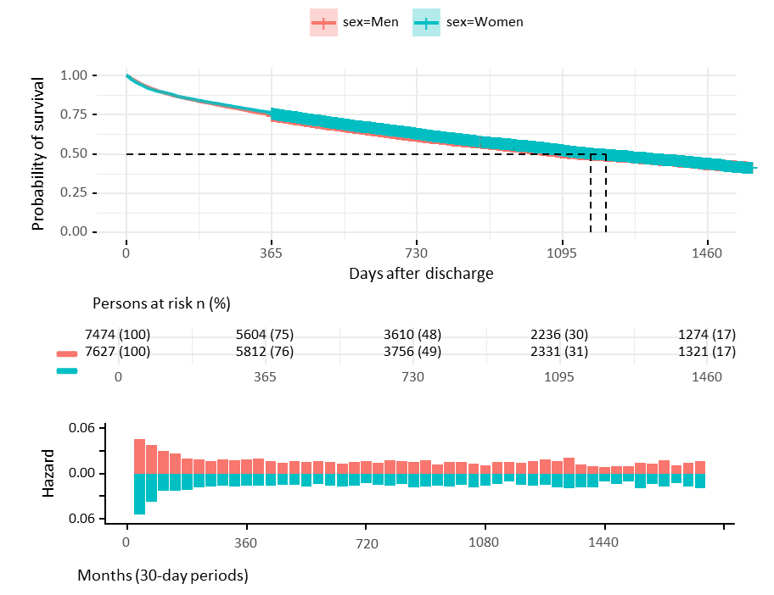
(a) First 4 years
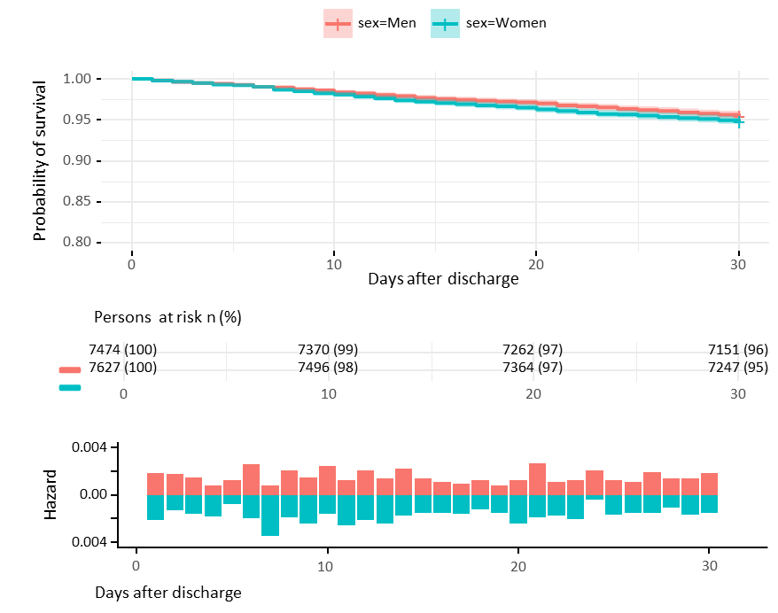
(b) First 30 days

