Survival without CKD progression
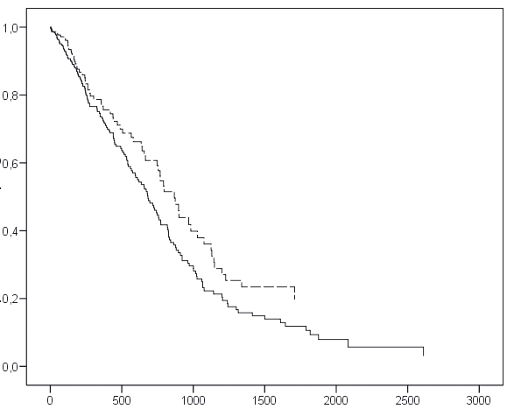
Time (days)

